合同编号:0149-2023-QEO
认证证书信息确认书
受审核方名称 | 河北雄达电力设备制造有限公司 |  |  |  | 审核组长 |  | 姜海军
订单号 |  |  |  |  | 证书号 |  | Q:,E:,O:
组织机构代码 | 911306283200201079 |  |  |  | 是否带CNAS标志 |  | Q:认可,E:未认可,O:未认可
认证标准 | ■ GB/T 19001-2016 idt ISO 9001:2015标准 (不适用：8.3 条款)  □ GB/T 50430-2017 (不适用： 条款)；  ■ GB/T 24001-2016 idt ISO 14001:2015标准；  ■ GB/T 45001-2020 idt ISO 45001:2018标准；  □ GB/T 23331-2020 idt ISO 50001:2018标准；  □RB/T XXXX-XXXX  □ISO 22000-2018  □危害分析与关键控制点（HACCP）体系认证要求（V1.0） |  |  |  | 企业体系有效人数 |  | Q:30,E:30,O:30
审核类型 | ■初次认证□监督审核□再认证□特殊审核□换证
变更内容 | □组织名称变更□地址变更□认证范围变更（□扩大□缩小）
申 请
■ 公司因投招标使用，需证书里的产品/服务内容一致
■ 公司需与其它体系或服务认证证书中的产品/服务范围表述一致，便于统一管理，统一招投标使用
□ 需与原获证证书范围一致，以便于统一管理。

特申请QMS为一张证书，无CNAS认可标志。

请选择所需求的证书语言. 对其它语言需求，如有必要，请另附表单.
 | 中文公司名称及地址 | 中文认证范围
公司名称 | 河北雄达电力设备制造有限公司 | Q：电力安全工器具（防鸟罩、驱鸟器、防鸟刺、标识牌、登杆脚扣、绝缘硬梯、拉闸杆、接地线、验电器、绝缘护罩、红布幔、安全警示带、绝缘伸缩围栏、拉线防护套）、电力金具、铁附件、复合绝缘横担、高压隔离开关、拉紧绝缘子、合成绝缘子，避雷器，高压跌落式熔断器、接线端子、接地石墨的生产和销售；电力设施器材配件（一次设备配件和二次设备配件）、镀锌螺栓的销售；  E：电力安全工器具（防鸟罩、驱鸟器、防鸟刺、标识牌、登杆脚扣、绝缘硬梯、拉闸杆、接地线、验电器、绝缘护罩、红布幔、安全警示带、绝缘伸缩围栏、拉线防护套）、电力金具、铁附件、复合绝缘横担、高压隔离开关、拉紧绝缘子、合成绝缘子，避雷器，高压跌落式熔断器、接线端子、接地石墨的生产和销售；电力设施器材配件（一次设备配件和二次设备配件）、镀锌螺栓的销售所涉及场所的相关环境管理活动  O：电力安全工器具（防鸟罩、驱鸟器、防鸟刺、标识牌、登杆脚扣、绝缘硬梯、拉闸杆、接地线、验电器、绝缘护罩、红布幔、安全警示带、绝缘伸缩围栏、拉线防护套）、电力金具、铁附件、复合绝缘横担、高压隔离开关、拉紧绝缘子、合成绝缘子，避雷器，高压跌落式熔断器、接线端子、接地石墨的生产和销售；电力设施器材配件（一次设备配件和二次设备配件）、镀锌螺栓的销售所涉及场所的相关职业健康安全管理活动
注册地址 | 河北省保定市高阳县庞家佐乡刘家连城村委会东行150米路北
经营地址 | 河北省保定市高阳县庞家佐乡刘家连城村委会东行150米路北
(注：除介词和连词外，首字母大写）
 | 英文公司名称及地址 English company name & address | 英文认证范围  English Scope
Company Name公司名称 | Hebei Xiongda Electric Power Equipment Manufacturing Co.Ltd | QMS/EcMS |  | Electric power safety tools (bird guard, bird repeller, bird thorn prevention, signboard, climbing pole foot buckle, insulated hard ladder, switch lever, grounding wire, electroscope, insulating shield, red cloth curtain, safety warning belt, insulating telescopic fence, cable protective sleeve), electric power hardware, iron accessories, composite insulating cross arm, high-voltage isolating switch, tension insulator, composite insulator and lightning arrester. Sales of power facility equipment accessories (primary equipment accessories and secondary equipment accessories) and galvanized bolts.
Company Name公司名称 | Hebei Xiongda Electric Power Equipment Manufacturing Co.Ltd | EMS |  | Electric power safety tools (bird guard, bird repeller, bird thorn prevention, signboard, climbing pole foot buckle, insulated hard ladder, switch lever, grounding wire, electroscope, insulating shield, red cloth curtain, safety warning belt, insulating telescopic fence, cable protective sleeve), electric power hardware, iron accessories, composite insulating cross arm, high-voltage isolating switch, tension insulator, composite insulator and lightning arrester. Environmental management activities in the places involved in the sales of power facilities and equipment accessories (primary equipment accessories and secondary equipment accessories) and galvanized bolts.
Registration Address注册地址 | 150 meters north of the east bound of Liujia Liancheng Village Committee, Pangjiazuo Township, Gaoyang County, Baoding City, Hebei Province. | OHSMS |  | 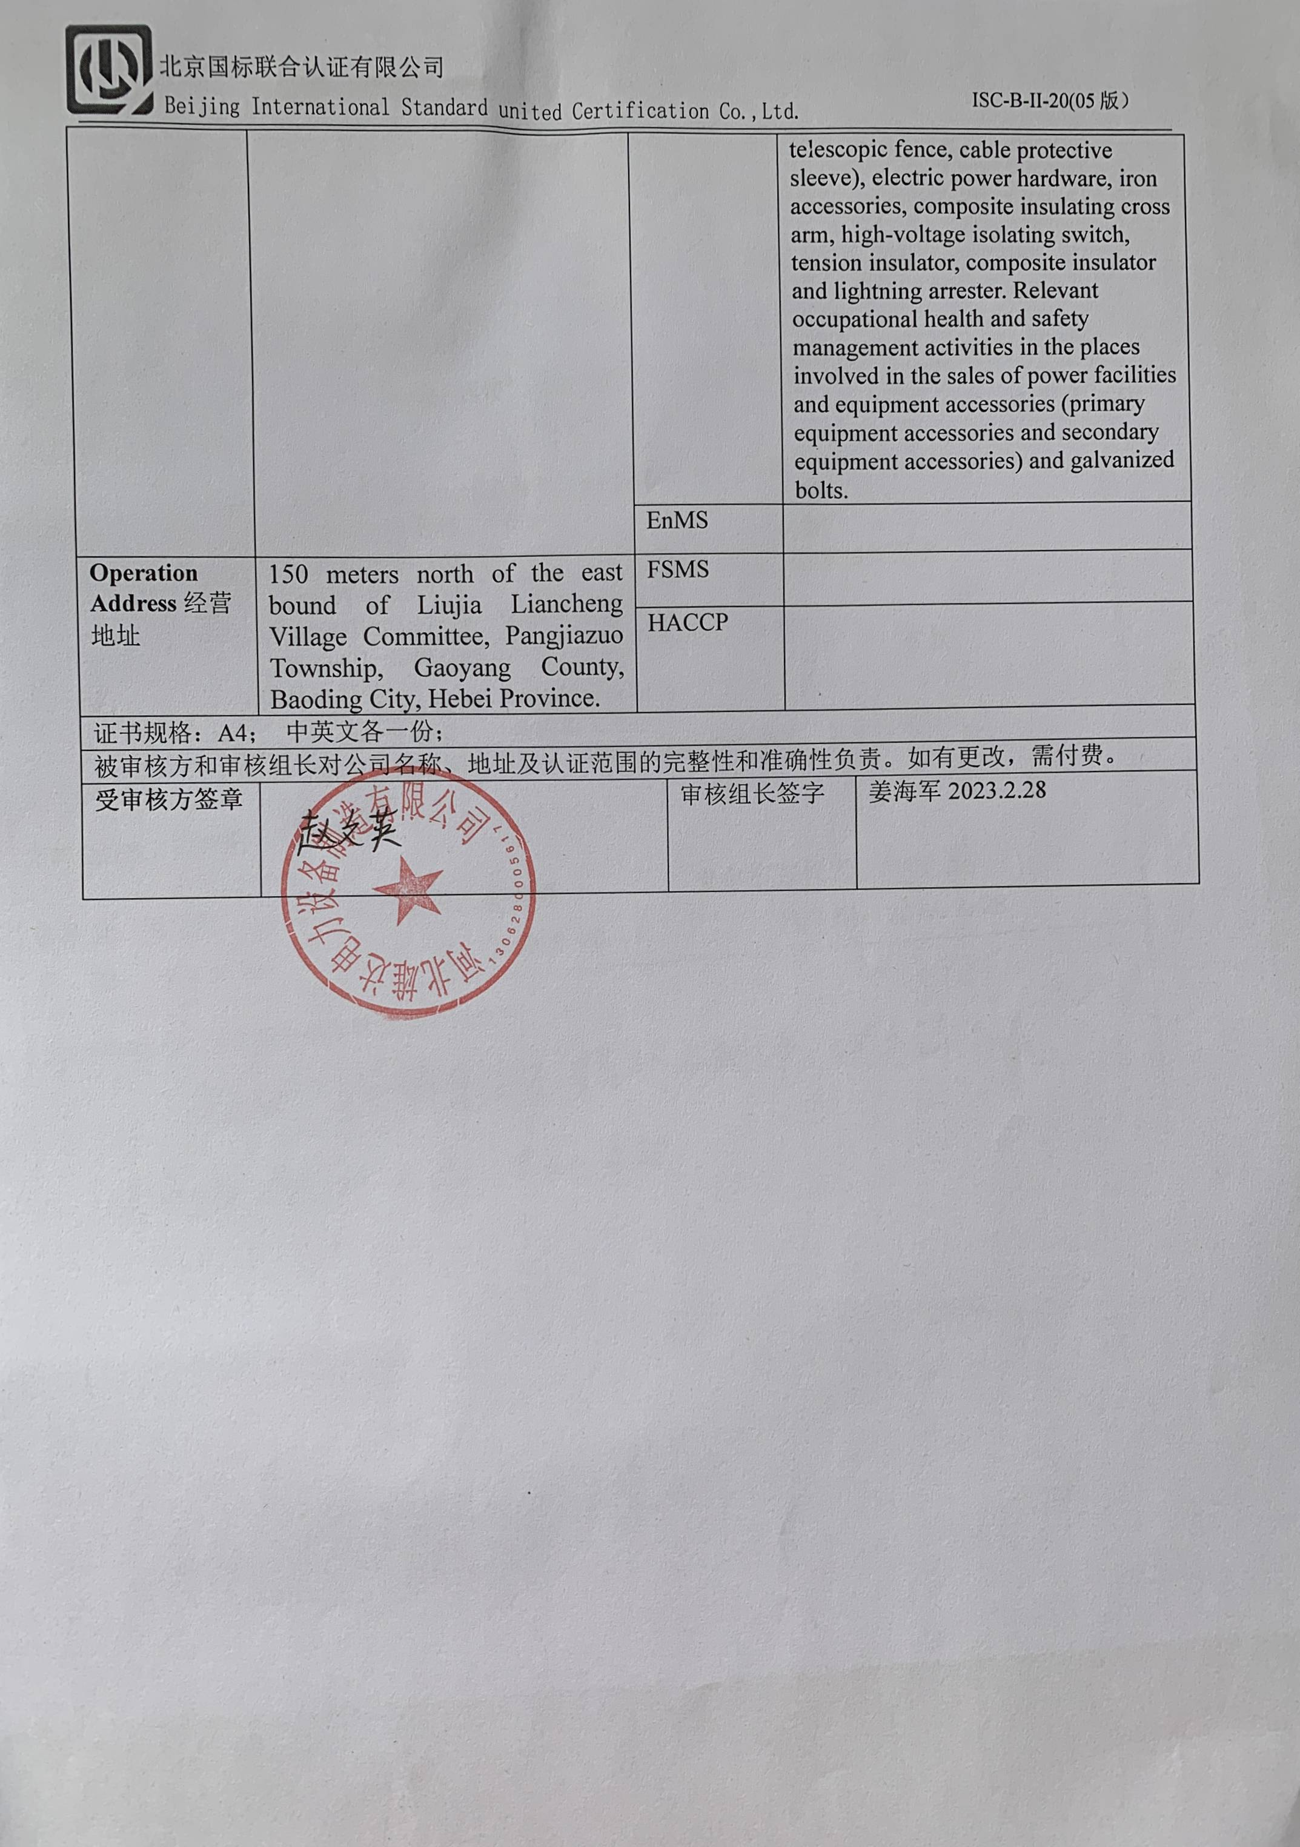  Electric power safety tools (bird guard, bird repeller, bird thorn prevention, signboard, climbing pole foot buckle, insulated hard ladder, switch lever, grounding wire, electroscope, insulating shield, red cloth curtain, safety warning belt, insulating telescopic fence, cable protective sleeve), electric power hardware, iron accessories, composite insulating cross arm, high-voltage isolating switch, tension insulator, composite insulator and lightning arrester. Relevant occupational health and safety management activities in the places involved in the sales of power facilities and equipment accessories (primary equipment accessories and secondary equipment accessories) and galvanized bolts.
Registration Address注册地址 |  | EnMS
Operation Address经营地址 | 150 meters north of the east bound of Liujia Liancheng Village Committee, Pangjiazuo Township, Gaoyang County, Baoding City, Hebei Province. | FSMS
Operation Address经营地址 |  | HACCP
证书规格：A4； 中英文各一份；
被审核方和审核组长对公司名称、地址及认证范围的完整性和准确性负责。如有更改，需付费。
受审核方签章 |  |  | 审核组长签字 |  |  | 姜海军2023.2.28

