合同编号:1297-2022-QEO
认证证书信息确认书
受审核方名称 | 山东瑞龙仪器设备有限公司 |  |  |  | 审核组长 |  | 姜海军
订单号 |  |  |  |  | 证书号 |  | Q:,E:,O:
组织机构代码 | 91371702MA3DP8U70M |  |  |  | 是否带CNAS标志 |  | Q:认可,E:认可,O:认可
认证标准 | ■ GB/T 19001-2016 idt ISO 9001:2015标准 (不适用： 8.3 条款)  □ GB/T 50430-2017 (不适用： 条款)；  ■ GB/T 24001-2016 idt ISO 14001:2015标准；  ■ GB/T 45001-2020 idt ISO 45001:2018标准；  □ GB/T 23331-2020 idt ISO 50001:2018标准；  □RB/T XXXX-XXXX  □ISO 22000-2018  □危害分析与关键控制点（HACCP）体系认证要求（V1.0） |  |  |  | 企业体系有效人数 |  | Q:6,E:6,O:6
审核类型 | ■初次认证□监督审核□再认证□特殊审核□换证
变更内容 | □组织名称变更□地址变更□认证范围变更（□扩大□缩小）
请选择所需求的证书语言. 对其它语言需求，如有必要，请另附表单.
 | 中文公司名称及地址 | 中文认证范围
公司名称 | 山东瑞龙仪器设备有限公司 | Q：教学仪器、实验室设备、课桌椅、音体美器材、健身器材、幼儿园教具、多媒体教室设备、厨房设备、心理咨询设备、教育机器人、广播设备、音响设备、电视设备、空调设备、水处理设备及耗材、消防器材、监控设备、安保器材(不含警用器材)、塑胶跑道、计算机及软硬件的销售  E：教学仪器、实验室设备、课桌椅、音体美器材、健身器材、幼儿园教具、多媒体教室设备、厨房设备、心理咨询设备、教育机器人、广播设备、音响设备、电视设备、空调设备、水处理设备及耗材、消防器材、监控设备、安保器材(不含警用器材)、塑胶跑道、计算机及软硬件的销售所涉及场所的相关环境管理活动  O：教学仪器、实验室设备、课桌椅、音体美器材、健身器材、幼儿园教具、多媒体教室设备、厨房设备、心理咨询设备、教育机器人、广播设备、音响设备、电视设备、空调设备、水处理设备及耗材、消防器材、监控设备、安保器材(不含警用器材)、塑胶跑道、计算机及软硬件的销售所涉及场所的相关职业健康安全管理活动
注册地址 | 山东省菏泽市牡丹区长城路88号
经营地址 | 山东省菏泽市牡丹区长城路88号
(注：除介词和连词外，首字母大写）
 | 英文公司名称及地址 English company name & address | 英文认证范围  English Scope
Company Name公司名称 | Shandong Ruilong Instrument Equipment Co.Ltd | QMS/EcMS |  | 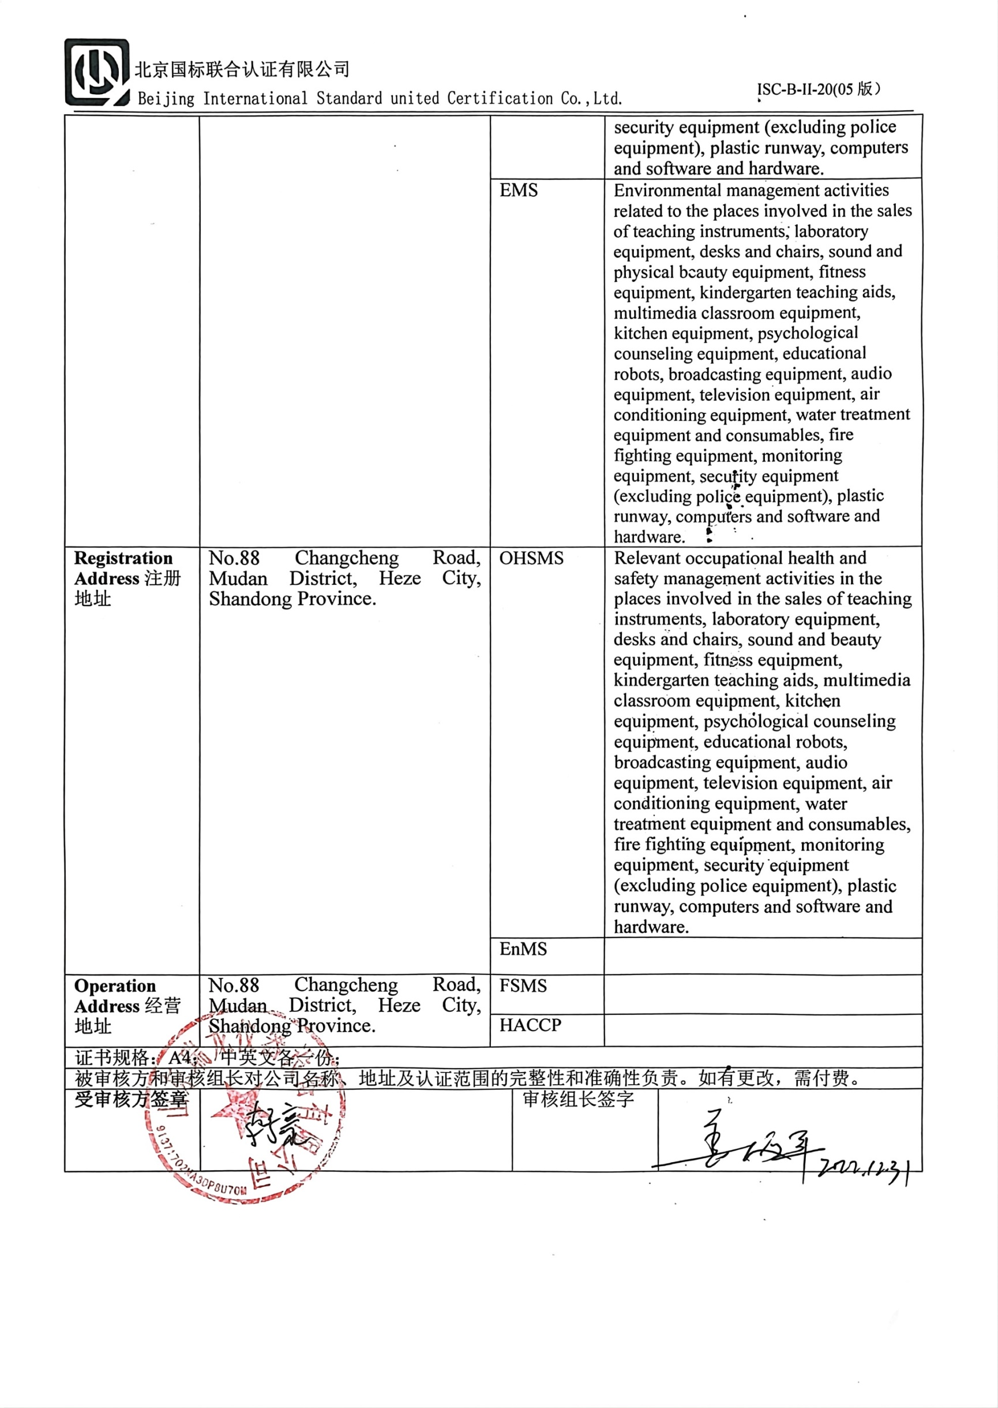  Sales of teaching instruments, laboratory equipment, desks and chairs, sound and beauty equipment, fitness equipment, kindergarten teaching aids, multimedia classroom equipment, kitchen equipment, psychological counseling equipment, educational robots, broadcasting equipment, audio equipment, television equipment, air conditioning equipment, water treatment equipment and consumables, fire fighting equipment, monitoring equipment, security equipment (excluding police equipment), plastic runway, computers and software and hardware.
Company Name公司名称 | Shandong Ruilong Instrument Equipment Co.Ltd | EMS |  | Environmental management activities related to the places involved in the sales of teaching instruments, laboratory equipment, desks and chairs, sound and physical beauty equipment, fitness equipment, kindergarten teaching aids, multimedia classroom equipment, kitchen equipment, psychological counseling equipment, educational robots, broadcasting equipment, audio equipment, television equipment, air conditioning equipment, water treatment equipment and consumables, fire fighting equipment, monitoring equipment, security equipment (excluding police equipment), plastic runway, computers and software and hardware.
Registration Address注册地址 | No.88 Changcheng Road, Mudan District, Heze City, Shandong Province. | OHSMS |  | Relevant occupational health and safety management activities in the places involved in the sales of teaching instruments, laboratory equipment, desks and chairs, sound and beauty equipment, fitness equipment, kindergarten teaching aids, multimedia classroom equipment, kitchen equipment, psychological counseling equipment, educational robots, broadcasting equipment, audio equipment, television equipment, air conditioning equipment, water treatment equipment and consumables, fire fighting equipment, monitoring equipment, security equipment (excluding police equipment), plastic runway, computers and software and hardware.
Registration Address注册地址 |  | EnMS
Operation Address经营地址 | No.88 Changcheng Road, Mudan District, Heze City, Shandong Province. | FSMS
Operation Address经营地址 |  | HACCP
证书规格：A4； 中英文各一份；
被审核方和审核组长对公司名称、地址及认证范围的完整性和准确性负责。如有更改，需付费。
受审核方签章 |  |  | 审核组长签字

