合同编号:1298-2022-QEO
认证证书信息确认书
受审核方名称 | 山东三辰教学设备有限公司 |  |  |  | 审核组长 |  | 姜海军
订单号 |  |  |  |  | 证书号 |  | Q:,E:,O:
组织机构代码 | 91371702493806271A |  |  |  | 是否带CNAS标志 |  | Q:认可,E:认可,O:认可
认证标准 | ■ GB/T 19001-2016 idt ISO 9001:2015标准 (不适用：8.3 条款)  □ GB/T 50430-2017 (不适用： 条款)；  ■ GB/T 24001-2016 idt ISO 14001:2015标准；  ■ GB/T 45001-2020 idt ISO 45001:2018标准；  □ GB/T 23331-2020 idt ISO 50001:2018标准；  □RB/T XXXX-XXXX  □ISO 22000-2018  □危害分析与关键控制点（HACCP）体系认证要求（V1.0） |  |  |  | 企业体系有效人数 |  | Q:6,E:6,O:6
审核类型 | ■初次认证□监督审核□再认证□特殊审核□换证
变更内容 | □组织名称变更□地址变更□认证范围变更（□扩大□缩小）
请选择所需求的证书语言. 对其它语言需求，如有必要，请另附表单.
 | 中文公司名称及地址 | 中文认证范围
公司名称 | 山东三辰教学设备有限公司 | Q：教学仪器、实验室设备、课桌椅设备、仪器仪表、音乐器材、体育器材、美术器材、健身器材、人造草坪、塑胶跑道、幼儿园教具、综合实验室及厨房设备、数字化教室设备、多媒体教室设备、空调设备的销售  E：教学仪器、实验室设备、课桌椅设备、仪器仪表、音乐器材、体育器材、美术器材、健身器材、人造草坪、塑胶跑道、幼儿园教具、综合实验室及厨房设备、数字化教室设备、多媒体教室设备、空调设备的销售所涉及场所的相关环境管理活动  O：教学仪器、实验室设备、课桌椅设备、仪器仪表、音乐器材、体育器材、美术器材、健身器材、人造草坪、塑胶跑道、幼儿园教具、综合实验室及厨房设备、数字化教室设备、多媒体教室设备、空调设备的销售所涉及场所的相关职业健康安全管理活动
注册地址 | 山东省菏泽市牡丹区北城宏利社区市传染病医院南邻
经营地址 | 山东省菏泽市牡丹区天华电商产业园电商大楼305
(注：除介词和连词外，首字母大写）
 | 英文公司名称及地址 English company name & address | 英文认证范围  English Scope
Company Name公司名称 | Shandong Sanchen Teaching Equipment Co.Ltd | QMS/EcMS |  | Sales of teaching instruments, laboratory equipment, desks and chairs, instruments and meters, music equipment, sports equipment, art equipment, fitness equipment, artificial lawn, plastic runway, kindergarten teaching aids, comprehensive laboratory and kitchen equipment, digital classroom equipment, multimedia classroom equipment and air conditioning equipment.
Company Name公司名称 | Shandong Sanchen Teaching Equipment Co.Ltd | EMS |  | 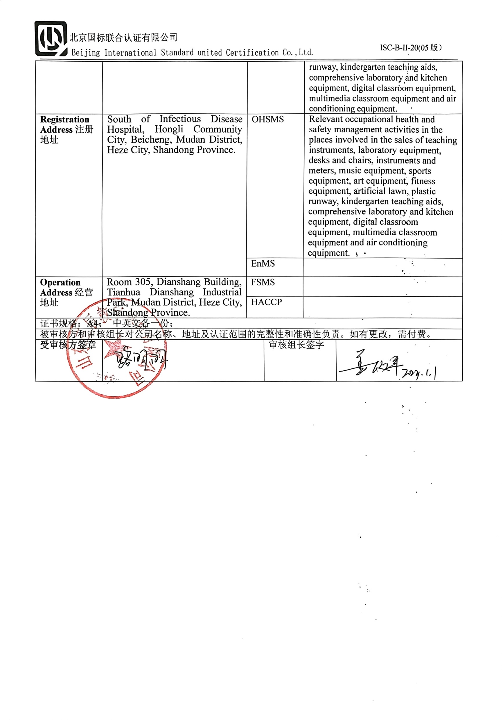  Relevant environmental management activities of places involved in the sales of teaching instruments, laboratory equipment, desks and chairs, instruments and meters, music equipment, sports equipment, art equipment, fitness equipment, artificial lawn, plastic runway, kindergarten teaching aids, comprehensive laboratory and kitchen equipment, digital classroom equipment, multimedia classroom equipment and air conditioning equipment.
Registration Address注册地址 | South of Infectious Disease Hospital, Hongli Community City, Beicheng, Mudan District, Heze City, Shandong Province. | OHSMS |  | Relevant occupational health and safety management activities in the places involved in the sales of teaching instruments, laboratory equipment, desks and chairs, instruments and meters, music equipment, sports equipment, art equipment, fitness equipment, artificial lawn, plastic runway, kindergarten teaching aids, comprehensive laboratory and kitchen equipment, digital classroom equipment, multimedia classroom equipment and air conditioning equipment.
Registration Address注册地址 |  | EnMS
Operation Address经营地址 | Room 305, Dianshang Building, Tianhua Dianshang Industrial Park, Mudan District, Heze City, Shandong Province. | FSMS
Operation Address经营地址 |  | HACCP
证书规格：A4； 中英文各一份；
被审核方和审核组长对公司名称、地址及认证范围的完整性和准确性负责。如有更改，需付费。
受审核方签章 |  |  | 审核组长签字

