合同编号:0527-2022-QEO
认证证书信息确认书
受审核方名称 | 山东海声音科教仪器有限公司 |  |  |  | 审核组长 |  | 姜海军
订单号 |  |  |  |  | 证书号 |  | Q:,E:,O:
组织机构代码 | 91371726321844087M |  |  |  | 是否带CNAS标志 |  | ¨ 带标 ■不带标
认证标准 | ■ GB/T 19001-2016 idt ISO 9001:2015标准 (不适用： 8.3 条款)  □ GB/T 50430-2017 (不适用： 条款)；  ■ GB/T 24001-2016 idt ISO 14001:2015标准；  ■ GB/T 45001-2020 idt ISO 45001:2018标准；  □ GB/T 23331-2020 idt ISO 50001:2018标准；  □RB/T XXXX-XXXX  □ISO 22000-2018  □GB/T 27341-2009&GB 14881-2013&危害分析与关键控制点（HACCP体系）认证补充要求 1.0 |  |  |  | 企业体系有效人数 |  | Q:15,E:15,O:15
审核类型 | ■初次认证□监督审核□再认证□特殊审核□换证
变更内容 | □组织名称变更□地址变更□认证范围变更（□扩大□缩小）
请选择所需求的证书语言. 对其它语言需求，如有必要，请另附表单.
 | 中文公司名称及地址 | 中文认证范围
公司名称 | 山东海声音科教仪器有限公司 | Q：教学专用仪器、音响设备、实验分析仪器、仪器仪表、家具、办公用品、劳动保护用品、玩具、服装服饰、日用木制品、玻璃仪器、网络设备的销售，乐器、体育用品、厨具、计算机软硬件及辅助设备的零售  E：教学专用仪器、音响设备、实验分析仪器、仪器仪表、家具、办公用品、劳动保护用品、玩具、服装服饰、日用木制品、玻璃仪器、网络设备的销售，乐器、体育用品、厨具、计算机软硬件及辅助设备的零售所涉及场所的相关环境管理活动  O：教学专用仪器、音响设备、实验分析仪器、仪器仪表、家具、办公用品、劳动保护用品、玩具、服装服饰、日用木制品、玻璃仪器、网络设备的销售，乐器、体育用品、厨具、计算机软硬件及辅助设备的零售所涉及场所的相关职业健康安全管理活动
注册地址 | 山东省菏泽市鄄城县鄄十五路与经济街交叉路口北100米路西(凤凰开发区)
经营地址 | 山东省菏泽市鄄城县鄄十五路与经济街交叉路口北100米路西(凤凰开发区)
(注：除介词和连词外，首字母大写）
 | 英文公司名称及地址 English company name & address | 英文认证范围  English Scope
Company Name公司名称 | Shandong Haishengsheng Science Education Instrument Co., Ltd. | QMS/EcMS |  | 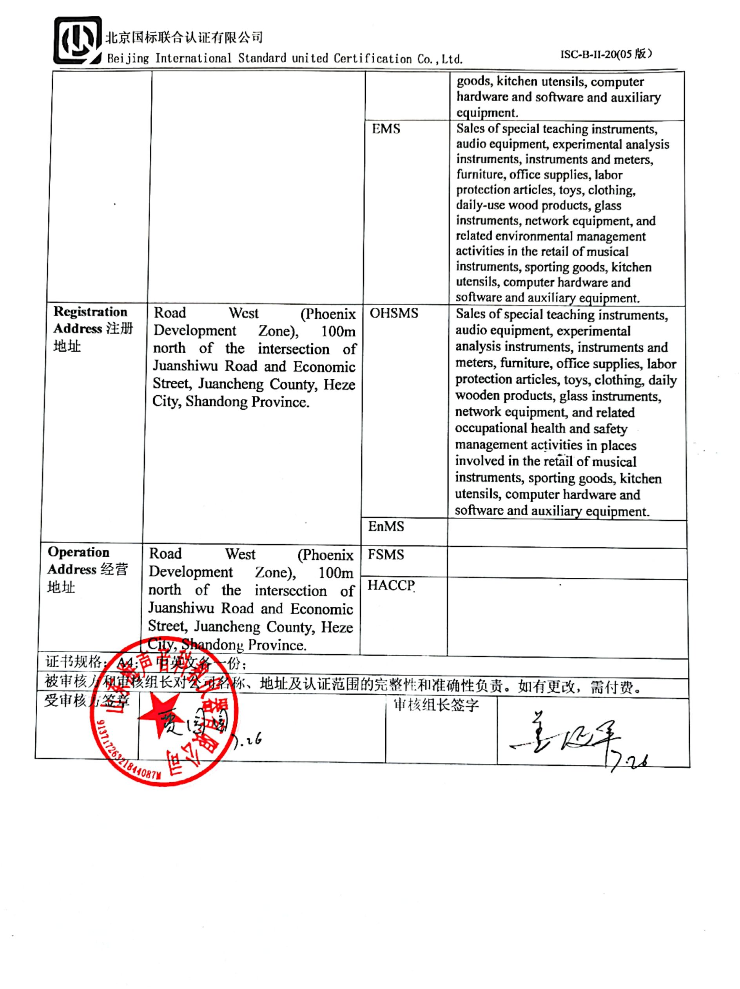  Sales of special teaching instruments, audio equipment, experimental analysis instruments, instruments and meters, furniture, office supplies, labor protection articles, toys, clothing, daily-use wood products, glass instruments, network equipment, and retail of musical instruments, sporting goods, kitchen utensils, computer hardware and software and auxiliary equipment.
Company Name公司名称 |  | EMS |  | Sales of special teaching instruments, audio equipment, experimental analysis instruments, instruments and meters, furniture, office supplies, labor protection articles, toys, clothing, daily-use wood products, glass instruments, network equipment, and related environmental management activities in the retail of musical instruments, sporting goods, kitchen utensils, computer hardware and software and auxiliary equipment.
Registration Address注册地址 | Road West (Phoenix Development Zone), 100m north of the intersection of Juanshiwu Road and Economic Street, Juancheng County, Heze City, Shandong Province. | OHSMS |  | Sales of special teaching instruments, audio equipment, experimental analysis instruments, instruments and meters, furniture, office supplies, labor protection articles, toys, clothing, daily wooden products, glass instruments, network equipment, and related occupational health and safety management activities in places involved in the retail of musical instruments, sporting goods, kitchen utensils, computer hardware and software and auxiliary equipment.
Registration Address注册地址 |  | EnMS
Operation Address经营地址 | Road West (Phoenix Development Zone), 100m north of the intersection of Juanshiwu Road and Economic Street, Juancheng County, Heze City, Shandong Province. | FSMS
Operation Address经营地址 |  | HACCP
证书规格：A4； 中英文各一份；
被审核方和审核组长对公司名称、地址及认证范围的完整性和准确性负责。如有更改，需付费。
受审核方签章 |  |  | 审核组长签字

