合同编号:0531-2022-QEO
认证证书信息确认书
受审核方名称 | 山东嘉硕文教用品有限公司 |  |  |  |  | 审核组长 |  | 冷春宇
订单号 |  |  |  |  |  | 证书号 |  | Q:,E:,O:
组织机构代码 | 913717263586480983 |  |  |  |  | 是否带CNAS标志 |  | ¨□带标 ■不带标
认证标准 | ■ GB/T 19001-2016 idt ISO 9001:2015标准 (不适用： 8.3 条款)  □ GB/T 50430-2017 (不适用： 条款)；  ■ GB/T 24001-2016 idt ISO 14001:2015标准；  ■ GB/T 45001-2020 idt ISO 45001:2018标准；  □ GB/T 23331-2020 idt ISO 50001:2018标准；  □RB/T XXXX-XXXX  □ISO 22000-2018  □GB/T 27341-2009&GB 14881-2013&危害分析与关键控制点（HACCP体系）认证补充要求 1.0 |  |  |  |  | 企业体系有效人数 |  | Q:15,E:15,O:15
审核类型 | ■初次认证□监督审核□再认证□特殊审核□换证
变更内容 | □组织名称变更□地址变更□认证范围变更（□扩大□缩小）
请选择所需求的证书语言. 对其它语言需求，如有必要，请另附表单.
 | 中文公司名称及地址 |  | 中文认证范围
公司名称 | 山东嘉硕文教用品有限公司 |  | Q：教学仪器、实验室成套设备、音体美卫劳器材、幼儿玩具、办公用品、课桌椅、床、校服、公寓用品、厨房设备、餐具、办公家具、公寓家具、心理咨询室设备、地理历史教室设备、家用电器、数码产品、监控设备、环保仪器、玻璃仪器的销售  E：教学仪器、实验室成套设备、音体美卫劳器材、幼儿玩具、办公用品、课桌椅、床、校服、公寓用品、厨房设备、餐具、办公家具、公寓家具、心理咨询室设备、地理历史教室设备、家用电器、数码产品、监控设备、环保仪器、玻璃仪器的销售所涉及场所的相关环境管理活动  O：教学仪器、实验室成套设备、音体美卫劳器材、幼儿玩具、办公用品、课桌椅、床、校服、公寓用品、厨房设备、餐具、办公家具、公寓家具、心理咨询室设备、地理历史教室设备、家用电器、数码产品、监控设备、环保仪器、玻璃仪器的销售所涉及场所的相关职业健康安全管理活动
注册地址 | 山东省菏泽市鄄城县旧城镇政府西临777号
经营地址 | 山东省菏泽市鄄城县凤凰路路西万星能源北邻
(注：除介词和连词外，首字母大写）
 | 英文公司名称及地址 English company name & address | 英文认证范围  English Scope
Company Name公司名称 | Shandong Jiashuo Culture and Education Products Co.Ltd | QMS/EcMS |  |  | 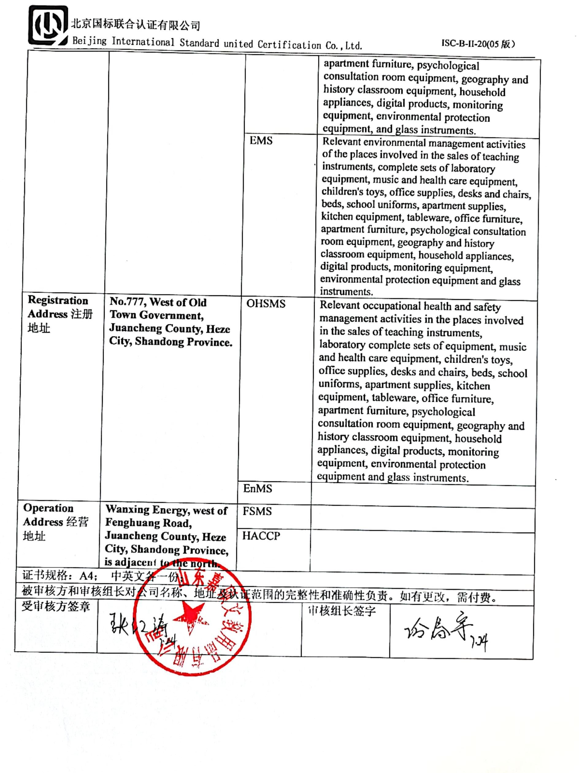  Sales of teaching instruments, complete sets of laboratory equipment, musical and physical beauty and health care equipment, children's toys, office supplies, desks and chairs, beds, school uniforms, apartment supplies, kitchen equipment, tableware, office furniture, apartment furniture, psychological consultation room equipment, geography and history classroom equipment, household appliances, digital products, monitoring equipment, environmental protection equipment, and glass instruments.
Company Name公司名称 | Shandong Jiashuo Culture and Education Products Co.Ltd | EMS |  |  | Relevant environmental management activities of the places involved in the sales of teaching instruments, complete sets of laboratory equipment, music and health care equipment, children's toys, office supplies, desks and chairs, beds, school uniforms, apartment supplies, kitchen equipment, tableware, office furniture, apartment furniture, psychological consultation room equipment, geography and history classroom equipment, household appliances, digital products, monitoring equipment, environmental protection equipment and glass instruments.
Registration Address注册地址 | No.777, West of Old Town Government, Juancheng County, Heze City, Shandong Province. | OHSMS |  |  | Relevant occupational health and safety management activities in the places involved in the sales of teaching instruments, laboratory complete sets of equipment, music and health care equipment, children's toys, office supplies, desks and chairs, beds, school uniforms, apartment supplies, kitchen equipment, tableware, office furniture, apartment furniture, psychological consultation room equipment, geography and history classroom equipment, household appliances, digital products, monitoring equipment, environmental protection equipment and glass instruments.
Registration Address注册地址 |  | EnMS
Operation Address经营地址 | Wanxing Energy, west of Fenghuang Road, Juancheng County, Heze City, Shandong Province, is adjacent to the north. | FSMS
Operation Address经营地址 |  | HACCP
证书规格：A4； 中英文各一份；
被审核方和审核组长对公司名称、地址及认证范围的完整性和准确性负责。如有更改，需付费。
受审核方签章 |  |  |  | 审核组长签字

