合同编号:0526-2022-QEO
认证证书信息确认书
受审核方名称 | 山东龙企教育装备有限公司 |  |  |  | 审核组长 |  | 冷春宇
订单号 |  |  |  |  | 证书号 |  | Q:,E:,O:
组织机构代码 | 91371726MA3P01HC4C |  |  |  | 是否带CNAS标志 |  | □带标 ■不带标
认证标准 | ■ GB/T 19001-2016 idt ISO 9001:2015标准 (不适用： 8.3 条款)  □ GB/T 50430-2017 (不适用： 条款)；  ■ GB/T 24001-2016 idt ISO 14001:2015标准；  ■ GB/T 45001-2020 idt ISO 45001:2018标准；  □ GB/T 23331-2020 idt ISO 50001:2018标准；  □RB/T XXXX-XXXX  □ISO 22000-2018  □GB/T 27341-2009&GB 14881-2013&危害分析与关键控制点（HACCP体系）认证补充要求 1.0 |  |  |  | 企业体系有效人数 |  | Q:10,E:10,O:10
审核类型 | □初次认证□监督审核■再认证□特殊审核□换证
变更内容 | □组织名称变更□地址变更■认证范围变更（□扩大■缩小）
请选择所需求的证书语言. 对其它语言需求，如有必要，请另附表单.
 | 中文公司名称及地址 |  | 中文认证范围
公司名称 | 山东龙企教育装备有限公司 |  | Q：教学仪器、实验室成套设备、学生课桌椅、综合实践室设备、幼儿玩具、厨房设备、餐具、音体美卫劳器材、探究仪器、多媒体教学设备、数字化教室设备、心理咨询室设施、床、学生校服、公寓用品、家用电器、监控设备、办公用品、办公家具、科普仪器、玻璃仪器、环保仪器、仪器橱柜的销售  E：教学仪器、实验室成套设备、学生课桌椅、综合实践室设备、幼儿玩具、厨房设备、餐具、音体美卫劳器材、探究仪器、多媒体教学设备、数字化教室设备、心理咨询室设施、床、学生校服、公寓用品、家用电器、监控设备、办公用品、办公家具、科普仪器、玻璃仪器、环保仪器、仪器橱柜的销售所涉及场所的相关环境管理活动  O：教学仪器、实验室成套设备、学生课桌椅、综合实践室设备、幼儿玩具、厨房设备、餐具、音体美卫劳器材、探究仪器、多媒体教学设备、数字化教室设备、心理咨询室设施、床、学生校服、公寓用品、家用电器、监控设备、办公用品、办公家具、科普仪器、玻璃仪器、环保仪器、仪器橱柜的销售所涉及场所的相关职业健康安全管理活动
注册地址 | 山东省菏泽市鄄城县陈王街道办事处临泽路与城濮街交叉口东80米路北
经营地址 | 山东省鄄城县鄄十五路工业园
(注：除介词和连词外，首字母大写）
 | 英文公司名称及地址 English company name & address | 英文认证范围  English Scope
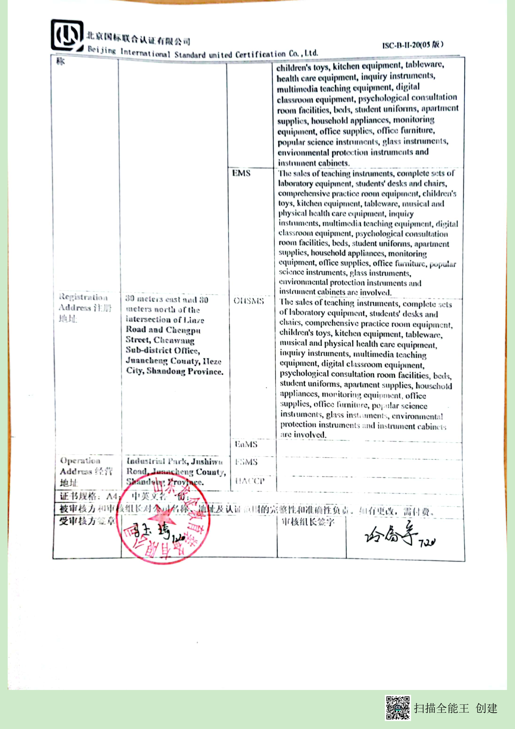  Company Name公司名称 | Shandong Longqi Education Equipment Co.Ltd | QMS/EcMS |  | Sales of teaching instruments, complete sets of laboratory equipment, students' desks and chairs, comprehensive practice room equipment, children's toys, kitchen equipment, tableware, health care equipment, inquiry instruments, multimedia teaching equipment, digital classroom equipment, psychological consultation room facilities, beds, student uniforms, apartment supplies, household appliances, monitoring equipment, office supplies, office furniture, popular science instruments, glass instruments, environmental protection instruments and instrument cabinets.
 | Shandong Longqi Education Equipment Co.Ltd | EMS |  | The sales of teaching instruments, complete sets of laboratory equipment, students' desks and chairs, comprehensive practice room equipment, children's toys, kitchen equipment, tableware, musical and physical health care equipment, inquiry instruments, multimedia teaching equipment, digital classroom equipment, psychological consultation room facilities, beds, student uniforms, apartment supplies, household appliances, monitoring equipment, office supplies, office furniture, popular science instruments, glass instruments, environmental protection instruments and instrument cabinets are involved.
Registration Address注册地址 | 80 meters east and 80 meters north of the intersection of Linze Road and Chengpu Street, Chenwang Sub-district Office, Juancheng County, Heze City, Shandong Province. | OHSMS |  | The sales of teaching instruments, complete sets of laboratory equipment, students' desks and chairs, comprehensive practice room equipment, children's toys, kitchen equipment, tableware, musical and physical health care equipment, inquiry instruments, multimedia teaching equipment, digital classroom equipment, psychological consultation room facilities, beds, student uniforms, apartment supplies, household appliances, monitoring equipment, office supplies, office furniture, popular science instruments, glass instruments, environmental protection instruments and instrument cabinets are involved.
Registration Address注册地址 |  | EnMS
Operation Address经营地址 | Industrial Park, Jushiwu Road, Juancheng County, Shandong Province. | FSMS
Operation Address经营地址 |  | HACCP
证书规格：A4； 中英文各一份；
被审核方和审核组长对公司名称、地址及认证范围的完整性和准确性负责。如有更改，需付费。
受审核方签章 |  |  |  | 审核组长签字

