合同编号:0529-2020-QJEO-2022
认证证书信息确认书
受审核方名称 | 黑龙江省万意达石油工程有限公司 |  |  | 审核组长 | 李俐
订单号 |  |  |  | 证书号 | EC:ISC-Q-2020-1126,E:ISC-E-2020-0751,O:ISC-O-2020-0688
组织机构代码 | 91230600772608673J |  |  | 是否带CNAS标志 | ¨ 带标 ¨不带标
认证标准 | ■☑ GB/T 19001-2016 idt ISO 9001:2015标准 (不适用： 条款)  ■ GB/T 50430-2017 (不适用： 条款)；  ■ GB/T 24001-2016 idt ISO 14001:2015标准；  ■ GB/T 45001-2020 idt ISO 45001:2018标准；  □ GB/T 23331-2020 idt ISO 50001:2018标准；  □RB/T XXXX-XXXX  □ISO 22000-2018  □GB/T 27341-2009&GB 14881-2013&危害分析与关键控制点（HACCP体系）认证补充要求 1.0 |  |  | 企业体系有效人数 | EC:102,E:102,O:102
审核类型 | □初次认证■监督审核□再认证□特殊审核□换证
变更内容 | □组织名称变更□地址变更☑认证范围变更（□扩大□缩小）
请选择所需求的证书语言. 对其它语言需求，如有必要，请另附表单.
 | 中文公司名称及地址 | 中文认证范围
公司名称 | 黑龙江省万意达石油工程有限公司 | EC：环保专用设备、A2级压力容器、石油钻采机械部件的生产、销售;钻井泥浆无害化处理设备、水处理(清水、软化水、污水、含油污水)设备、全自动软化水装置、稀油站、滤油机、油田专用设备、过滤器、电磁加热设备和电磁加热三项分离装置、太阳能用具的设计、制造、销售;金属软管的销售;油田技术服务（注气(汽)、井下作业、测试技术服务）;钻井泥浆(水基泥浆、油基泥浆、盐水泥浆)不落地无害化处理技术服务;固体废物处理(油固分离); GC1级工业管道安装, GB1、GB2级公用管道安装;资质范围内的建筑工程施工总承包三级;机电工程施工总承包三级;石油化工工程施工总承包三级;建筑机电安装工程专业承包三级;环保工程专业承包三级;防水防腐保温工程专业承包二级;消防设施专业承包二级;特种工程(特殊设备起重吊装);园林绿化工程施工。  E：环保专用设备、A2级压力容器、石油钻采机械部件的生产、销售;钻井泥浆无害化处理设备、水处理(清水、软化水、污水、含油污水)设备、全自动软化水装置、稀油站、滤油机、油田专用设备、过滤器、电磁加热设备和电磁加热三项分离装置、太阳能用具的设计、制造、销售;金属软管的销售;油田技术服务（注气(汽)、井下作业、测试技术服务）;钻井泥浆(水基泥浆、油基泥浆、盐水泥浆)不落地无害化处理技术服务;固体废物处理(油固分离); GC1级工业管道安装, GB1、GB2级公用管道安装;资质范围内的建筑工程施工总承包三级;机电工程施工总承包三级;石油化工工程施工总承包三级;建筑机电安装工程专业承包三级;环保工程专业承包三级;防水防腐保温工程专业承包二级;消防设施专业承包二级;特种工程(特殊设备起重吊装);园林绿化工程施工及相关环境管理活动;  O:环保专用设备、A2级压力容器、石油钻采机械部件的生产、销售;钻井泥浆无害化处理设备、水处理(清水、软化水、污水、含油污水)设备、全自动软化水装置、稀油站、滤油机、油田专用设备、过滤器、电磁加热设备和电磁加热三项分离装置、太阳能用具的设计、制造、销售;金属软管的销售;油田技术服务（注气(汽)、井下作业、测试技术服务）;钻井泥浆(水基泥浆、油基泥浆、盐水泥浆)不落地无害化处理技术服务;固体废物处理(油固分离); GC1级工业管道安装, GB1、GB2级公用管道安装;资质范围内的建筑工程施工总承包三级;机电工程施工总承包三级;石油化工工程施工总承包三级;建筑机电安装工程专业承包三级;环保工程专业承包三级;防水防腐保温工程专业承包二级;消防设施专业承包二级;特种工程(特殊设备起重吊装);园林绿化工程施工及相关职业健康安全管理活动
注册地址 | 黑龙江省大庆市萨尔图区勤奋村
经营地址 | 黑龙江省大庆市龙凤区新航路10号
(注：除介词和连词外，首字母大写）
 | 英文公司名称及地址 English company name & address | 英文认证范围  English Scope
Company Name公司名称 | Heilongjiang Wanyida Petroleum Engineering Co., Ltd | QMS/EcMS | Production and sales of special equipment for environmental protection, Grade A2 pressure vessels and oil drilling machinery components; Design, manufacture and sales of harmless treatment equipment for drilling mud, water treatment equipment (for clean water, softened water, sewage and oily sewage), full-automatic softened water device, thin oil station, oil filter press, special equipment for oil field, filter, electromagnetic heating equipment and electromagnetic heating three-point separation device, and solar appliances; Sales of metal hoses; Oilfield technical services (gas (steam) injection, downhole operation and testing technical services); Non landing harmless treatment technical services for drilling mud (water-based mud, oil-based mud and brine mud); Solid waste treatment (oil-solid separation); Grade GC1 industrial pipeline installation, Grade GB1 and GB2 public pipeline installation; Grade III General Contracting of construction projects within the scope of qualification; Grade III General Contracting of electromechanical engineering construction; Grade III General Contracting of petrochemical engineering construction; Grade III professional contracting of building electromechanical installation engineering; Grade III professional contracting of environmental protection engineering; Grade II professional contracting of waterproof, anti-corrosion and thermal insulation engineering; Grade II professional contracting of fire fighting facilities; Special works (hoisting of special equipment); Construction of landscaping works.
Company Name公司名称 | Heilongjiang Wanyida Petroleum Engineering Co., Ltd | EMS | Production and sales of special equipment for environmental protection, Grade A2 pressure vessels and oil drilling machinery components; Design, manufacture and sales of harmless treatment equipment for drilling mud, water treatment equipment (for clean water, softened water, sewage and oily sewage), full-automatic softened water device, thin oil station, oil filter press, special equipment for oil field, filter, electromagnetic heating equipment and electromagnetic heating three-point separation device, and solar appliances; Sales of metal hoses; Oilfield technical services (gas (steam) injection, downhole operation and testing technical services); Non landing harmless treatment technical services for drilling mud (water-based mud, oil-based mud and brine mud); Solid waste treatment (oil-solid separation); Grade GC1 industrial pipeline installation, Grade GB1 and GB2 public pipeline installation; Grade III General Contracting of construction projects within the scope of qualification; Grade III General Contracting of electromechanical engineering construction; Grade III General Contracting of petrochemical engineering construction; Grade III professional contracting of building electromechanical installation engineering; Grade III professional contracting of environmental protection engineering; Grade II professional contracting of waterproof, anti-corrosion and thermal insulation engineering; Grade II professional contracting of fire fighting facilities; Special works (hoisting of special equipment); Landscape engineering construction and related environmental management activities;
Registration Address注册地址 | Qinfen Village, Saertu District, Daqing City, Heilongjiang Province | OHSMS | 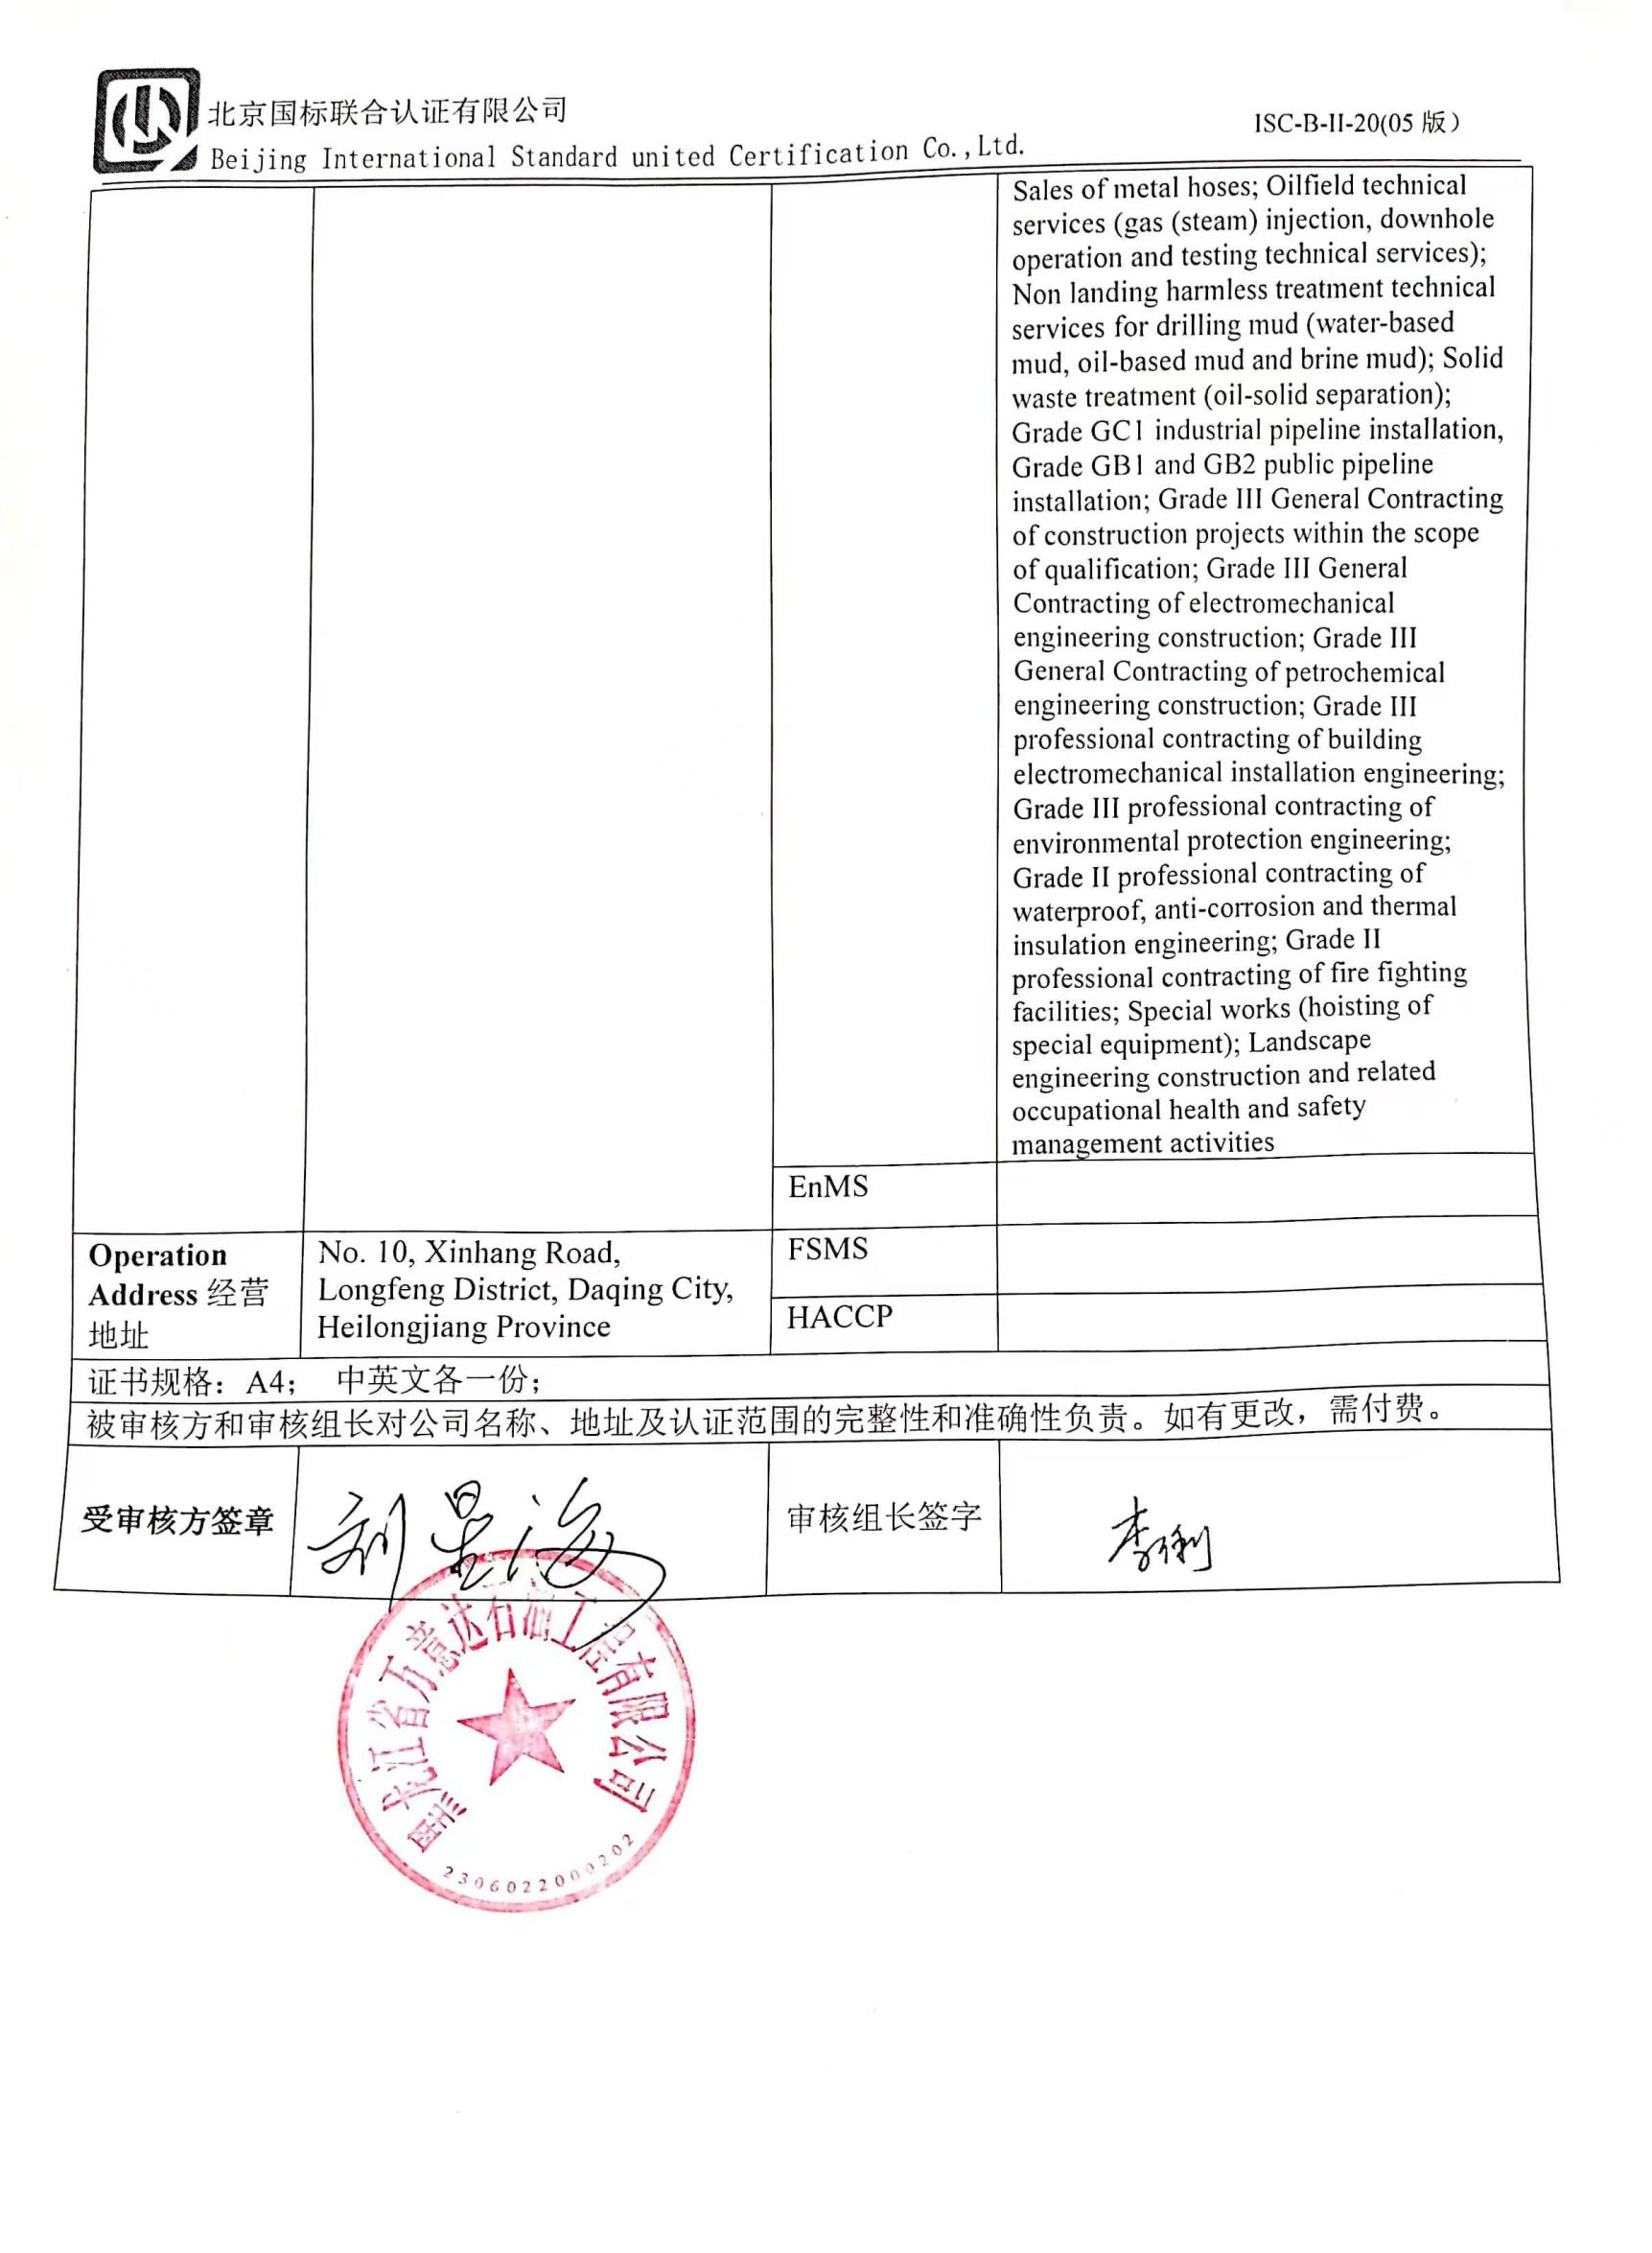  Production and sales of special equipment for environmental protection, Grade A2 pressure vessels and oil drilling machinery components; Design, manufacture and sales of harmless treatment equipment for drilling mud, water treatment equipment (for clean water, softened water, sewage and oily sewage), full-automatic softened water device, thin oil station, oil filter press, special equipment for oil field, filter, electromagnetic heating equipment and electromagnetic heating three-point separation device, and solar appliances; Sales of metal hoses; Oilfield technical services (gas (steam) injection, downhole operation and testing technical services); Non landing harmless treatment technical services for drilling mud (water-based mud, oil-based mud and brine mud); Solid waste treatment (oil-solid separation); Grade GC1 industrial pipeline installation, Grade GB1 and GB2 public pipeline installation; Grade III General Contracting of construction projects within the scope of qualification; Grade III General Contracting of electromechanical engineering construction; Grade III General Contracting of petrochemical engineering construction; Grade III professional contracting of building electromechanical installation engineering; Grade III professional contracting of environmental protection engineering; Grade II professional contracting of waterproof, anti-corrosion and thermal insulation engineering; Grade II professional contracting of fire fighting facilities; Special works (hoisting of special equipment); Landscape engineering construction and related occupational health and safety management activities
Registration Address注册地址 |  | EnMS
Operation Address经营地址 | No. 10, Xinhang Road, Longfeng District, Daqing City, Heilongjiang Province | FSMS
Operation Address经营地址 |  | HACCP
证书规格：A4； 中英文各一份；
被审核方和审核组长对公司名称、地址及认证范围的完整性和准确性负责。如有更改，需付费。
受审核方签章 |  | 审核组长签字 | 

