合同编号:0349-2022-QEO
认证证书信息确认书
受审核方名称 | 江西永成家俱制造有限公司 |  |  | 审核组长 | 褚敏杰
订单号 |  |  |  | 证书号 | Q:,E:,O:
组织机构代码 | 9136010076978692XK |  |  | 是否带CNAS标志 | ¨ 带标 ¨不带标
认证标准 | ■ GB/T 19001-2016 idt ISO 9001:2015标准 (不适用： 条款)  □ GB/T 50430-2017 (不适用： 条款)；  ■ GB/T 24001-2016 idt ISO 14001:2015标准；  ■ GB/T 45001-2020 idt ISO 45001:2018标准；  □ GB/T 23331-2020 idt ISO 50001:2018标准；  □RB/T XXXX-XXXX  □ISO 22000-2018  □GB/T 27341-2009&GB 14881-2013&危害分析与关键控制点（HACCP体系）认证补充要求 1.0 |  |  | 企业体系有效人数 | Q:29,E:29,O:29
审核类型 | ■初次认证□监督审核□再认证□特殊审核□换证
变更内容 | □组织名称变更□地址变更□认证范围变更（□扩大□缩小）
请选择所需求的证书语言. 对其它语言需求，如有必要，请另附表单.
 | 中文公司名称及地址 | 中文认证范围
公司名称 | 江西永成家俱制造有限公司 | Q：办公家具（班台、办公桌、书画桌、书柜、文件柜、茶几、会议台、会议椅、条桌、茶水柜、演讲台、主席台、培训桌、洽谈桌、非现金柜、接待台、电脑桌、主控桌、活动桌、副柜、主机架、网银台、屏风、办公椅、课桌椅、公寓床、浏览桌椅、沙发、礼堂椅、折叠桌椅）；酒店/宿舍实木家具（床、床头柜、衣柜、储物柜、鞋柜、行李柜、电视柜、餐桌、餐椅、写字桌、写字椅、衣架、实木高低床、边餐柜、休闲椅、茶几、沙发、床尾凳）；需资质要求除外的医疗通用家具（诊查桌椅、诊查床、医护更衣柜、服务咨询台、医护交班桌、医护值班床，医药柜，医护操作台柜、等候椅、输液桌椅、陪护折叠椅、床边移动餐台、导诊台、预防接种台、无菌柜、消毒柜、分类垃圾柜）；实验室家具（试验台桌、实验凳）；钢木家具；校用家具；儿童家具；银行家具；军队家具；公检法家具；定制家具的设计、生产、销售、安装和售后服务（退换货、维护）。  E：办公家具（班台、办公桌、书画桌、书柜、文件柜、茶几、会议台、会议椅、条桌、茶水柜、演讲台、主席台、培训桌、洽谈桌、非现金柜、接待台、电脑桌、主控桌、活动桌、副柜、主机架、网银台、屏风、办公椅、课桌椅、公寓床、浏览桌椅、沙发、礼堂椅、折叠桌椅）；酒店/宿舍实木家具（床、床头柜、衣柜、储物柜、鞋柜、行李柜、电视柜、餐桌、餐椅、写字桌、写字椅、衣架、实木高低床、边餐柜、休闲椅、茶几、沙发、床尾凳）；需资质要求除外的医疗通用家具（诊查桌椅、诊查床、医护更衣柜、服务咨询台、医护交班桌、医护值班床，医药柜，医护操作台柜、等候椅、输液桌椅、陪护折叠椅、床边移动餐台、导诊台、预防接种台、无菌柜、消毒柜、分类垃圾柜）；实验室家具（试验台桌、实验凳）；钢木家具；校用家具；儿童家具；银行家具；军队家具；公检法家具；定制家具的设计、生产、销售、安装和售后服务（退换货、维护）所涉及场所的相关环境管理活动。  O：办公家具（班台、办公桌、书画桌、书柜、文件柜、茶几、会议台、会议椅、条桌、茶水柜、演讲台、主席台、培训桌、洽谈桌、非现金柜、接待台、电脑桌、主控桌、活动桌、副柜、主机架、网银台、屏风、办公椅、课桌椅、公寓床、浏览桌椅、沙发、礼堂椅、折叠桌椅）；酒店/宿舍实木家具（床、床头柜、衣柜、储物柜、鞋柜、行李柜、电视柜、餐桌、餐椅、写字桌、写字椅、衣架、实木高低床、边餐柜、休闲椅、茶几、沙发、床尾凳）；需资质要求除外的医疗通用家具（诊查桌椅、诊查床、医护更衣柜、服务咨询台、医护交班桌、医护值班床，医药柜，医护操作台柜、等候椅、输液桌椅、陪护折叠椅、床边移动餐台、导诊台、预防接种台、无菌柜、消毒柜、分类垃圾柜）；实验室家具（试验台桌、实验凳）；钢木家具；校用家具；儿童家具；银行家具；军队家具；公检法家具；定制家具的设计、生产、销售、安装和售后服务（退换货、维护）。所涉及场所的相关职业健康安全管理活动。
注册地址 | 江西省南昌市青山湖区湖坊镇顺外村昌东工业园昌东三路3号楼2楼
经营地址 | 江西省南昌市青山湖区昌北经开区芙蓉路261号
(注：除介词和连词外，首字母大写）
 | 英文公司名称及地址 English company name & address | 英文认证范围  English Scope
Company Name公司名称 | Jiangxi Yongcheng Furniture Manufacturing Co., LTD | QMS/EcMS | Office furniture (class desk, office desk, painting and calligraphy desk, bookcase, file cabinet, tea table, conference desk, conference chair, bar table, tea cabinet, lecture desk, rostrum, training desk, negotiation desk, non cash cabinet, reception desk, computer desk, main control desk, activity desk, auxiliary cabinet, mainframe, online banking desk, screen, office chair, desks and chairs, apartment bed, browsing desks and chairs, sofa, auditorium chair, folding tables and chairs); Hotel / dormitory solid wood furniture (bed, bedside table, wardrobe, locker, shoe cabinet, luggage cabinet, TV cabinet, dining table, dining chair, writing table, writing chair, coat hanger, solid wood high-low bed, side dining cabinet, leisure chair, tea table, sofa, bed stool); Medical general furniture excluding qualification requirements (examination tables and chairs, examination beds, medical dressing cabinets, service desks, medical shift tables, medical duty beds, medical cabinets, medical operation cabinets, waiting chairs, infusion tables and chairs, escort folding chairs, bedside mobile dining tables, guide tables, vaccination tables, sterile cabinets, disinfection cabinets, classified garbage cabinets); Laboratory furniture (test bench table, test bench); Steel and wood furniture; School furniture; Children's furniture; Bank furniture; Military furniture; Public security, procuratorial and judicial furniture; Design, production, sales, installation and after-sales service (return, replacement and maintenance) of customized furniture.
Company Name公司名称 | Jiangxi Yongcheng Furniture Manufacturing Co., LTD | EMS | Office furniture (class desk, office desk, painting and calligraphy desk, bookcase, file cabinet, tea table, conference desk, conference chair, bar table, tea cabinet, lecture desk, rostrum, training desk, negotiation desk, non cash cabinet, reception desk, computer desk, main control desk, activity desk, auxiliary cabinet, mainframe, online banking desk, screen, office chair, desks and chairs, apartment bed, browsing desks and chairs, sofa, auditorium chair, folding tables and chairs); Hotel / dormitory solid wood furniture (bed, bedside table, wardrobe, locker, shoe cabinet, luggage cabinet, TV cabinet, dining table, dining chair, writing table, writing chair, coat hanger, solid wood high-low bed, side dining cabinet, leisure chair, tea table, sofa, bed stool); Medical general furniture excluding qualification requirements (examination tables and chairs, examination beds, medical dressing cabinets, service desks, medical shift tables, medical duty beds, medical cabinets, medical operation cabinets, waiting chairs, infusion tables and chairs, escort folding chairs, bedside mobile dining tables, guide tables, vaccination tables, sterile cabinets, disinfection cabinets, classified garbage cabinets); Laboratory furniture (test bench table, test bench); Steel and wood furniture; School furniture; Children's furniture; Bank furniture; Military furniture; Public security, procuratorial and judicial furniture; Relevant environmental management activities in the places involved in the design, production, sales, installation and after-sales service (return and replacement, maintenance) of customized furniture.
Registration Address注册地址 | 2nd Floor, Building 3, Changdong 3rd Road, Changdong Industrial Park, Shunwai Village, Hufang Town, Qingshanhu District, Nanchang city, Jiangxi Province | OHSMS | 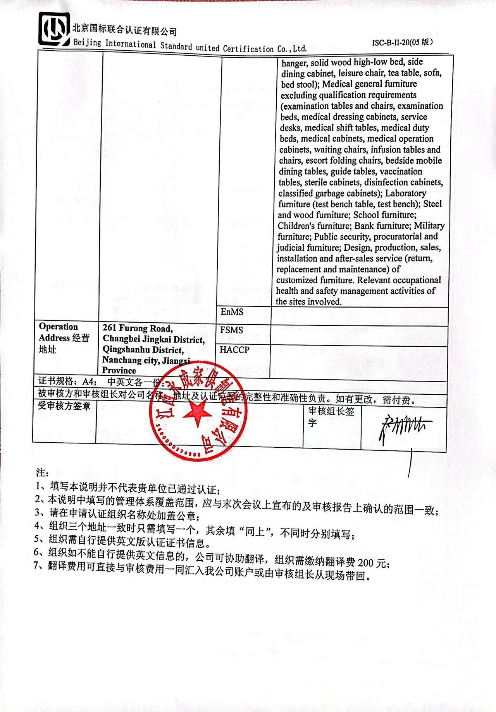  Office furniture (class desk, office desk, painting and calligraphy desk, bookcase, file cabinet, tea table, conference desk, conference chair, bar table, tea cabinet, lecture desk, rostrum, training desk, negotiation desk, non cash cabinet, reception desk, computer desk, main control desk, activity desk, auxiliary cabinet, mainframe, online banking desk, screen, office chair, desks and chairs, apartment bed, browsing desks and chairs, sofa, auditorium chair, folding tables and chairs); Hotel / dormitory solid wood furniture (bed, bedside table, wardrobe, locker, shoe cabinet, luggage cabinet, TV cabinet, dining table, dining chair, writing table, writing chair, coat hanger, solid wood high-low bed, side dining cabinet, leisure chair, tea table, sofa, bed stool); Medical general furniture excluding qualification requirements (examination tables and chairs, examination beds, medical dressing cabinets, service desks, medical shift tables, medical duty beds, medical cabinets, medical operation cabinets, waiting chairs, infusion tables and chairs, escort folding chairs, bedside mobile dining tables, guide tables, vaccination tables, sterile cabinets, disinfection cabinets, classified garbage cabinets); Laboratory furniture (test bench table, test bench); Steel and wood furniture; School furniture; Children's furniture; Bank furniture; Military furniture; Public security, procuratorial and judicial furniture; Design, production, sales, installation and after-sales service (return, replacement and maintenance) of customized furniture. Relevant occupational health and safety management activities of the sites involved.
Registration Address注册地址 |  | EnMS
Operation Address经营地址 | 261 Furong Road, Changbei Jingkai District, Qingshanhu District, Nanchang city, Jiangxi Province | FSMS
Operation Address经营地址 |  | HACCP
证书规格：A4； 中英文各一份；
被审核方和审核组长对公司名称、地址及认证范围的完整性和准确性负责。如有更改，需付费。
受审核方签章 |  |  |  | 审核组长签字

注：
1、填写本说明并不代表贵单位已通过认证；
2、本说明中填写的管理体系覆盖范围，应与末次会议上宣布的及审核报告上确认的范围一致；
3、请在申请认证组织名称处加盖公章；
4、组织三个地址一致时只需填写一个，其余填“同上”，不同时分别填写；
5、组织需自行提供英文版认证证书信息。
6、组织如不能自行提供英文信息的，公司可协助翻译，组织需缴纳翻译费200元；
7、翻译费用可直接与审核费用一同汇入我公司账户或由审核组长从现场带回。

