合同编号:0146-2021-QEO-2022
认证证书信息确认书
受审核方名称 | 鄄城县华东教学仪器设备有限公司 |  |  |  | 审核组长 |  | 姜海军
订单号 |  |  |  |  | 证书号 |  | Q:ISC-Q-2021-1327,E:ISC-E-2021-0908,O:ISC-O-2021-0841
组织机构代码 | 91371726786101064C |  |  |  | 是否带CNAS标志 |  | ¨ 带标 ■不带标
认证标准 | ■ GB/T 19001-2016 idt ISO 9001:2015标准 (不适用： 8.3 条款)  □ GB/T 50430-2017 (不适用： 条款)；  ■ GB/T 24001-2016 idt ISO 14001:2015标准；  ■ GB/T 45001-2020 idt ISO 45001:2018标准；  □ GB/T 23331-2020 idt ISO 50001:2018标准；  □RB/T XXXX-XXXX  □ISO 22000-2018  □GB/T 27341-2009&GB 14881-2013&危害分析与关键控制点（HACCP体系）认证补充要求 1.0 |  |  |  | 企业体系有效人数 |  | Q:10,E:10,O:10
审核类型 | □初次认证■监督审核□再认证□特殊审核□换证
变更内容 | □组织名称变更■地址变更□认证范围变更（□扩大□缩小）
请选择所需求的证书语言. 对其它语言需求，如有必要，请另附表单.
 | 中文公司名称及地址 |  | 中文认证范围
公司名称 | 鄄城县华东教学仪器设备有限公司 |  | Q：教学仪器、实验室设备、探究仪器、课桌椅、办公家具、公寓家具、仪器橱柜、床、音体美卫劳器材、玻璃仪器、环保仪器、幼儿玩具及教具、多媒体教学设备、科技馆设备、心理咨询室设备、职教实训设备、办公用品、窗帘、学生校服、塑胶跑道、人造草坪、厨房设备、餐具的销售  E：教学仪器、实验室设备、探究仪器、课桌椅、办公家具、公寓家具、仪器橱柜、床、音体美卫劳器材、玻璃仪器、环保仪器、幼儿玩具及教具、多媒体教学设备、科技馆设备、心理咨询室设备、职教实训设备、办公用品、窗帘、学生校服、塑胶跑道、人造草坪、厨房设备、餐具的销售所涉及场所的相关环境管理活动  O：教学仪器、实验室设备、探究仪器、课桌椅、办公家具、公寓家具、仪器橱柜、床、音体美卫劳器材、玻璃仪器、环保仪器、幼儿玩具及教具、多媒体教学设备、科技馆设备、心理咨询室设备、职教实训设备、办公用品、窗帘、学生校服、塑胶跑道、人造草坪、厨房设备、餐具的销售所涉及场所的相关职业健康安全管理活动
注册地址 | 山东省菏泽市鄄城县陈王街道办事处雷泽大道西金堤路北300米路东
经营地址 | 山东省菏泽市鄄城县陈王街道办事处雷泽大道西金堤路北300米路东
(注：除介词和连词外，首字母大写）
 | 英文公司名称及地址 English company name & address |  | 英文认证范围  English Scope
Company Name公司名称 | Juancheng county east China teaching instrument equipment Co.Ltd |  | QMS/EcMS | Sales of teaching instruments, laboratory equipment, inquiry instruments, desks and chairs, office furniture, apartment furniture, instrument cabinets, beds, sound, body, beauty, health and labor equipment, glass instruments, environmental protection instruments, children's toys and teaching AIDS, multimedia teaching equipment, science and technology museum equipment, psychological consultation room equipment, vocational training equipment, office supplies, curtains, school uniforms, plastic runways, artificial lawns, kitchen equipment and tableware.
Company Name公司名称 |  |  | EMS | Teaching instruments, laboratory equipment, inquiry instruments, desks and chairs, office furniture, apartment furniture, instrument cabinets, beds, sound, body, beauty, health and labor equipment, glass instruments, environmental protection instruments, children's toys and teaching AIDS, multimedia teaching equipment, science and technology museum equipment, psychological consultation room equipment, vocational training equipment, office supplies, curtains, student uniforms, plastic runways, artificial lawns, kitchen equipment and tableware.
Registration Address注册地址 | East of Road, 300 meters north of West Jindi Road, Leize Avenue, Chenwang Subdistrict Office, Juancheng County, Heze City, Shandong Province. |  | OHSMS | Teaching instruments, laboratory equipment, inquiry instruments, desks and chairs, office furniture, apartment furniture, instrument cabinets, beds, sound, body, beauty, health and labor equipment, glass instruments, environmental protection instruments, children's toys and teaching AIDS, multimedia teaching equipment, science and technology museum equipment, psychological consultation room equipment, vocational training equipment, office supplies, curtains, student uniforms, plastic runways, artificial lawns, kitchen equipment and tableware.
Registration Address注册地址 |  |  | EnMS
Operation Address经营地址 | East of Road, 300 meters north of West Jindi Road, Leize Avenue, Chenwang Subdistrict Office, Juancheng County, Heze City, Shandong Province. |  | FSMS
Operation Address经营地址 |  |  | HACCP
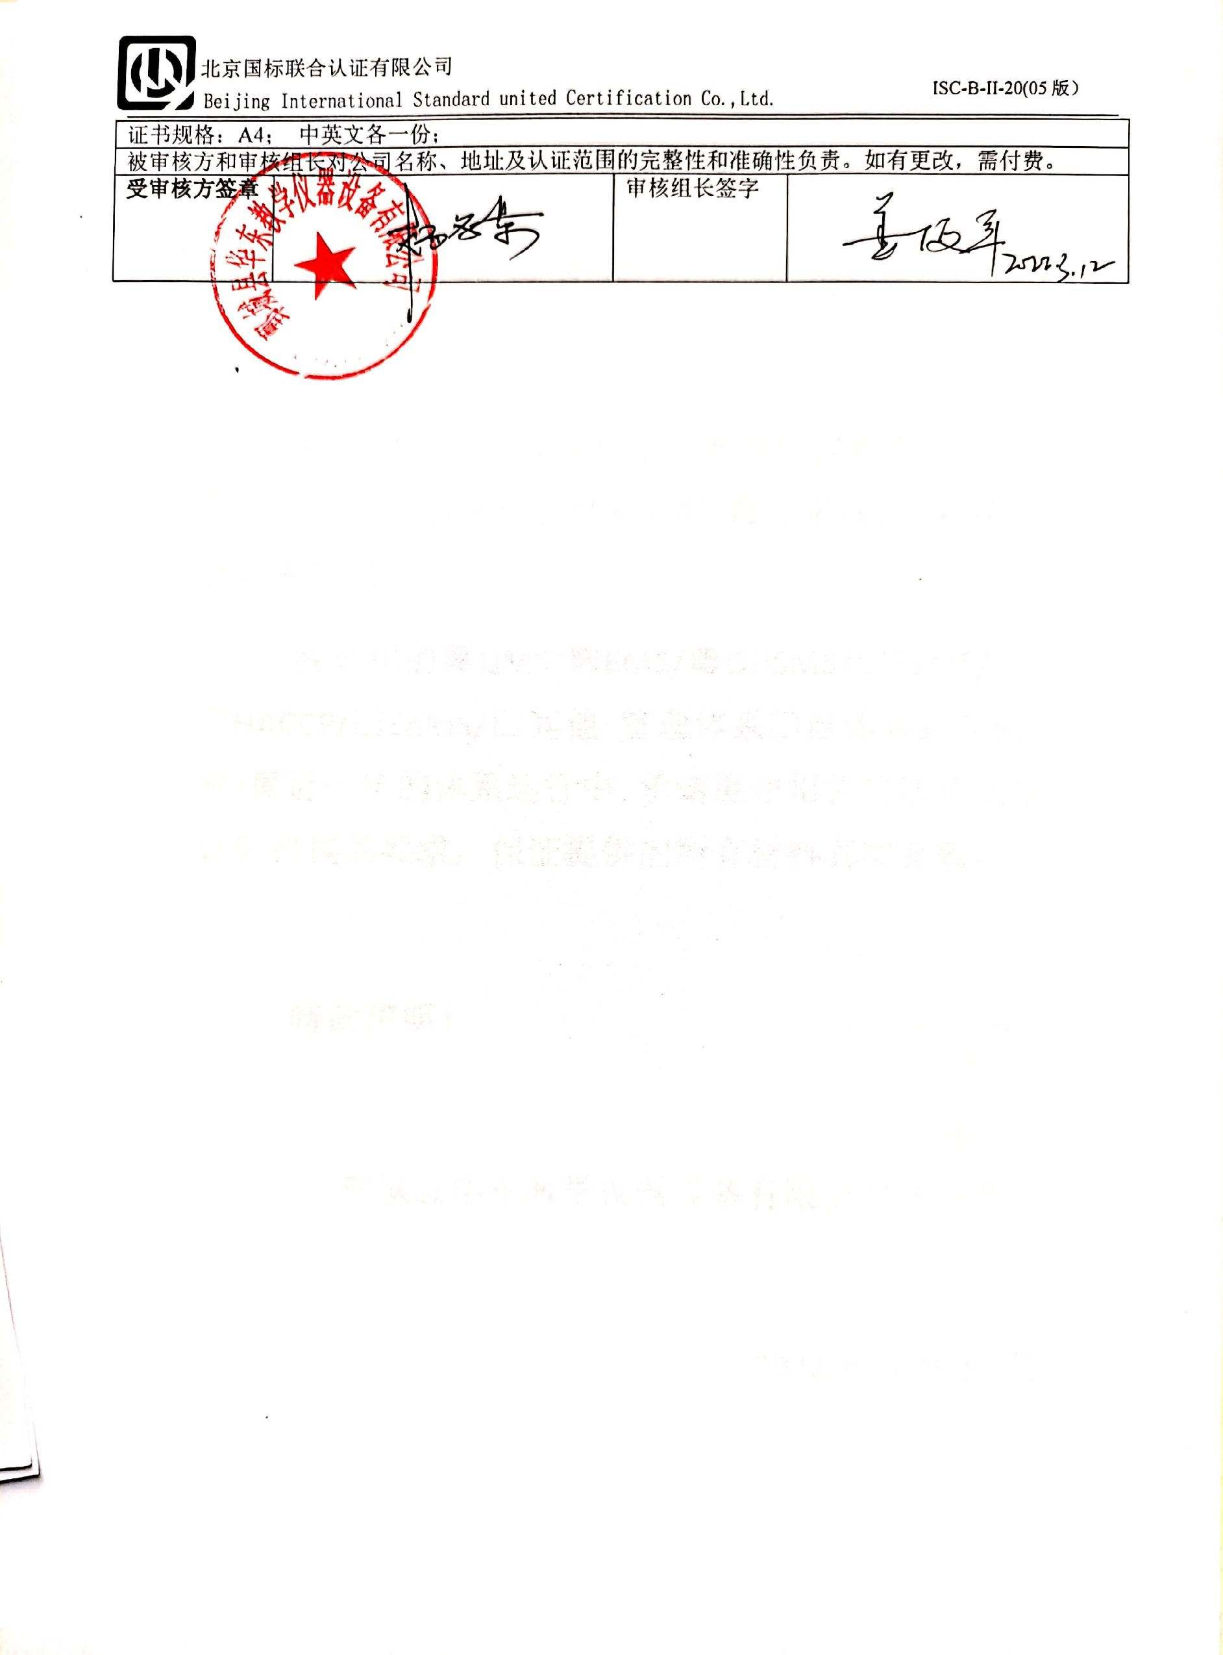
证书规格：A4； 中英文各一份；
被审核方和审核组长对公司名称、地址及认证范围的完整性和准确性负责。如有更改，需付费。
受审核方签章 |  | 审核组长签字

