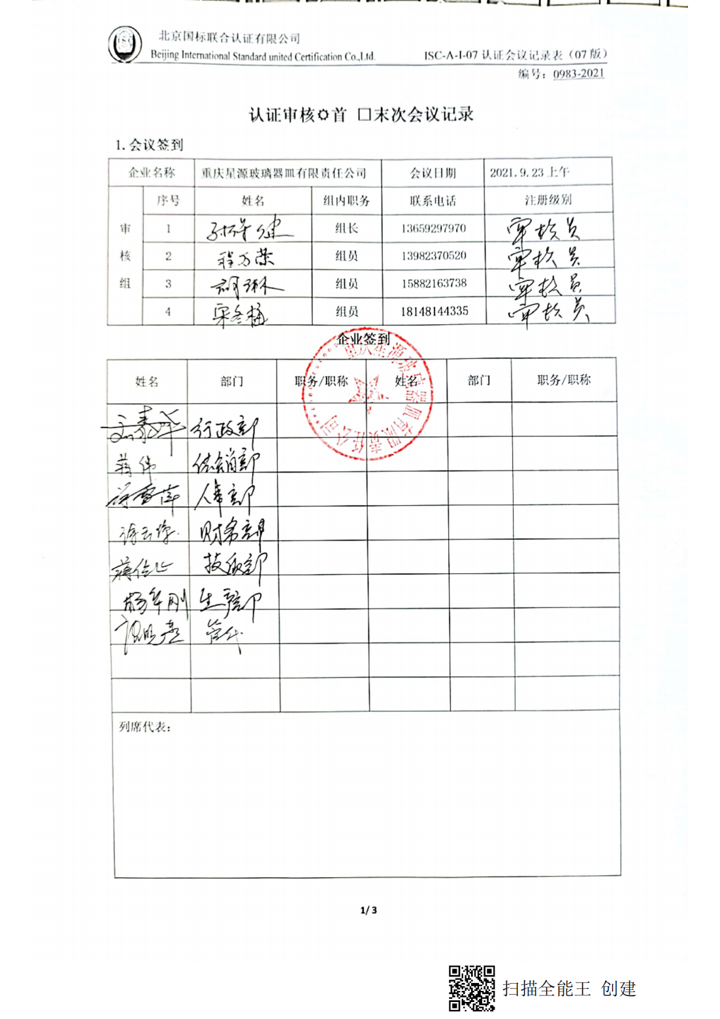编号：0983-2021

**认证审核☑首 □末次会议记录**

**1.会议签到**

|  |  |  |  |  |  |  |
| --- | --- | --- | --- | --- | --- | --- |
| 企业名称 | | 重庆星源玻璃器皿有限责任公司 | | | 会议日期 | 2021.09.23 |
| 审核组 | 序号 | | 姓名 | 组内职务 | 联系电话 | 注册级别 |
| 1 | |  | 组长 | 13659297970 | 审核员 |
| 2 | |  | 组员 | 15882163738 | 审核员 |
| 3 | |  | 组员 | 18148144335 | 审核员 |
| 4 | |  | 组员 | 13982370520 | 审核员 |

**企业签到**

|  |  |  |  |  |  |
| --- | --- | --- | --- | --- | --- |
| 姓名 | 部门 | 职务/职称 | 姓名 | 部门 | 职务/职称 |
|  |  |  |  |  |  |
|  |  |  |  |  |  |
|  |  |  |  |  |  |
|  |  |  |  |  |  |
|  |  |  |  |  |  |
|  |  |  |  |  |  |
|  |  |  |  |  |  |
|  |  |  |  |  |  |
|  |  |  |  |  |  |
| 列席代表： | | | | | |