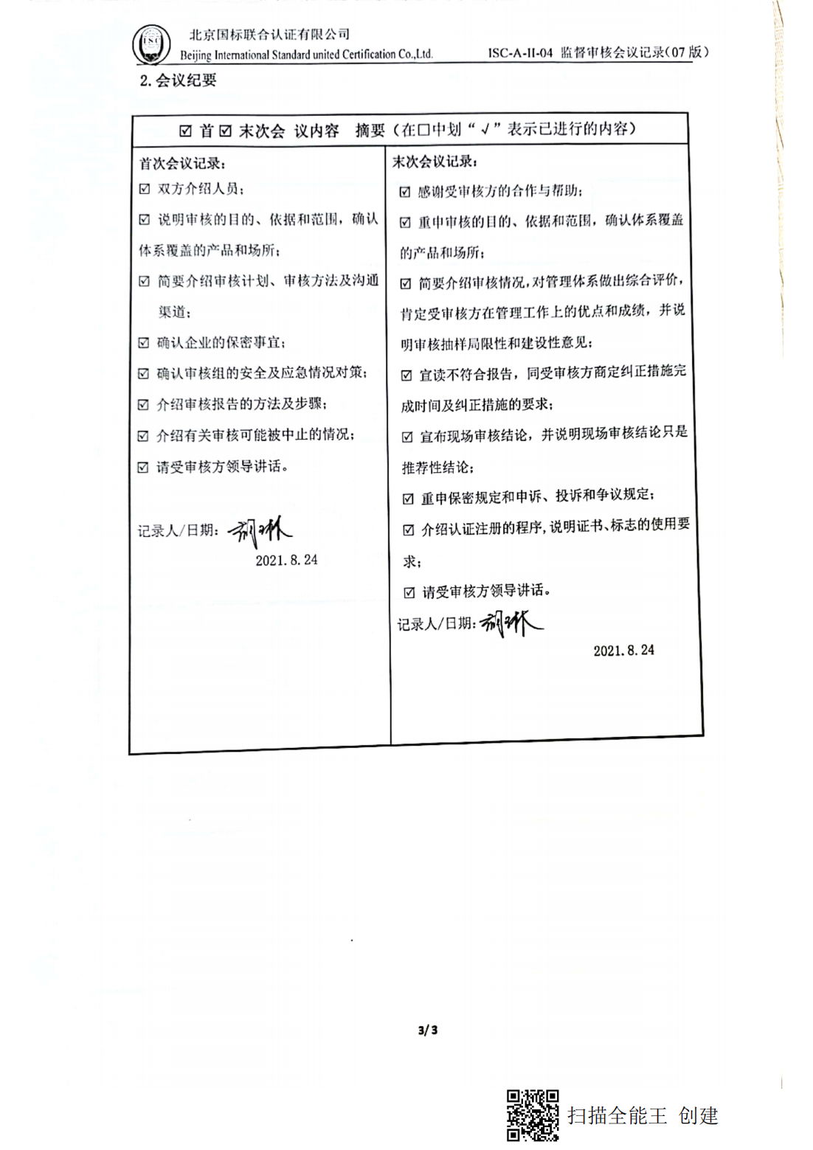编号：0129-2019-AA-2021

**监督审核□首 □末次会议记录**

**1.会议签到**

|  |  |  |  |  |  |  |
| --- | --- | --- | --- | --- | --- | --- |
| 企业名称 | | 四川金土地实业有限公司 | | | 会议日期 | 2021.8.24 |
| 审核组 | 序号 | | 姓名 | 组内职务 | 联系电话 | 注册级别 |
|  | |  |  |  |  |
|  | |  |  |  |  |
|  | |  |  |  |  |

**企业签到**

|  |  |  |  |  |  |
| --- | --- | --- | --- | --- | --- |
| 姓名 | 部门 | 职务/职称 | 姓名 | 部门 | 职务/职称 |
|  |  |  |  |  |  |
|  |  |  |  |  |  |
|  |  |  |  |  |  |
|  |  |  |  |  |  |
|  |  |  |  |  |  |
|  |  |  |  |  |  |
|  |  |  |  |  |  |
|  |  |  |  |  |  |
|  |  |  |  |  |  |
| 列席代表： | | | | | |