**合同编号:****0609-2021-EO**

**组织认证证书信息确认书**

**为保证认证证书准确反映组织实际情况及管理体系特点，请将组织准确名称、地址、体系覆盖范围等有关信息正式表述如下，以便打印认证证书时作为依据。**

**组织名称 (中文)：****大庆市三星机械制造有限公司**

**(英文)：****Daqing Samsung Machinery Manufacturing Co. , Ltd.**

**组织注册地址(中文)：****黑龙江省大庆市高新技术开发区宏伟园区孵化器3号 邮编:** **163312**

**(英文)：No. 3, Hongwei Park Incubator, High-tech Development Zone, Daqing City, Heilongjiang Province OPS: 163312**

**☑组织经营地址(中文)：****黑龙江省大庆市高新技术开发区宏伟园区孵化器3号 邮编:****163312**

**(英文)：No. 3, Hongwei Park Incubator, High-tech Development Zone, Daqing City, Heilongjiang Province OPS: 163312**

**组织机构代码证号（社会信用号）：****91230607716629867H传真：****电话.：****0459-5694700**

**法人代表：****王磊管代/联系人(职务)：****张福林组织人数：****43**

**认证标准：****E：GB/T 24001-2016/ISO14001:2015,O：GB/T45001-2020 / ISO45001：2018**

**认证类型：****E:再认证,O:再认证**

**变更内容：□组织名称变更□地址变更☑认证范围变更（☑扩大□缩小）**

**E：石油化工设备及配件(聚丙烯酰胺专用设备、压力容器、炉用燃烧器及配件)的制造、销售及技术服务;石油钻采专用设备及配件、水处理设备及配件、环境保护专用设备、化工生产专用设备、阴极保护系统的技术研发及销售；仪器仪表、工业自动控制系统装置、电机、橡胶制品、压力管道元件、阀门及配件、金属密封件、泵及配件、紧固件、阴极保护设备、工业清洗服务、管线的清洗服务，锅炉物理清洗服务、化工生产专用设备的维修和销售所涉及场所的相关环境管理活动。**

**O：石油化工设备及配件(聚丙烯酰胺专用设备、压力容器、炉用燃烧器及配件)的制造、销售及技术服务;石油钻采专用设备及配件、水处理设备及配件、环境保护专用设备、化工生产专用设备、阴极保护系统的技术研发及销售；仪器仪表、工业自动控制系统装置、电机、橡胶制品、压力管道元件、阀门及配件、金属密封件、泵及配件、紧固件、阴极保护设备、工业清洗服务、管线的清洗服务，锅炉物理清洗服务、化工生产专用设备的维修和销售所涉及场所的相关职业健康安全管理活动。**

**□QMS（英文：）：**

**☑EMS（英文：）：**

**Manufacturing, sales and technical services of petrochemical equipment and accessories (special equipment for polyacrylamide, pressure vessels, burners and accessories for furnace); Technical research and development and sales of special equipment and accessories for petroleum drilling and 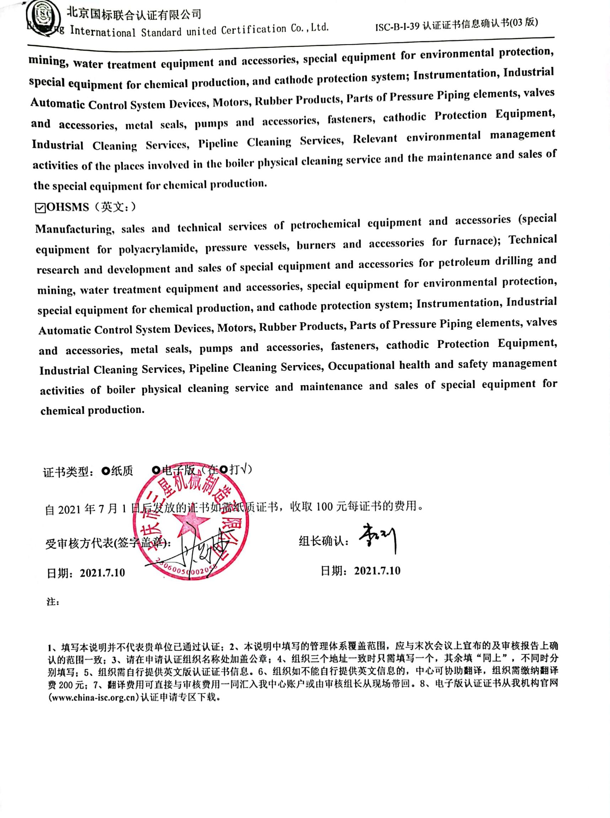mining, water treatment equipment and accessories, special equipment for environmental protection, special equipment for chemical production, and cathode protection system; Instrumentation, Industrial Automatic Control System Devices, Motors, Rubber Products, Parts of Pressure Piping elements, valves and accessories, metal seals, pumps and accessories, fasteners, cathodic Protection Equipment, Industrial Cleaning Services, Pipeline Cleaning Services, Relevant environmental management activities of the places involved in the boiler physical cleaning service and the maintenance and sales of the special equipment for chemical production.**

**☑OHSMS（英文：）**

**Manufacturing, sales and technical services of petrochemical equipment and accessories (special equipment for polyacrylamide, pressure vessels, burners and accessories for furnace); Technical research and development and sales of special equipment and accessories for petroleum drilling and mining, water treatment equipment and accessories, special equipment for environmental protection, special equipment for chemical production, and cathode protection system; Instrumentation, Industrial Automatic Control System Devices, Motors, Rubber Products, Parts of Pressure Piping elements, valves and accessories, metal seals, pumps and accessories, fasteners, cathodic Protection Equipment, Industrial Cleaning Services, Pipeline Cleaning Services, Occupational health and safety management activities of boiler physical cleaning service and maintenance and sales of special equipment for chemical production.**

**证书类型：□纸质 □电子版**（在□打√）

自2021年7月1日后发放的证书如需纸质证书，收取100元每证书的费用。

**受审核方代表(签字盖章)： 组长确认：**

**日期：2021.7.10 日期：2021.7.10**

**注：**

**1、填写本说明并不代表贵单位已通过认证；2、本说明中填写的管理体系覆盖范围，应与末次会议上宣布的及审核报告上确认的范围一致；3、请在申请认证组织名称处加盖公章；4、组织三个地址一致时只需填写一个，其余填“同上”，不同时分别填写；5、组织需自行提供英文版认证证书信息。6、组织如不能自行提供英文信息的，中心可协助翻译，组织需缴纳翻译费200元；7、翻译费用可直接与审核费用一同汇入我中心账户或由审核组长从现场带回。8、电子版认证证书从我机构官网([www.china-isc.org.cn](http://www.china-isc.org.cn))认证申请专区下载。**