**合同编号:****0161-2021-QEO**

**组织认证证书信息确认书**

**为保证认证证书准确反映组织实际情况及管理体系特点，请将组织准确名称、地址、体系覆盖范围等有关信息正式表述如下，以便打印认证证书时作为依据。**

**组织名称 (中文)：****山东智慧树科教仪器设备有限公司**

**(英文)：****Shandong wisdom Shu science education instrument equipment co., ltd.**

**组织注册地址(中文)：****鄄城县什集镇工业园666号 邮编:** **274000**

**(英文)：No.666, Shiji Town Industrial Park, Juancheng County.**

**□组织经营地址(中文)：****山东省菏泽市永昌路299号东方夏威夷大厦1号楼707室 邮编:****274000**

**(英文)：Room 707, Building 1, Oriental Hawaii Building, No.299 Yongchang Road, Heze City, Shandong Province.**

**□组织经营地址1(中文)：邮编:**

**(英文)：**

**组织机构代码证号（社会信用号）：****913717005887547187 传真：****电话.：****13356201181**

**法人代表：****申慧 管代/联系人(职务)：****梁金现 组织人数：****10**

**认证标准：****Q：GB/T19001-2016/ISO9001:2015,E：GB/T 24001-2016/ISO14001:2015,O：GB/T45001-2020 / ISO45001：2018认证类型：****Q:二阶段,E:二阶段,O:二阶段**

**变更内容：□组织名称变更□地址变更□认证范围变更（□扩大□缩小）**

**认证范围：**

**Q：教学仪器、实验室设备、学生课桌椅、学生床、幼儿园教具、玩具、中小学音体美卫劳器材、科技器材、玻璃仪器、科普仪器、环保仪器、多媒体教学设备、数字化教室设备、多功能教室设备、心理咨询室设备、综合实践设备、教学机器人、办公家具、办公用品、厨房设备、餐具、厨具、健身器材、窗帘、学生服装的销售**

**E：教学仪器、实验室设备、学生课桌椅、学生床、幼儿园教具、玩具、中小学音体美卫劳器材、科技器材、玻璃仪器、科普仪器、环保仪器、多媒体教学设备、数字化教室设备、多功能教室设备、心理咨询室设备、综合实践设备、教学机器人、办公家具、办公用品、厨房设备、餐具、厨具、健身器材、窗帘、学生服装的销售所涉及场所的环境管理活动**

**O：教学仪器、实验室设备、学生课桌椅、学生床、幼儿园教具、玩具、中小学音体美卫劳器材、科技器材、玻璃仪器、科普仪器、环保仪器、多媒体教学设备、数字化教室设备、多功能教室设备、心理咨询室设备、综合实践设备、教学机器人、办公家具、办公用品、厨房设备、餐具、厨具、健身器材、窗帘、学生服装的销售所涉及场所的职业健康安全管理活动**

**□QMS（英文：）：Teaching instruments, laboratory equipment, student desks and chairs, student beds, kindergarten teaching AIDS, toys, musical, physical, aesthetic, health and labor equipment for primary and secondary schools, scientific and technological equipment, glass instruments, popular science instruments, environmental protection instruments, multimedia teaching equipment, digital classroom equipment, multifunctional classroom equipment, psychological consultation room equipment, comprehensive practice equipment, teaching robots, office furniture, office supplies, kitchen equipment, tableware, kitchen utensils, fitness equipment and curtains.**

**□EMS（英文：）：Teaching instruments, laboratory equipment, student desks and chairs, student beds, kindergarten teaching AIDS, toys, musical, physical, aesthetic, health and labor equipment for primary and secondary schools, scientific and technological equipment, glass instruments, popular science instruments, environmental protection instruments, multimedia teaching equipment, digital classroom equipment, multifunctional classroom equipment, psychological consultation room equipment, comprehensive practice equipment, teaching robots, office furniture, office supplies, kitchen equipment, tableware, kitchen utensils, fitness equipment and curtains.**

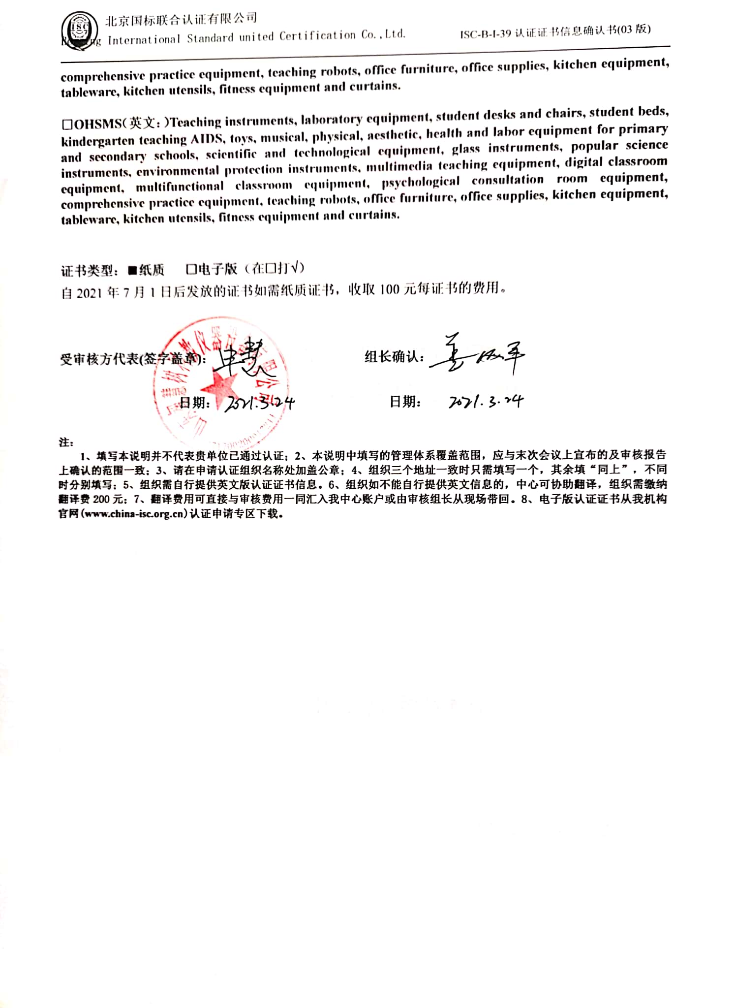

**□OHSMS（英文：）Teaching instruments, laboratory equipment, student desks and chairs, student beds, kindergarten teaching AIDS, toys, musical, physical, aesthetic, health and labor equipment for primary and secondary schools, scientific and technological equipment, glass instruments, popular science instruments, environmental protection instruments, multimedia teaching equipment, digital classroom equipment, multifunctional classroom equipment, psychological consultation room equipment, comprehensive practice equipment, teaching robots, office furniture, office supplies, kitchen equipment, tableware, kitchen utensils, fitness equipment and curtains.**

**证书类型：**■**纸质 □电子版**（在□打√）

自2021年7月1日后发放的证书如需纸质证书，收取100元每证书的费用。

**受审核方代表(签字盖章)： 组长确认：**

**日期： 日期：**

**注：**

**1、填写本说明并不代表贵单位已通过认证；2、本说明中填写的管理体系覆盖范围，应与末次会议上宣布的及审核报告上确认的范围一致；3、请在申请认证组织名称处加盖公章；4、组织三个地址一致时只需填写一个，其余填“同上”，不同时分别填写；5、组织需自行提供英文版认证证书信息。6、组织如不能自行提供英文信息的，中心可协助翻译，组织需缴纳翻译费200元；7、翻译费用可直接与审核费用一同汇入我中心账户或由审核组长从现场带回。8、电子版认证证书从我机构官网(**[**www.china-isc.org.cn**](http://www.china-isc.org.cn)**)认证申请专区下载。**