**合同编号:****0157-2018-QEO-2020**

**组织认证证书信息确认书**

**为保证认证证书准确反映组织实际情况及管理体系特点，请将组织准确名称、地址、体系覆盖范围等有关信息正式表述如下，以便打印认证证书时作为依据。**

**组织名称 (中文)：****山东圣哲石油装备有限公司**

**(英文)：****Shandong Shengeer Petroleum Equipment Co.,ltd.**

**组织注册地址(中文)：****山东省东营市东营区邹城路29号 邮编:****257232**

**(英文)：No.29 Zoucheng Road, Dongying District, Dongying City, Shandong Province.**

**组织经营地址(中文)：****山东省东营市东营区邹城路29号 邮编:****257232**

**(英文)：No.29 Zoucheng Road, Dongying District, Dongying City, Shandong Province.**

**组织经营地址1(中文)：****山东省东营市东营区邹城路29号 邮编:****257232**

**(英文)：No.29 Zoucheng Road, Dongying District, Dongying City, Shandong Province.**

**组织机构代码证号（社会信用号）：****913705030713021373 传真：****电话.：****0546-3282866**

**法人代表：****王红梅 管代/联系人(职务)：张晓妮 组织人数：****Q:25,E:25,O:25**

**认证标准：****■ GB/T 19001-2016 idt ISO 9001:2015标准 (不适用：条款)**

**□ GB/T 50430-2017 (不适用： 条款)；**

**■ GB/T 24001-2016 idt ISO 14001:2015标准；**

**□GB/T 28001-2011 idt OHSMS 18001:2007标准；**

**■ GB/T 45001-2020 idtISO45001:2018；**

**认证类型：****Q:监查2,E:监查2,O:监查2**

**变更内容：□组织名称变更□地址变更■认证范围变更（■扩大□缩小）**

Q：油层解堵增产增注方案技术服务;油井液面自动监测仪、原油储罐自动盘库装置、智能加药装置、电磁加热装置、撬装过滤装置、油泥处理装置、泥浆不落地处理装置、定量装车系统、井口数据采集及传输系统、油井群控变频装置、油井多参数测量装置、自动注水装置、井口撬、挂接阀组撬的生产（组装）

E：油层解堵增产增注方案技术服务;油井液面自动监测仪、原油储罐自动盘库装置、智能加药装置、电磁加热装置、撬装过滤装置、油泥处理装置、泥浆不落地处理装置、定量装车系统、井口数据采集及传输系统、油井群控变频装置、油井多参数测量装置、自动注水装置、井口撬、挂接阀组撬的生产（组装）所涉及场所的相关环境管理活动

O：油层解堵增产增注方案技术服务;油井液面自动监测仪、原油储罐自动盘库装置、智能加药装置、电磁加热装置、撬装过滤装置、油泥处理装置、泥浆不落地处理装置、定量装车系统、井口数据采集及传输系统、油井群控变频装置、油井多参数测量装置、自动注水装置、井口撬、挂接阀组撬的生产（组装）所涉及场所相关的职业健康安全管理活动所涉及的相关职业健康安全管理活动

**□QMS（英文：）：Technical service of oil layer plugging removal, production increase and injection increase scheme; Production (assembly) of oil well liquid level automatic monitor, crude oil storage tank automatic inventory device, intelligent dosing device, electromagnetic heating device, skid-mounted filter device, sludge treatment device, mud non-landing treatment device, quantitative loading system, wellhead data acquisition and transmission system, oil well group control frequency conversion device, oil well multi-parameter measuring device, automatic water injection device, wellhead skid and articulated valve block skid.**

**□EMS（英文：）：Technical service of oil layer plugging removal, production increase and injection increase scheme; Environmental management activities related to production (assembly) of oil well liquid level automatic monitor, crude oil storage tank automatic inventory device, intelligent dosing device, electromagnetic heating device, skid-mounted filter device, sludge treatment device, mud non-landing treatment device, quantitative loading system, wellhead data acquisition and transmission system, oil well group control frequency conversion device, oil well multi-parameter measuring device, automatic water injection device, wellhead skid and articulated valve block skid.**

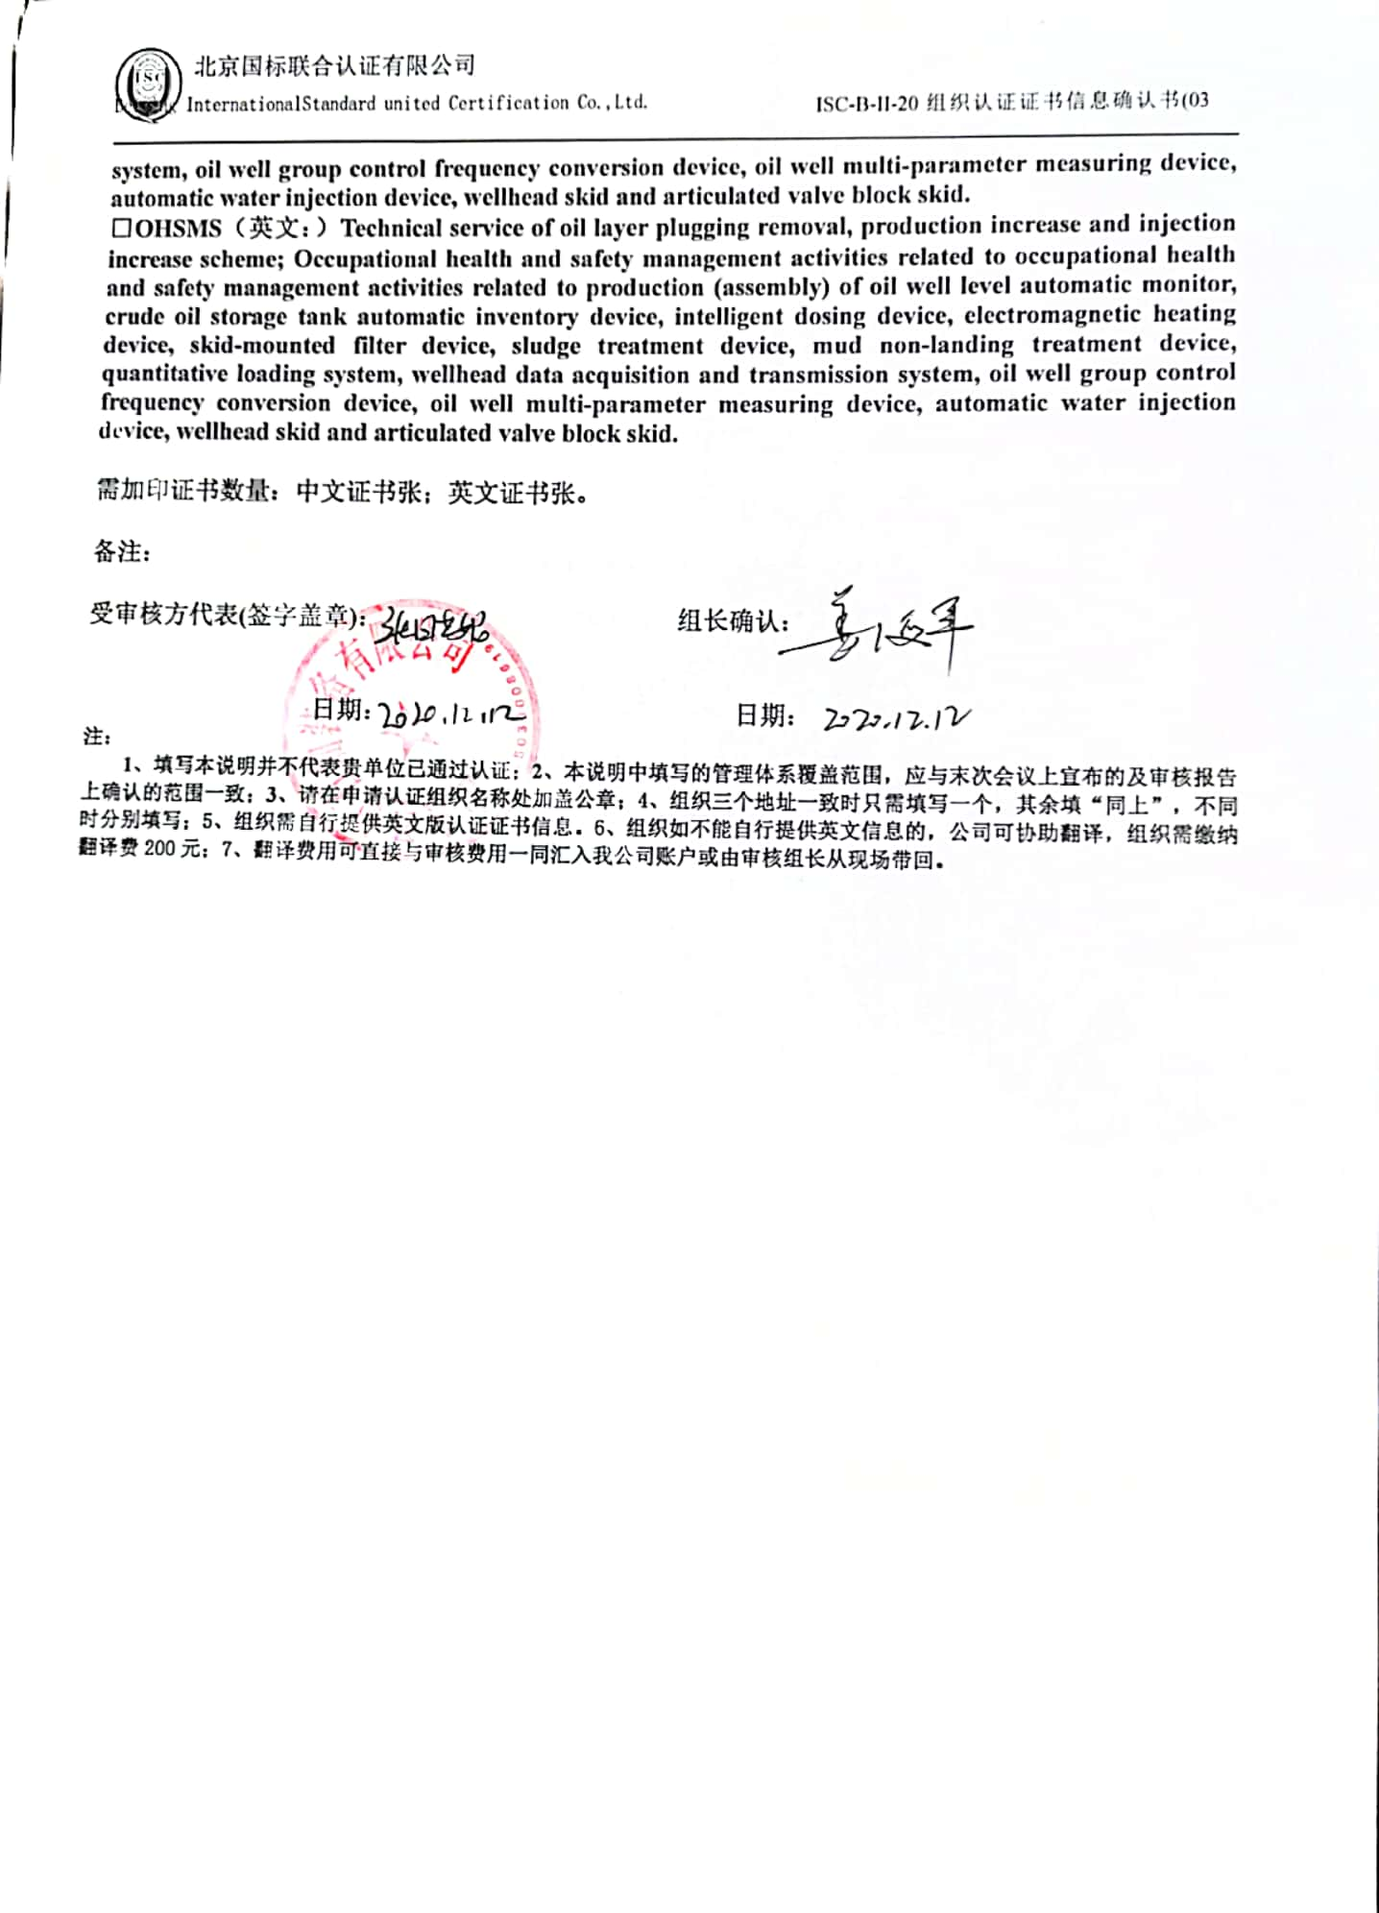**□OHSMS（英文：）Technical service of oil layer plugging removal, production increase and injection increase scheme; Occupational health and safety management activities related to occupational health and safety management activities related to production (assembly) of oil well level automatic monitor, crude oil storage tank automatic inventory device, intelligent dosing device, electromagnetic heating device, skid-mounted filter device, sludge treatment device, mud non-landing treatment device, quantitative loading system, wellhead data acquisition and transmission system, oil well group control frequency conversion device, oil well multi-parameter measuring device, automatic water injection device, wellhead skid and articulated valve block skid.**

**需加印证书数量：中文证书张；英文证书张。**

**备注：**

**受审核方代表(签字盖章)： 组长确认：**

**日期： 日期：**

**注：**

**1、填写本说明并不代表贵单位已通过认证；2、本说明中填写的管理体系覆盖范围，应与末次会议上宣布的及审核报告上确认的范围一致；3、请在申请认证组织名称处加盖公章；4、组织三个地址一致时只需填写一个，其余填“同上”，不同时分别填写；5、组织需自行提供英文版认证证书信息。6、组织如不能自行提供英文信息的，公司可协助翻译，组织需缴纳翻译费200元；7、翻译费用可直接与审核费用一同汇入我公司账户或由审核组长从现场带回。**