**公开**

**精密压力表测量过程分析报告**

1. **测量数据**

每季度进行一次过程分析，2020年第四季度获取数据如下：

单位：MPa

|  |  |  |  |  |  |
| --- | --- | --- | --- | --- | --- |
| **批次** | **压力1** | **压力2** | **压力3** | **压力4** | **压力5** |
| 1 | 10.010 | 10.015 | 9.990 | 9.995 | 10.005 |
| 2 | 9.990 | 10.005 | 10.010 | 10.005 | 9.995 |
| 3 | 10.005 | 9.990 | 10.005 | 10.010 | 9.990 |
| 4 | 10.005 | 10.000 | 9.985 | 10.005 | 9.995 |
| 5 | 9.990 | 9.995 | 10.010 | 10.005 | 10.010 |
| 6 | 10.005 | 9.990 | 10.015 | 9.990 | 10.015 |
| 7 | 10.010 | 10.005 | 9.990 | 10.015 | 9.990 |
| 8 | 9.985 | 10.010 | 10.005 | 10.000 | 10.010 |
| 9 | 9.990 | 10.005 | 9.995 | 9.995 | 10.005 |
| 10 | 10.005 | 9.995 | 9.995 | 10.000 | 10.005 |
| 11 | 10.005 | 10.005 | 10.010 | 9.990 | 10.000 |
| 12 | 9.995 | 10.005 | 10.005 | 9.990 | 10.000 |
| 13 | 10.005 | 10.005 | 9.985 | 10.010 | 9.995 |
| 14 | 10.005 | 9.990 | 10.005 | 10.000 | 10.020 |
| 15 | 9.995 | 10.005 | 10.010 | 10.015 | 10.005 |
| 16 | 9.990 | 10.005 | 9.995 | 10.005 | 9.985 |
| 17 | 10.020 | 9.995 | 9.990 | 10.000 | 10.005 |
| 18 | 9.990 | 9.985 | 10.015 | 9.990 | 9.995 |
| 19 | 10.010 | 10.010 | 9.995 | 9.990 | 10.005 |
| 20 | 9.995 | 10.005 | 9.995 | 9.990 | 10.015 |
| 21 | 10.015 | 10.005 | 9.995 | 9.990 | 10.000 |
| 22 | 10.010 | 9.995 | 10.005 | 9.985 | 9.990 |
| 23 | 10.015 | 9.995 | 10.005 | 9.995 | 9.995 |
| 24 | 10.010 | 9.990 | 10.015 | 9.995 | 10.015 |
| 25 | 9.995 | 10.000 | 10.015 | 9.990 | 9.995 |
| 测量上限 | | | 10.04 | | |
| 测量下限 | | | 9.96 | | |

1. **过程能力分析**

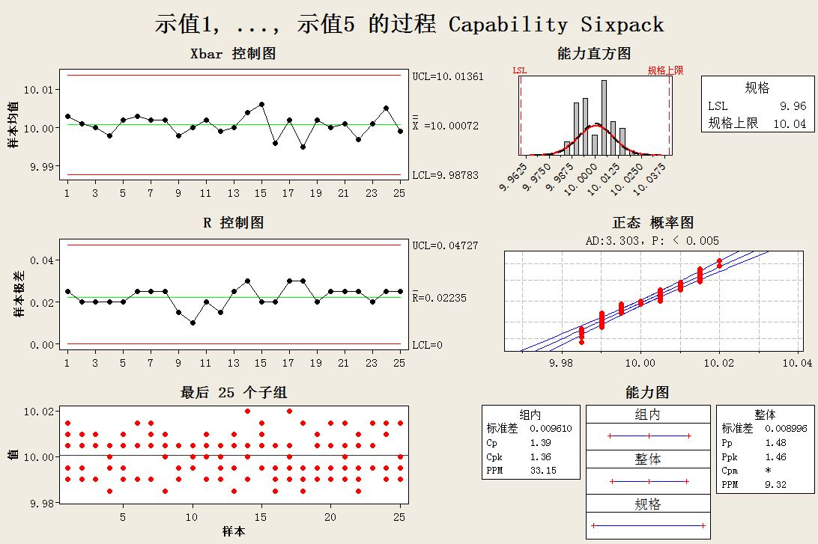

Xbar控制图和R控制图没有出现红点，满足8个判异准则

Cp=1.39

Cpk=1.36

**结论：过程能力充分。**

**分析人员： 日期：**