**合同编号:**0529-2020-QJEO

**组织认证证书信息确认书**

**为保证认证证书准确反映组织实际情况及管理体系特点，请将组织准确名称、地址、体系覆盖范围等有关信息正式表述如下，以便打印认证证书时作为依据。**

**组织名称 (中文)：****黑龙江省万意达石油工程有限公司**

**(英文)：****Heilongjiang** **Province wanyida Petroleum Engineering Co., Ltd**

**组织注册地址(中文)：****黑龙江省大庆市萨尔图区勤奋村 邮编:** **163310**

**(英文)：Diligent Village，Sartu District ，Daqing City, Heilongjiang Province**

**组织经营地址(中文)：****黑龙江省大庆市龙凤区新航路10号 邮编:****163310**

**(英文)：No.10, Xinhang Road , Longfeng District, Daqing City, Heilongjiang Province**

**组织机构代码证号（社会信用号）：****91230600772608673J 传真：** **电话.：****0459-8883228**

**法人代表：****刘星海 管代/联系人(职务)：****李永双 组织人数：** **102**

**认证标准：****EC：GB/T19001-2016 idt ISO9001:2015和GB/T50430-2017,E：GB/T 24001-2016/ISO14001:2015,O：GB/T45001-2020 / ISO45001：2018认证类型：****EC:二阶段,E:二阶段,O:二阶段**

**变更内容：□组织名称变更□地址变更□认证范围变更（□扩大□缩小）**

**Q：环保专用设备、A2级压力容器、石油钻采机械部件的生产、销售；**

**钻井泥浆无害化处理设备、水处理（清水、软化水、污水、含油污水）设备、全自动软化水装置、稀油站、滤油机、油田专用设备、过滤器、电磁加热设备和电磁加热三项分离装置、太阳能用具的设计、制造、销售；**

**金属软管的销售；**

**油田技术服务；钻井泥浆（水基泥浆、油基泥浆、盐水泥浆）不落地无害化处理技术服务；固体废物处理（油固分离）；GC1级工业管道安装, GB1、GB2级公用管道安装；**

**资质范围内的建筑工程施工总承包三级；机电工程施工总承包三级；石油化工工程施工总承包三级；建筑机电安装工程专业承包三级；环保工程专业承包三级；防水防腐保温工程专业承包二级；消防设施专业承包二级；特种工程（特殊设备起重吊装）；园林绿化工程施工。**

**Q: Manufacture and sale of environment-protection-specific equipment, A2 pressure vessels, and components of petroleum drilling and recovery machineries;**

**Design，manufacture and sale of equipment for harmless treatment of drilling fluid, equipment for water (clean, softened, polluted, or oily polluted water) treatment, fully-automated water softening devices, thin oil station, oil filter press, oilfield-specific equipment, filter, electromagnetic heating device , electromagnetic heating 3-phase separation unit and solar items;**

**Sale of metallic hose.**

**Oilfield technical service; technical service for no-landing harmless treatment of drilling fluids (oil-based, water-based and salt-based mud fluids); treatment of solid wastes (oil separation from solids). Installation of GC1 industrial piping, and GB1 and GB2 public piping;**

**Within the scope of qualification: class-3 general contractor of construction projects of building ; Class-3 general contractor of construction of electrical and mechanical projects; Class-3 general contractor of construction of petrochemical projects; Class-3 specialist contractor of installation of electric and mechanical projects for buildings; Class-3 specialist contractor of environmental-protection projects; Class-2 specialist contractor of waterproofing, anti-corrosion and thermal insulation projects; Class-2 specialist contractor of fire-fighting facilities; special projects (hoisting and installation of special equipment); and construction of gardening and landscaping projects.**

**E：A2级压力容器、环保专用设备、石油钻采机械部件的生产、销售；钻井泥浆无害化处理设备、水处理（清水、软化水、污水、含油污水）设备、全自动软化水装置、稀油站、滤油机、油田专用设备、过滤器、电磁加热设备和电磁加热三项分离装置、太阳能用具的设计、制造、销售；金属软管的销售；**

**油田技术服务；钻井泥浆（水基泥浆、油基泥浆、盐水泥浆）不落地无害化处理技术服务；固体废物处理（油固分离）；GC1级工业管道安装, GB1、GB2级公用管道安装及相关环境管理活动**

**资质范围内的建筑工程施工总承包三级；机电工程施工总承包三级；石油化工工程施工总承包三级；建筑机电安装工程专业承包三级；环保工程专业承包三级；防水防腐保温工程专业承包二级；消防设施专业承包二级；特种工程（特殊设备起重吊装）；园林绿化工程施工及相关环境管理活动;**

**(英文)：**

**Environmental management activities related to the manufacture and sale of environment-protection-specific equipment, A2 pressure vessels, and components of petroleum drilling and recovery machineries;**

**Environmental management activities related to the design，manufacture and sale of equipment for harmless treatment of drilling fluid, equipment for water (clean, softened, polluted, or oily polluted water) treatment, fully-automated water softening devices, thin oil station, oil filter press, oilfield-specific equipment, filter, electromagnetic heating device , electromagnetic heating 3-phase separation unit and solar items;**

**Environmental management activities related to the sale of metallic hose.**

**Environmental management activities related to the oilfield technical service; technical service for no-landing harmless treatment of drilling fluids (oil-based, water-based and salt-based mud fluids); treatment of solid wastes (oil separation from solids). Installation of GC1 industrial piping, and GB1 and GB2 public piping;**

**Within the scope of qualification: environmental management activities related to the class-3 general contractor of construction projects of building ; Class-3 general contractor of construction of electrical and mechanical projects; Class-3 general contractor of construction of petrochemical projects; Class-3 specialist contractor of installation of electric and mechanical projects for buildings; Class-3 specialist contractor of environmental-protection projects; Class-2 specialist contractor of waterproofing, anti-corrosion and thermal insulation projects; Class-2 specialist contractor of fire-fighting facilities; special projects (hoisting and installation of special equipment); and construction of gardening and landscaping projects.**

**O：A2级压力容器、环保专用设备、石油钻采机械部件的生产、销售；钻井泥浆无害化处理设备、水处理（清水、软化水、污水、含油污水）设备、全自动软化水装置、稀油站、滤油机、油田专用设备、过滤器、电磁加热设备和电磁加热三项分离装置、太阳能用具的设计、制造、销售；金属软管的销售；**

**油田技术服务；钻井泥浆（水基泥浆、油基泥浆、盐水泥浆）不落地无害化处理技术服务；固体废物处理（油固分离）；GC1级工业管道安装, GB1、GB2级公用管道安装及相关职业健康安全管理活动;**

**资质范围内的建筑工程施工总承包三级；机电工程施工总承包三级；石油化工工程施工总承包三级；建筑机电安装工程专业承包三级；环保工程专业承包三级；防水防腐保温工程专业承包二级；消防设施专业承包二级；特种工程（特殊设备起重吊装）；园林绿化工程施工及相关职业健康安全管理活动**

**Occupational health and safety management activities related to the manufacture and sale of environment-protection-specific equipment, A2 pressure vessels, and components of petroleum drilling and recovery machineries;**

**Occupational health and safety management activities related to the design，manufacture and sale of equipment for harmless treatment of drilling fluid, equipment for water (clean, softened, polluted, or oily polluted water) treatment, fully-automated water softening devices, thin oil station, oil filter press, oilfield-specific equipment, filter, electromagnetic heating device , electromagnetic heating 3-phase separation unit and solar items;**

**Occupational health and safety management activities related to the sale of metallic hose.**

**Occupational health and safety management activities related to the oilfield technical service; technical service for no-landing harmless treatment of drilling fluids (oil-based, water-based and salt-based mud fluids); treatment of solid wastes (oil separation from solids). Installation of GC1 industrial piping, and GB1 and GB2 public piping;**

**Within the scope of qualification: Occupational health and safety management activities related to the class-3 general contractor of construction projects of building; Class-3 general contractor of construction of electrical and mechanical projects; Class-3 general contractor of construction of 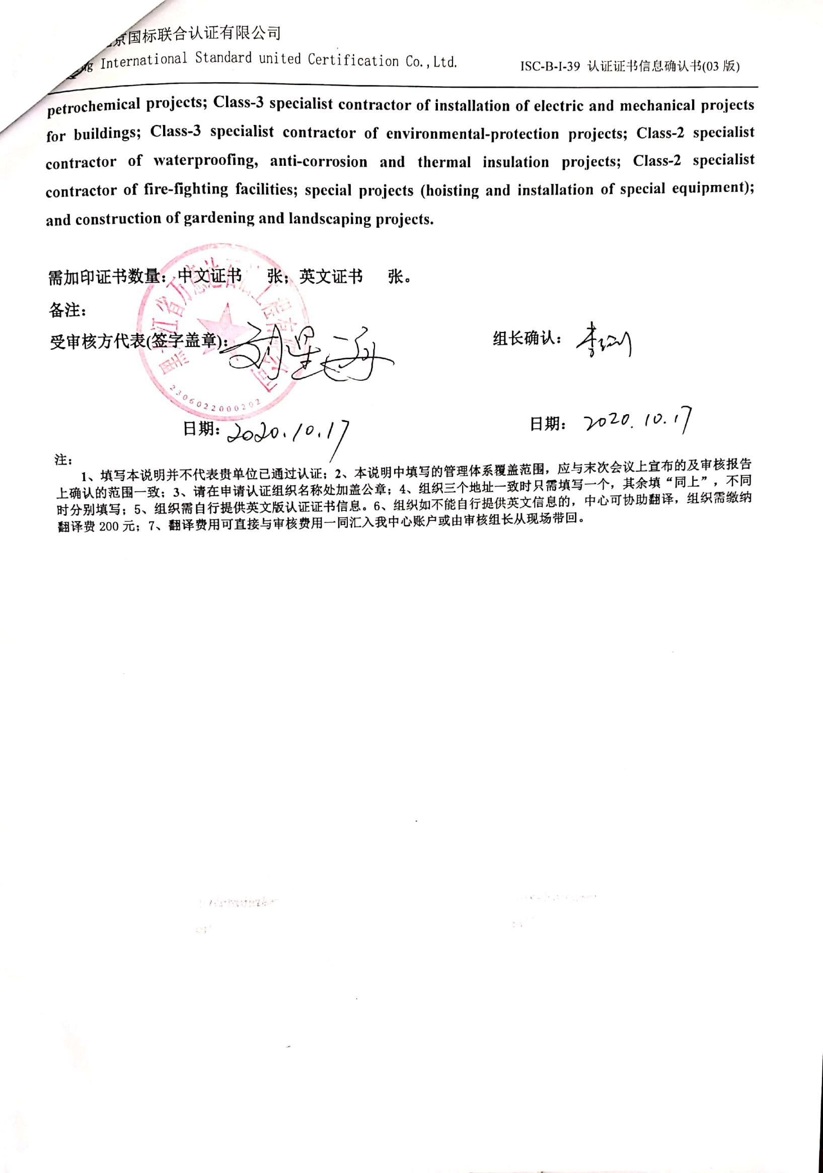petrochemical projects; Class-3 specialist contractor of installation of electric and mechanical projects for buildings; Class-3 specialist contractor of environmental-protection projects; Class-2 specialist contractor of waterproofing, anti-corrosion and thermal insulation projects; Class-2 specialist contractor of fire-fighting facilities; special projects (hoisting and installation of special equipment); and construction of gardening and landscaping projects.**

**需加印证书数量：中文证书 张；英文证书 张。**

**备注：**

**受审核方代表(签字盖章)： 组长确认：**

**日期： 日期：**

**注：**

**1、填写本说明并不代表贵单位已通过认证；2、本说明中填写的管理体系覆盖范围，应与末次会议上宣布的及审核报告上确认的范围一致；3、请在申请认证组织名称处加盖公章；4、组织三个地址一致时只需填写一个，其余填“同上”，不同时分别填写；5、组织需自行提供英文版认证证书信息。6、组织如不能自行提供英文信息的，中心可协助翻译，组织需缴纳翻译费200元；7、翻译费用可直接与审核费用一同汇入我中心账户或由审核组长从现场带回。**