**合同编号.:**0477-2020-EO

**组织认证证书信息确认书**

**为保证认证证书准确反映组织实际情况及管理体系特点，请将组织准确名称、地址、体系覆盖范围等有关信息正式表述如下，以便打印认证证书时作为依据。**

**组织名称 (中文)：****江西白莲智能科技集团有限公司**

**(英文)：****Jiangxi Bailian Intelligent Technology Group Co., Ltd**

**组织注册地址(中文)：****江西省九江市永修县新城县城工业园集中区 邮编:** **330300**

**(英文)：Industrial Park concentration area of Xincheng County seat, Yongxiu County, Jiujiang City, Jiangxi Province Postcode：330300**

**□组织经营地址(中文)：****江西省九江市永修县新城县城工业园集中区 邮编:****330300**

**(英文)：Industrial Park concentration area of Xincheng County seat, Yongxiu County, Jiujiang City, Jiangxi Province Postcode：33030**

**□组织经营地址1(中文)： 邮编:**

**(英文)：**

**组织机构代码证号（社会信用号）：****91360425739197526M 传真：** **电话.：****0792-3227640**

**法人代表：****周春香 管代/联系人(职务)：****石仕义 组织人数：** **48**

**认证标准：****E：GB/T 24001-2016/ISO14001:2015,O：GB/T45001-2020 / ISO45001：2018认证类型：****E:二阶段,O:二阶段**

**变更内容：□组织名称变更□地址变更□认证范围变更（□扩大□缩小）**

**E：密集架(智能型密集架、手动密集架、无轨密集架、电动密集架)；书架（智能书架、不锈钢书架、钢木书架、期刊架、报架）；档案馆设备（智慧馆库、智能书车、智能储物柜（指纹人脸识别、语音识别、指静脉、刷卡、扫码开启方式）、智能手机屏蔽柜、智能物证（卷宗）柜、文件柜、防磁柜、博物馆珍藏架、文物柜架）；医用家具（药品柜、智能药品柜、药架、中药柜、导诊台（护士站））；床（共享陪护床、军用床、公寓床）；校用家具（仪器柜、阅览桌椅、讲台、电脑桌、金属架柜、课桌椅）；保险箱（智能快递柜、智能枪弹柜、智能枪弹一体柜、枪弹柜）的设计、生产、售后服务(安装、施工)及其所涉及的环境管理活动**

**(英文)：Shelves (intelligent shelving, manual shelving, trackless shelving, electric shelving); bookshelf (smart bookshelf, stainless steel bookshelf, steel-wood bookshelf, periodical rack, newspaper rack); archives equipment (smart library library, smart book Cars, smart lockers (fingerprint face recognition, voice recognition, finger vein, swipe card, scan code opening methods), smart phone shielding cabinets, smart physical evidence (file) cabinets, file cabinets, antimagnetic cabinets, museum storage racks, cultural relics cabinets Shelf); medical furniture (medicine cabinet, smart medicine 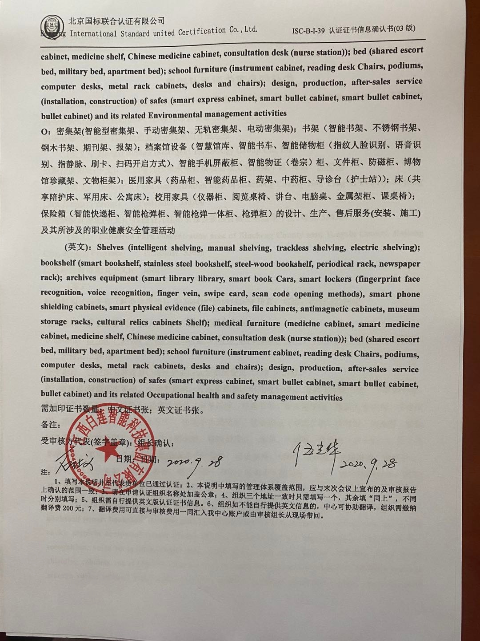cabinet, medicine shelf, Chinese medicine cabinet, consultation desk (nurse station)); bed (shared escort bed, military bed, apartment bed); school furniture (instrument cabinet, reading desk Chairs, podiums, computer desks, metal rack cabinets, desks and chairs); design, production, after-sales service (installation, construction) of safes (smart express cabinet, smart bullet cabinet, smart bullet cabinet, bullet cabinet) and its related Environmental management activities**

**O：密集架(智能型密集架、手动密集架、无轨密集架、电动密集架)；书架（智能书架、不锈钢书架、钢木书架、期刊架、报架）；档案馆设备（智慧馆库、智能书车、智能储物柜（指纹人脸识别、语音识别、指静脉、刷卡、扫码开启方式）、智能手机屏蔽柜、智能物证（卷宗）柜、文件柜、防磁柜、博物馆珍藏架、文物柜架）；医用家具（药品柜、智能药品柜、药架、中药柜、导诊台（护士站））；床（共享陪护床、军用床、公寓床）；校用家具（仪器柜、阅览桌椅、讲台、电脑桌、金属架柜、课桌椅）；保险箱（智能快递柜、智能枪弹柜、智能枪弹一体柜、枪弹柜）的设计、生产、售后服务(安装、施工)及其所涉及的职业健康安全管理活动**

**(英文)：Shelves (intelligent shelving, manual shelving, trackless shelving, electric shelving); bookshelf (smart bookshelf, stainless steel bookshelf, steel-wood bookshelf, periodical rack, newspaper rack); archives equipment (smart library library, smart book Cars, smart lockers (fingerprint face recognition, voice recognition, finger vein, swipe card, scan code opening methods), smart phone shielding cabinets, smart physical evidence (file) cabinets, file cabinets, antimagnetic cabinets, museum storage racks, cultural relics cabinets Shelf); medical furniture (medicine cabinet, smart medicine cabinet, medicine shelf, Chinese medicine cabinet, consultation desk (nurse station)); bed (shared escort bed, military bed, apartment bed); school furniture (instrument cabinet, reading desk Chairs, podiums, computer desks, metal rack cabinets, desks and chairs); design, production, after-sales service (installation, construction) of safes (smart express cabinet, smart bullet cabinet, smart bullet cabinet, bullet cabinet) and its related Occupational health and safety management activities**

**需加印证书数量：中文证书张；英文证书张。**

**备注：**

**受审核方代表(签字盖章)： 组长确认：**

**日期： 日期：**

**注：**

**1、填写本说明并不代表贵单位已通过认证；2、本说明中填写的管理体系覆盖范围，应与末次会议上宣布的及审核报告上确认的范围一致；3、请在申请认证组织名称处加盖公章；4、组织三个地址一致时只需填写一个，其余填“同上”，不同时分别填写；5、组织需自行提供英文版认证证书信息。6、组织如不能自行提供英文信息的，中心可协助翻译，组织需缴纳翻译费200元；7、翻译费用可直接与审核费用一同汇入我中心账户或由审核组长从现场带回。**