**合同编号:****0147-2019-QEO-2020**

**组织认证证书信息确认书**

**为保证认证证书准确反映组织实际情况及管理体系特点，请将组织准确名称、地址、体系覆盖范围等有关信息正式表述如下，以便打印认证证书时作为依据。**

**组织名称 (中文)：****江西光正金属设备集团有限公司**

**(英文)：****Jiangxi Guangzheng Metal Equipment Group Co. LTD**

**组织注册地址(中文)：****江西省樟树市城北工业园邮编:****331200**

**(英文)：Chengbei Industrial Park zhangshu City Jiangxi Province Zip code :331200**

**组织经营地址(中文)：****江西省樟树市城北工业园邮编:****331200**

**(英文)：Chengbei Industrial Park zhangshu City Jiangxi Province Zip code :331200**

**组织经营地址1(中文)：****江西省樟树市城北工业园邮编:****331200**

**(英文)：Chengbei Industrial Park zhangshu City Jiangxi Province Zip code :331200**

**组织机构代码证号（社会信用号）：****91360982054429275P传真：****电话.：****18172960103**

**法人代表：管代/联系人(职务)：****杨波 组织人数：****Q:43,E:43,O:43**

**认证标准：****■ GB/T 19001-2016 idt ISO 9001:2015标准 (不适用：条款)**

**□ GB/T 50430-2017 (不适用： 条款)；**

**■ GB/T 24001-2016 idt ISO 14001:2015标准；**

**□GB/T 28001-2011 idt OHSMS 18001:2007标准；**

**■ ISO45001:2018；**

**认证类型：****Q:监查1,E:监查1,O:监查1**

**变更内容：□组织名称变更□地址变更☑认证范围变更（☑扩大□缩小）**

**■QMS□50430覆盖范围：密集架（智能密集架、手动密集架、箱式密集架、橱式密集架、木纹转印密集架、无轨密集架、防水防喷淋型密集架、无焊接传动密集架、报纸密集架、油画密集架、文物档案密集架、重型密集架藏品架）、书架（杂志书架、文物架、专用架体、智能书架、智能物证架、文物存放架（柜）、移动病历存放架、期刊架（柜）、书梯、书车）、货架（智能货架、药架、博物馆珍藏架（柜）、智能寄存架）、档案柜（防磁柜、印章档案柜、目录柜、智能宗卷柜））、办公家具(阅览桌（椅）、文件柜、公寓床)、实验室设备(仪器架（柜）、档案杀菌消毒整理架（柜）档案净化整理台)的设计、制造、销售、安装服务及出口；可拆装爆破器材库、图书设备、银行用自动保管箱、智慧档案馆系统设备、枪支弹药专用保险箱、枪支弹药一体专用保险柜的制造、销售；档案室环境控制系统、数字化管理系统、恒温恒湿控制系统的开发**

**(英文)：Dense frame（Intelligent dense frame、Manual dense rack、box-type dense frame、Cabinet type compact frame、Wood grain transfer printing dense frame、Trackless dense frame、Waterproof and spray proof dense frame、No welding drive dense frame、The newspaper dense frame、Oil painting dense frame、Cultural relic archivesdense frame、Heavydense frame collection rack）、Bookcase（Magazinebookcase、Cultural relics frame、The special frame body、Intelligent bookshelf, intelligent material evidence rack, cultural relics storage rack (cabinet), mobile medical record storage rack, periodical rack (cabinet), book ladder and book cart）、Shelves (smart shelf, medicine rack, museum collection rack (cabinet), Smart locker)、Filing cabinet (Antimagnetic cabinet, seal filing cabinet, catalog cabinet, intelligent filing cabinet)、Office furniture (reading tables (chairs), file cabinets, apartment beds)、Design, manufacture, sale, installation service and export of laboratory equipment (instrument rack (cabinet), file sterilization and finishing rack (cabinet), file purification and finishing table)、Manufacturing and sales of detachable blasting equipment storehouses, books and equipment, automatic safe boxes for Banks, intelligent archives system equipment, special safes for guns and ammunition, special safes for guns and ammunition、Development of environmental control system, digital management system and constant temperature and humidity control system for archives room.**

**■EMS覆盖范围：密集架（智能密集架、手动密集架、箱式密集架、橱式密集架、木纹转印密集架、无轨密集架、防水防喷淋型密集架、无焊接传动密集架、报纸密集架、油画密集架、文物档案密集架、重型密集架藏品架）、书架（杂志书架、文物架、专用架体、智能书架、智能物证架、文物存放架（柜）、移动病历存放架、期刊架（柜）、书梯、书车）、货架（智能货架、药架、博物馆珍藏架（柜）、智能寄存架）、档案柜（防磁柜、印章档案柜、目录柜、智能宗卷柜））、办公家具(阅览桌（椅）、文件柜、公寓床)、实验室设备(仪器架（柜）、档案杀菌消毒整理架（柜）档案净化整理台)的设计、制造、销售、安装服务及出口；可拆装爆破器材库、图书设备、银行用自动保管箱、智慧档案馆系统设备、枪支弹药专用保险箱、枪支弹药一体专用保险柜的制造、销售；档案室环境控制系统、数字化管理系统、恒温恒湿控制系统的开发及其相关场所涉及的相关环境管理活动**

**(英文)：Dense frame（Intelligent dense frame、Manual dense rack、box-type dense frame、Cabinet type compact frame、Wood grain transfer printing dense frame、Trackless dense frame、Waterproof and spray proof dense frame、No welding drive dense frame、The newspaper dense frame、Oil painting dense frame、Cultural relic archivesdense frame、Heavydense frame collection rack）、Bookcase（Magazinebookcase、Cultural relics frame、The special frame body、Intelligent bookshelf, intelligent material evidence rack, cultural relics storage rack (cabinet), mobile medical record storage rack, periodical rack (cabinet), book ladder and book cart）、Shelves (smart shelf, medicine rack, museum collection rack (cabinet), Smart locker)、Filing cabinet (Antimagnetic cabinet, seal filing cabinet, catalog cabinet, intelligent filing cabinet)、Office furniture (reading tables (chairs), file cabinets, apartment beds)、Design, manufacture, sale, installation service and export of laboratory equipment (instrument rack (cabinet), file sterilization and finishing rack (cabinet), file purification and finishing table)、Manufacturing and sales of detachable blasting equipment storehouses, books and equipment, automatic safe boxes for Banks, intelligent archives system equipment, special safes for guns and ammunition, special safes for guns and ammunition、Development of environmental control system, digital management system and constant temperature and humidity control system for archives room and relevant environmental management activities related to the relevant premises.**

**■OHSMS覆盖范围：密集架（智能密集架、手动密集架、箱式密集架、橱式密集架、木纹转印密集架、无轨密集架、防水防喷淋型密集架、无焊接传动密集架、报纸密集架、油画密集架、文物档案密集架、重型密集架藏品架）、书架（杂志书架、文物架、专用架体、智能书架、智能物证架、文物存放架（柜）、移动病历存放架、期刊架（柜）、书梯、书车）、货架（智能货架、药架、博物馆珍藏架（柜）、智能寄存架）、档案柜（防磁柜、印章档案柜、目录柜、智能宗卷柜））、办公家具(阅览桌（椅）、文件柜、公寓床)、实验室设备(仪器架（柜）、档案杀菌消毒整理架（柜）档案净化整理台)的设计、制造、销售、安装服务及出口；可拆装爆破器材库、图书设备、银行用自动保管箱、智慧档案馆系统设备、枪支弹药专用保险箱、枪支弹药一体专用保险柜的制造、销售；档案室环境控制系统、数字化管理系统、恒温恒湿控制系统的开发及其相关场所涉及的职业健康安全管理活动。**

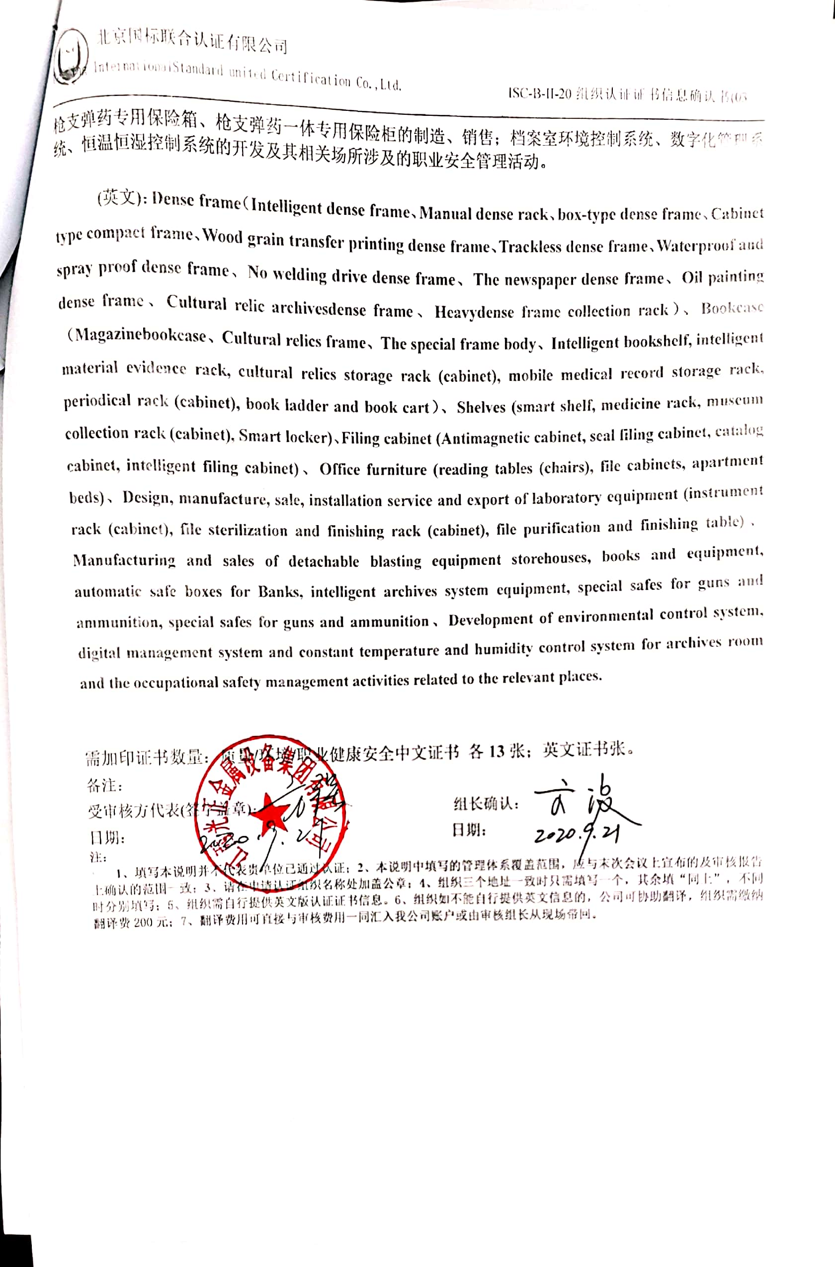

**(英文)：Dense frame（Intelligent dense frame、Manual dense rack、box-type dense frame、Cabinet type compact frame、Wood grain transfer printing dense frame、Trackless dense frame、Waterproof and spray proof dense frame、No welding drive dense frame、The newspaper dense frame、Oil painting dense frame、Cultural relic archivesdense frame、Heavydense frame collection rack）、Bookcase（Magazinebookcase、Cultural relics frame、The special frame body、Intelligent bookshelf, intelligent material evidence rack, cultural relics storage rack (cabinet), mobile medical record storage rack, periodical rack (cabinet), book ladder and book cart）、Shelves (smart shelf, medicine rack, museum collection rack (cabinet), Smart locker)、Filing cabinet (Antimagnetic cabinet, seal filing cabinet, catalog cabinet, intelligent filing cabinet)、Office furniture (reading tables (chairs), file cabinets, apartment beds)、Design, manufacture, sale, installation service and export of laboratory equipment (instrument rack (cabinet), file sterilization and finishing rack (cabinet), file purification and finishing table)、Manufacturing and sales of detachable blasting equipment storehouses, books and equipment, automatic safe boxes for Banks, intelligent archives system equipment, special safes for guns and ammunition, special safes for guns and ammunition、Development of environmental control system, digital management system and constant temperature and humidity control system for archives room and the occupational safety management activities related to the relevant places.**

**需加印证书数量：质量/环境/职业健康安全中文证书各13张；英文证书张。**

**备注：**

**受审核方代表(签字盖章)： 组长确认：**

**日期： 日期：**

**注：**

**1、填写本说明并不代表贵单位已通过认证；2、本说明中填写的管理体系覆盖范围，应与末次会议上宣布的及审核报告上确认的范围一致；3、请在申请认证组织名称处加盖公章；4、组织三个地址一致时只需填写一个，其余填“同上”，不同时分别填写；5、组织需自行提供英文版认证证书信息。6、组织如不能自行提供英文信息的，公司可协助翻译，组织需缴纳翻译费200元；7、翻译费用可直接与审核费用一同汇入我公司账户或由审核组长从现场带回。**