**合同编号.:** 0479-2020-QEO

**组织认证证书信息确认书**

**为保证认证证书准确反映组织实际情况及管理体系特点，请将组织准确名称、地址、体系覆盖范围等有关信息正式表述如下，以便打印认证证书时作为依据。**

**组织名称 (中文)：****山东艺财科教设备有限公司**

**(英文)：****Shandong yicai science education equipment co., ltd.**

**组织注册地址(中文)：****山东省菏泽市鄄城县人民路南、鄄六路西 邮编:** **274600**

**(英文)：South Renmin Road and West Juanliu Road, Juancheng County, Heze City, Shandong Province.**

**□组织经营地址(中文)：****山东省菏泽市鄄城县人民路南、鄄六路西 邮编:****274600**

**(英文)：South Renmin Road and West Juanliu Road, Juancheng County, Heze City, Shandong Province.**

**□组织经营地址1(中文)： 邮编:**

**(英文)：**

**组织机构代码证号（社会信用号）：****91371726MA3CJQQC10 传真：** **电话.：****15005405999**

**法人代表：****冯爱荣 管代/联系人(职务)：****王志业 组织人数：** **10**

**认证标准：****Q：GB/T19001-2016/ISO9001:2015,E：GB/T 24001-2016/ISO14001:2015,O：GB/T45001-2020 / ISO45001：2018认证类型：****Q:二阶段,E:二阶段,O:二阶段**

**变更内容：□组织名称变更□地址变更□认证范围变更（□扩大□缩小）**

**认证范围：**

**Q：教学仪器、实验室设备、音体美卫劳器材、健身器材、探究仪器、幼儿玩具及教具、课桌椅、床、仪器橱柜、公寓家俱、办公家俱、办公用品、厨房设备、心理咨询室设备、图书阅览设备、职教实训设备、电子设备（多媒体、数字化）、教室设备（书法、地理、历史）、环保仪器、玻璃仪器、学生服装的销售**

**E：教学仪器、实验室设备、音体美卫劳器材、健身器材、探究仪器、幼儿玩具及教具、课桌椅、床、仪器橱柜、公寓家俱、办公家俱、办公用品、厨房设备、心理咨询室设备、图书阅览设备、职教实训设备、电子设备（多媒体、数字化）、教室设备（书法、地理、历史）、环保仪器、玻璃仪器、学生服装的销售及所涉及场所的环境管理活动**

**O：教学仪器、实验室设备、音体美卫劳器材、健身器材、探究仪器、幼儿玩具及教具、课桌椅、床、仪器橱柜、公寓家俱、办公家俱、办公用品、厨房设备、心理咨询室设备、图书阅览设备、职教实训设备、电子设备（多媒体、数字化）、教室设备（书法、地理、历史）、环保仪器、玻璃仪器、学生服装的销售及所涉及场所的职业健康安全管理活动**

**英文：**

**Q:Teaching equipment, laboratory equipment, music, beauty, health and labor equipment, fitness equipment, inquiry equipment, children's toys and teaching AIDS, desks and chairs, beds, instrument cabinets, apartment furniture, office furniture, office supplies, kitchen equipment, psychological consultation room equipment, book reading equipment, vocational training equipment, electronic equipment (multimedia, digital), classroom equipment (calligraphy, geography, history), environmental protection equipment.**

**E:Teaching equipment, laboratory equipment, music, beauty, health and labor equipment, fitness equipment, inquiry equipment, children's toys and teaching AIDS, desks and chairs, beds, instrument cabinets, apartment furniture, office furniture, office supplies, kitchen equipment, psychological consultation room equipment, book reading equipment, vocational training equipment, electronic equipment (multimedia, digital), classroom equipment (calligraphy, geography, history), environmental protection equipment.**

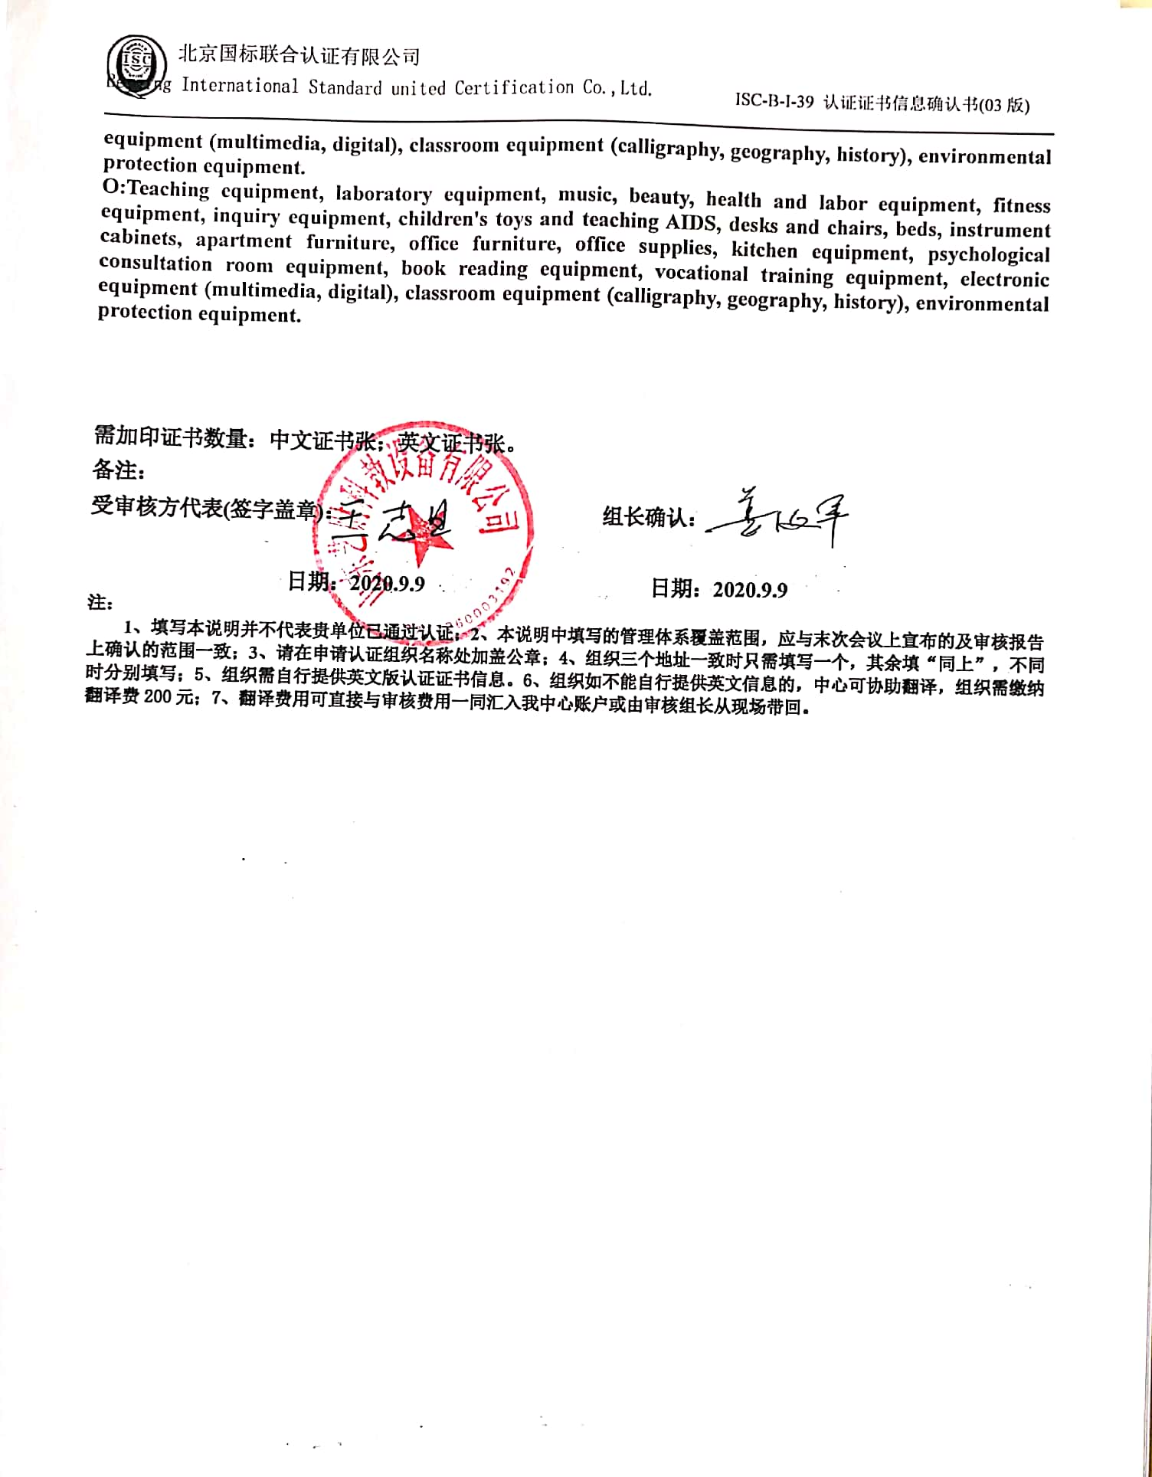**O:Teaching equipment, laboratory equipment, music, beauty, health and labor equipment, fitness equipment, inquiry equipment, children's toys and teaching AIDS, desks and chairs, beds, instrument cabinets, apartment furniture, office furniture, office supplies, kitchen equipment, psychological consultation room equipment, book reading equipment, vocational training equipment, electronic equipment (multimedia, digital), classroom equipment (calligraphy, geography, history), environmental protection equipment.**

**需加印证书数量：中文证书张；英文证书张。**

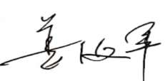**备注：**

**受审核方代表(签字盖章)： 组长确认：**

**日期：2020.9.9 日期：2020.9.9**

**注：**

**1、填写本说明并不代表贵单位已通过认证；2、本说明中填写的管理体系覆盖范围，应与末次会议上宣布的及审核报告上确认的范围一致；3、请在申请认证组织名称处加盖公章；4、组织三个地址一致时只需填写一个，其余填“同上”，不同时分别填写；5、组织需自行提供英文版认证证书信息。6、组织如不能自行提供英文信息的，中心可协助翻译，组织需缴纳翻译费200元；7、翻译费用可直接与审核费用一同汇入我中心账户或由审核组长从现场带回。**