**合同编号:****0146-2019-QEO-2020**

**组织认证证书信息确认书**

**为保证认证证书准确反映组织实际情况及管理体系特点，请将组织准确名称、地址、体系覆盖范围等有关信息正式表述如下，以便打印认证证书时作为依据。**

组织名称：成安县优胜教育科技有限公司

英文: Chengan Yousheng Education Technology Co. LTD

注册地址：河北省邯郸市成安县高庄村 邮编056700

英文: Gaozhuang Village, Chengan County, Handan City, Hebei Province

经营地址：河北省邯郸市成安县学院路与一环路交叉口北20米 邮编056700

英文: 20 meters north of the intersection of Xueyuan Road and Yihuan Road, Chengan County, Handan City, Hebei Province

**组织机构代码证号（社会信用号）：****91130424MA08HRHU4W 传真：** **电话.：****15132030625**

**法人代表：管代/联系人(职务)：****靳少波组织人数：****Q:10,E:10,O:10**

**认证标准：****■ GB/T 19001-2016 idt ISO 9001:2015标准 (不适用：条款)**

**□ GB/T 50430-2017 (不适用： 条款)；**

**■ GB/T 24001-2016 idt ISO 14001:2015标准；**

**□GB/T 28001-2011 idt OHSMS 18001:2007标准；**

**■ GB/T 45001-2020 idtISO45001:2018；**

**认证类型：****Q:监查1,E:监查1,O:监查1**

**变更内容：□组织名称变更□地址变更□认证范围变更（□扩大□缩小）**

☑QMS 中文: **QMS:** 教学仪器、多媒体教学设备、幼儿玩具、实验室设备和仪器、办公家具、厨房设备、学生课桌椅、床、心理咨询室设备、音体美器材、录播教室设备、教学一体机、数字化教室、电子显示屏、办公用品、白板一体机和软硬件的销售；

英文：Instrument, the multimedia teaching equipment, children's toys, laboratory equipment and instruments, office furniture, kitchen equipment, student desks and chairs, bed, psychological consulting room, the sound body beauty equipment, recorded the classroom equipment, digital classrooms, teaching machine, electronic display screen, and office supplies, board machine software and hardware sales.

☑EMS中文:

**EMS:** 教学仪器、多媒体教学设备、幼儿玩具、实验室设备和仪器、办公家具、厨房设备、学生课桌椅、床、心理咨询室设备、音体美器材、录播教室设备、教学一体机、数字化教室、电子显示屏、办公用品、白板一体机和软硬件的销售及所涉及场所的相关环境管理活动；

EMS: **Instrument, the multimedia teaching equipment, children's toys, laboratory equipment and instruments, office furniture, kitchen equipment, student desks and chairs, bed, psychological consulting room equipment, sound body beauty equipment, recorded the classroom equipment, digital classrooms, teaching machine, electronic display screen and the hardware and software sales, office supplies, board machine and the environment management activities of the location involved.**

**OHSMS**中文**:** 教学仪器、多媒体教学设备、幼儿玩具、实验室设备和仪器、办公家具、厨房设备、学生课桌椅、床、心理咨询室设备、音体美器材、录播教室设备、教学一体机、数字化教室、电子显示屏、办公用品、白板一体机和软硬件的销售及所涉及场所的相关职业健康安全管理活动。

英文：

**OHSMS: Instrument, the multimedia teaching equipment, children's toys, laboratory equipment and instruments, office furniture, kitchen equipment, student desks and chairs, bed, psychological consulting room equipment, sound body beauty equipment, recorded the classroom equipment, digital classrooms, teaching machine, electronic display screen and the hardware and software sales, office supplies, board machine and occupational health and safety management activities of the location involved**.

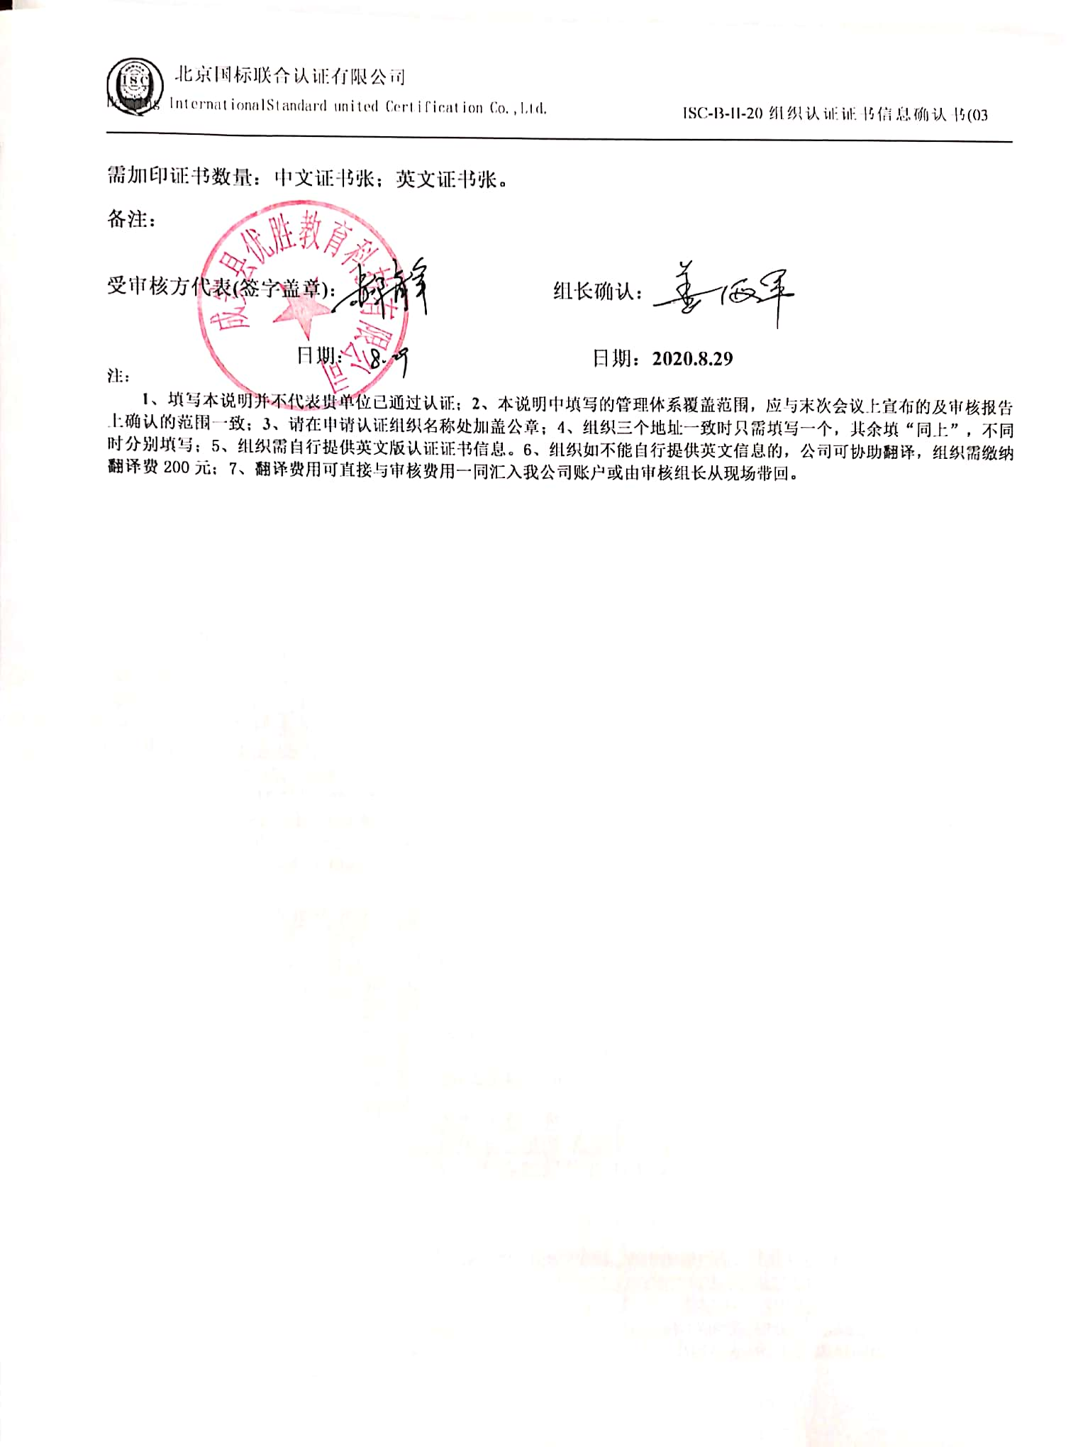

**需加印证书数量：中文证书张；英文证书张。**

**备注：**



**受审核方代表(签字盖章)： 组长确认：**

**日期： 日期：2020.8.29**

**注：**

**1、填写本说明并不代表贵单位已通过认证；2、本说明中填写的管理体系覆盖范围，应与末次会议上宣布的及审核报告上确认的范围一致；3、请在申请认证组织名称处加盖公章；4、组织三个地址一致时只需填写一个，其余填“同上”，不同时分别填写；5、组织需自行提供英文版认证证书信息。6、组织如不能自行提供英文信息的，公司可协助翻译，组织需缴纳翻译费200元；7、翻译费用可直接与审核费用一同汇入我公司账户或由审核组长从现场带回。**