**合同编号.:****0328-2020-QEO**

**组织认证证书信息确认书**

**为保证认证证书准确反映组织实际情况及管理体系特点，请将组织准确名称、地址、体系覆盖范围等有关信息正式表述如下，以便打印认证证书时作为依据。**

**组织名称 (中文)：****山东鄄城同心科教仪器设备有限公司**

**(英文)：****Shandong juancheng Tongxin science education instrument equipment co., ltd.**

**组织注册地址(中文)：****山东省菏泽市鄄城县富春乡大史庄行政村大史庄村北20米路南 邮编:** **274600**

**(英文)：20 meters north of Dashizhuang Village, Dashizhuang Administrative Village, Fuchun Township, Juancheng County, Heze City, Shandong Province.**

**□组织经营地址(中文)：****山东省菏泽市牡丹区天华电商物流园众创空间A112 邮编:****274600**

**(英文)：A112, Zhongchuang Space, Tianhua Dianshang Logistics Park, Mudan District, Heze City, Shandong Province.**

**□组织经营地址1(中文)： 邮编:**

**(英文)：**

**组织机构代码证号（社会信用号）：****91371726312907971J 传真：** **电话.：****18364009992**

**法人代表：****刘素兰 管代/联系人(职务)：****刘素环 组织人数：** **12**

**认证标准：****Q：GB/T19001-2016/ISO9001:2015,E：GB/T 24001-2016/ISO14001:2015,O：GB/T45001-2020 / ISO45001：2018认证类型：****Q:二阶段,E:二阶段,O:二阶段**

**变更内容：□组织名称变更□地址变更□认证范围变更（□扩大□缩小）**

**Q：教学仪器、实验室成套设备、学生课桌椅、音体美卫器材、幼教器材、玻璃仪器、多媒体教学设备、计算机及设备、办公家具、公寓家具、净水设备、消防器材、环保无尘粉笔的销售**

**E：教学仪器、实验室成套设备、学生课桌椅、音体美卫器材、幼教器材、玻璃仪器、多媒体教学设备、计算机及设备、办公家具、公寓家具、净水设备、消防器材、环保无尘粉笔的销售所涉及场所的相关环境管理活动**

**O：教学仪器、实验室成套设备、学生课桌椅、音体美卫器材、幼教器材、玻璃仪器、多媒体教学设备、计算机及设备、办公家具、公寓家具、净水设备、消防器材、环保无尘粉笔的销售所涉及场所的相关职业健康安全管理活动**

**英文：**

**Q:Sales of teaching instruments, complete sets of laboratory equipment, students' desks and chairs, musical, physical, aesthetic and health equipment, preschool education equipment, glass instruments, multimedia teaching equipment, computers and equipment, office furniture, apartment furniture, water purification equipment, fire fighting equipment and environmental protection dust-free chalk.**

**E:Environmental management activities in places involved in the sales of teaching instruments, laboratory equipment, students' desks and chairs, musical, physical, aesthetic and health equipment, preschool education equipment, glass instruments, multimedia teaching equipment, computers and equipment, office furniture, apartment furniture, water purification equipment, fire fighting equipment and environmental protection dust-free chalk.**

**O:Relevant occupational health and safety management activities in places involved in the sales of teaching instruments, laboratory equipment, students' desks and chairs, music, sports, beauty and health equipment, preschool education equipment, glass instruments, multimedia teaching equipment, computers and equipment, office furniture, apartment furniture, water purification equipment, fire fighting equipment and environmental protection dust-free chalk.**

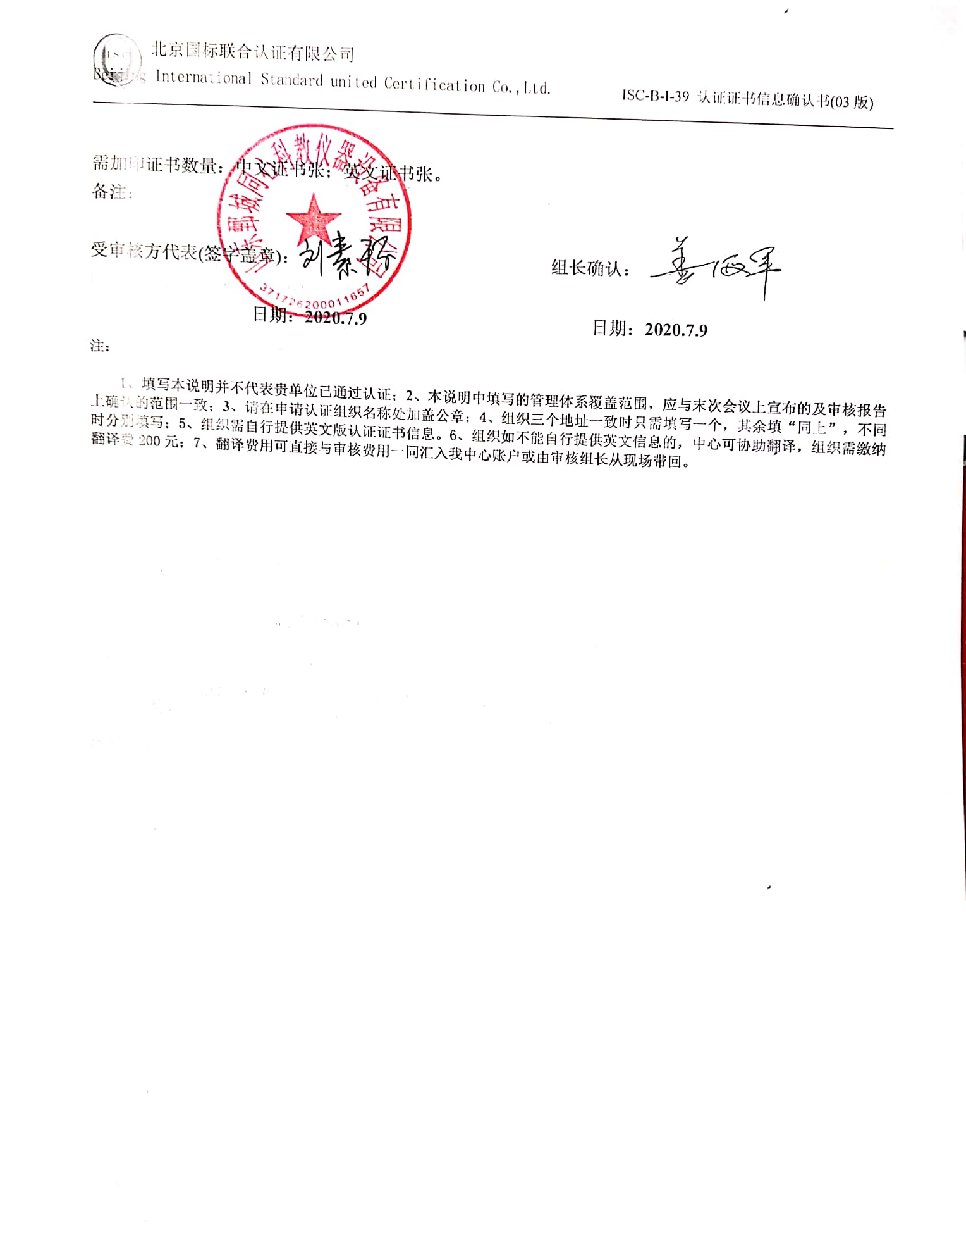

**需加印证书数量：中文证书张；英文证书张。**

**备注：**



**受审核方代表(签字盖章)： 组长确认：**

**日期：2020.7.9 日期：2020.7.9**

**注：**

**1、填写本说明并不代表贵单位已通过认证；2、本说明中填写的管理体系覆盖范围，应与末次会议上宣布的及审核报告上确认的范围一致；3、请在申请认证组织名称处加盖公章；4、组织三个地址一致时只需填写一个，其余填“同上”，不同时分别填写；5、组织需自行提供英文版认证证书信息。6、组织如不能自行提供英文信息的，中心可协助翻译，组织需缴纳翻译费200元；7、翻译费用可直接与审核费用一同汇入我中心账户或由审核组长从现场带回。**