**合同编号.:0254-2020-QEO**

**组织认证证书信息确认书**

**为保证认证证书准确反映组织实际情况及管理体系特点，请将组织准确名称、地址、体系覆盖范围等有关信息正式表述如下，以便打印认证证书时作为依据。**

**组织名称 (中文)：****江西锐盾智能科技有限公司**

**(英文)：****Jiangxi ruidun Intelligent Technology Co., Ltd**

**组织注册地址(中文)：****江西省宜春市樟树市观上镇观中路6号 邮编:** **331207**

**(英文)：No. 6, Guanzhong Road, Guanshang Town, Zhangshu City, Yichun City, Jiangxi Province**

**□组织经营地址(中文)：****江西省樟树市盐城大道锦绣江南19-25 邮编:****331200**

**(英文)：19-25 Jinxiu Jiangnan, Yancheng Avenue, Zhangshu City, Jiangxi Province**

**□组织经营地址1(中文)： 邮编:**

**(英文)：**

**组织机构代码证号（社会信用号）：****91360982MA35QYMT9T传真：****电话.：****0795-7838886**

**法人代表：****聂林管代/联系人(职务)：****赖艳华组织人数：** **10**

**认证标准：****Q：GB/T 19001-2016idtISO 9001:2015,E：GB/T 24001-2016idtISO 14001:2015,O：GB/T45001—2020/ISO 45001:2018**

**认证类型：****Q:二阶段,E:二阶段,O:二阶段**

**变更内容：□组织名称变更□地址变更□认证范围变更（□扩大□缩小）**

**Q：警用装备（防弹服、防刺服、防弹头盔、防爆盾牌、警棍、强光手电、执法记录仪、伸缩抓捕器、阻车路障器、智能枪弹柜、居民身份证自助申领机、居民身份证自助领证机）、射击器械及器材（靶场设备、报靶系统）、安防设备（无人机、无人机干扰拦截仪、排爆干扰仪、金属探测门、X射线安全检查设备、液体探测仪、物证柜）、医疗设备（法医解剖台）、实验室设备（实验室台（桌））、密集架、书架、货架的销售**

**(英文)：Sales of police equipment (bullet proof clothing, stab proof clothing, bullet proof helmet, explosion-proof shield, baton, flashlight, law enforcement recorder, retractable catcher, roadblock, smart gun and ammunition cabinet, self-service application machine for resident ID card, self-service license machine for resident ID card) police equipment (bullet proof clothing, stab proof clothing, bullet proof helmet, explosion-proof shield, baton, flashlight, law enforcement recorder) , retractable grabber, roadblock, smart bullet cabinet, ID card self application machine, ID card self application machine, shooting equipment and equipment (shooting range equipment, target reporting system), security equipment (UAV, UAV interference interceptor, explosion elimination jammer, metal detection door, X-ray safety inspection equipment, liquid detector, physical evidence cabinet), medical equipment （forensic anatomy table）, laboratory equipment (laboratory table), intensive shelves, bookshelves and shelves**

**E：警用装备（防弹服、防刺服、防弹头盔、防爆盾牌、警棍、强光手电、执法记录仪、伸缩抓捕器、阻车路障器、智能枪弹柜、居民身份证自助申领机、居民身份证自助领证机）、射击器械及器材（靶场设备、报靶系统）、安防设备（无人机、无人机干扰拦截仪、排爆干扰仪、金属探测门、X射线安全检查设备、液体探测仪、物证柜）、医疗设备（法医解剖台）、实验室设备（实验室台（桌））、密集架、书架、货架的销售及其所涉及的相关环境管理活动**

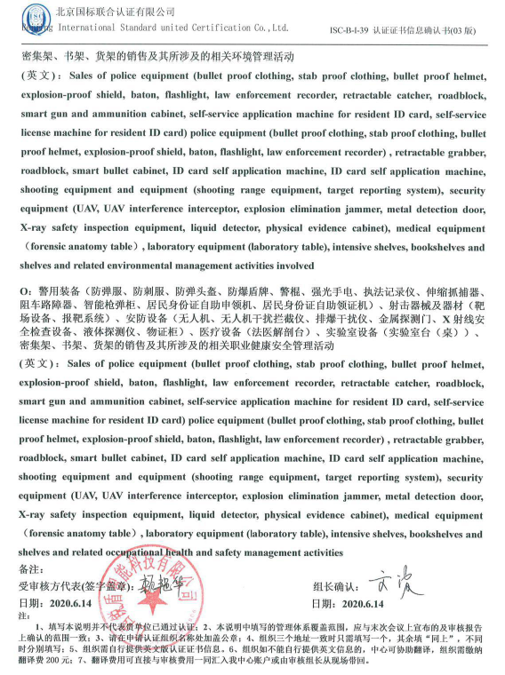**(英文)：Sales of police equipment (bullet proof clothing, stab proof clothing, bullet proof helmet, explosion-proof shield, baton, flashlight, law enforcement recorder, retractable catcher, roadblock, smart gun and ammunition cabinet, self-service application machine for resident ID card, self-service license machine for resident ID card) police equipment (bullet proof clothing, stab proof clothing, bullet proof helmet, explosion-proof shield, baton, flashlight, law enforcement recorder) , retractable grabber, roadblock, smart bullet cabinet, ID card self application machine, ID card self application machine, shooting equipment and equipment (shooting range equipment, target reporting system), security equipment (UAV, UAV interference interceptor, explosion elimination jammer, metal detection door, X-ray safety inspection equipment, liquid detector, physical evidence cabinet), medical equipment （forensic anatomy table）, laboratory equipment (laboratory table), intensive shelves, bookshelves and shelvesand related environmental management activities involved**

**O：警用装备（防弹服、防刺服、防弹头盔、防爆盾牌、警棍、强光手电、执法记录仪、伸缩抓捕器、阻车路障器、智能枪弹柜、居民身份证自助申领机、居民身份证自助领证机）、射击器械及器材（靶场设备、报靶系统）、安防设备（无人机、无人机干扰拦截仪、排爆干扰仪、金属探测门、X射线安全检查设备、液体探测仪、物证柜）、医疗设备（法医解剖台）、实验室设备（实验室台（桌））、密集架、书架、货架的销售及其所涉及的相关职业健康安全管理活动**

**(英文)：Sales of police equipment (bullet proof clothing, stab proof clothing, bullet proof helmet, explosion-proof shield, baton, flashlight, law enforcement recorder, retractable catcher, roadblock, smart gun and ammunition cabinet, self-service application machine for resident ID card, self-service license machine for resident ID card) police equipment (bullet proof clothing, stab proof clothing, bullet proof helmet, explosion-proof shield, baton, flashlight, law enforcement recorder) , retractable grabber, roadblock, smart bullet cabinet, ID card self application machine, ID card self application machine, shooting equipment and equipment (shooting range equipment, target reporting system), security equipment (UAV, UAV interference interceptor, explosion elimination jammer, metal detection door, X-ray safety inspection equipment, liquid detector, physical evidence cabinet), medical equipment （forensic anatomy table）, laboratory equipment (laboratory table), intensive shelves, bookshelves and shelvesand related occupational health and safety management activities**

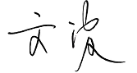**备注：**

**受审核方代表(签字盖章)： 组长确认：**

**日期： 日期：2020.6.14**

**注：**

**1、填写本说明并不代表贵单位已通过认证；2、本说明中填写的管理体系覆盖范围，应与末次会议上宣布的及审核报告上确认的范围一致；3、请在申请认证组织名称处加盖公章；4、组织三个地址一致时只需填写一个，其余填“同上”，不同时分别填写；5、组织需自行提供英文版认证证书信息。6、组织如不能自行提供英文信息的，中心可协助翻译，组织需缴纳翻译费200元；7、翻译费用可直接与审核费用一同汇入我中心账户或由审核组长从现场带回。**