**合同编号.:**0198-2020-QEO

**组织认证证书信息确认书**

**为保证认证证书准确反映组织实际情况及管理体系特点，请将组织准确名称、地址、体系覆盖范围等有关信息正式表述如下，以便打印认证证书时作为依据。**

**组织名称 (中文)：****山东瑞龙仪器设备有限公司**

**(英文)：****Shandong Ruilong Instrument and Equipment Co., Ltd.**

**组织注册地址(中文)：****山东省菏泽市牡丹区长城路88号 邮编:** **274000**

**(英文)：88 Changcheng Road, Mudan District, Heze City, Shandong Province.**

**□组织经营地址(中文)：****山东省菏泽市牡丹区长城路88号 邮编:****274000**

**(英文)：88 Changcheng Road, Mudan District, Heze City, Shandong Province.**

**□组织经营地址1(中文)： 邮编:**

**(英文)：**

**组织机构代码证号（社会信用号）：****91371702MA3DP8U70M 传真：** **电话.：****13954054081**

**法人代表：****田合云 管代/联系人(职务)：****路明 组织人数：** **6**

**认证标准：****Q：GB/T 19001-2016idtISO 9001:2015,E：GB/T 24001-2016idtISO 14001:2015,O：GB/T45001—2020/ISO 45001:2018认证类型：****Q:二阶段,E:二阶段,O:二阶段**

**变更内容：□组织名称变更□地址变更□认证范围变更（□扩大□缩小）**

**Q：教学仪器、实验室设备、课桌椅、音体美器材、健身器材、幼儿园教具、多媒体教室设备、厨房设备、心理咨询设备、教育机器人、广播设备、音响设备、电视设备、空调设备、水处理设备及耗材、消防器材、监控设备、安保器材(不含警用器材)、塑胶跑道、计算机及软硬件的销售**

**E：教学仪器、实验室设备、课桌椅、音体美器材、健身器材、幼儿园教具、多媒体教室设备、厨房设备、心理咨询设备、教育机器人、广播设备、音响设备、电视设备、空调设备、水处理设备及耗材、消防器材、监控设备、安保器材(不含警用器材)、塑胶跑道、计算机及软硬件的销售所涉及场所的相关环境管理活动**

**O：教学仪器、实验室设备、课桌椅、音体美器材、健身器材、幼儿园教具、多媒体教室设备、厨房设备、心理咨询设备、教育机器人、广播设备、音响设备、电视设备、空调设备、水处理设备及耗材、消防器材、监控设备、安保器材(不含警用器材)、塑胶跑道、计算机及软硬件的销售所涉及场所的相关职业健康安全管理活动**

**英文：**

**Q: Sales of teaching instruments, laboratory equipment, desks and chairs, audio and sports equipment, fitness equipment, kindergarten teaching aids, multimedia classroom equipment, kitchen equipment, psychological consultation equipment, educational robots, broadcasting equipment, audio equipment, television equipment, air conditioning equipment, water treatment equipment and consumables, fire fighting equipment, monitoring equipment, security equipment (excluding police equipment), plastic runways, computers and software and hardware.**

**E:Environmental management activities related to places involved in the sales of teaching instruments, laboratory equipment, desks and chairs, audio and sports equipment, fitness equipment, kindergarten teaching aids, multimedia classroom equipment, kitchen equipment, psychological consultation equipment, educational robots, broadcasting equipment, audio equipment, television equipment, air conditioning equipment, water treatment equipment and consumables, fire fighting equipment, monitoring equipment, security equipment (excluding police equipment), plastic runways, computers and software and hardware.**

**O:Relevant occupational health and safety management activities in places involved in the sales of teaching instruments, laboratory equipment, desks and chairs, audio and sports equipment, fitness equipment, kindergarten teaching aids, multimedia classroom equipment, kitchen equipment, psychological consultation equipment, educational robots, broadcasting equipment, audio equipment, television equipment, air conditioning equipment, water treatment equipment and consumables, fire fighting equipment, monitoring equipment, security equipment (excluding police equipment), plastic runways, computers and software and hardware.**

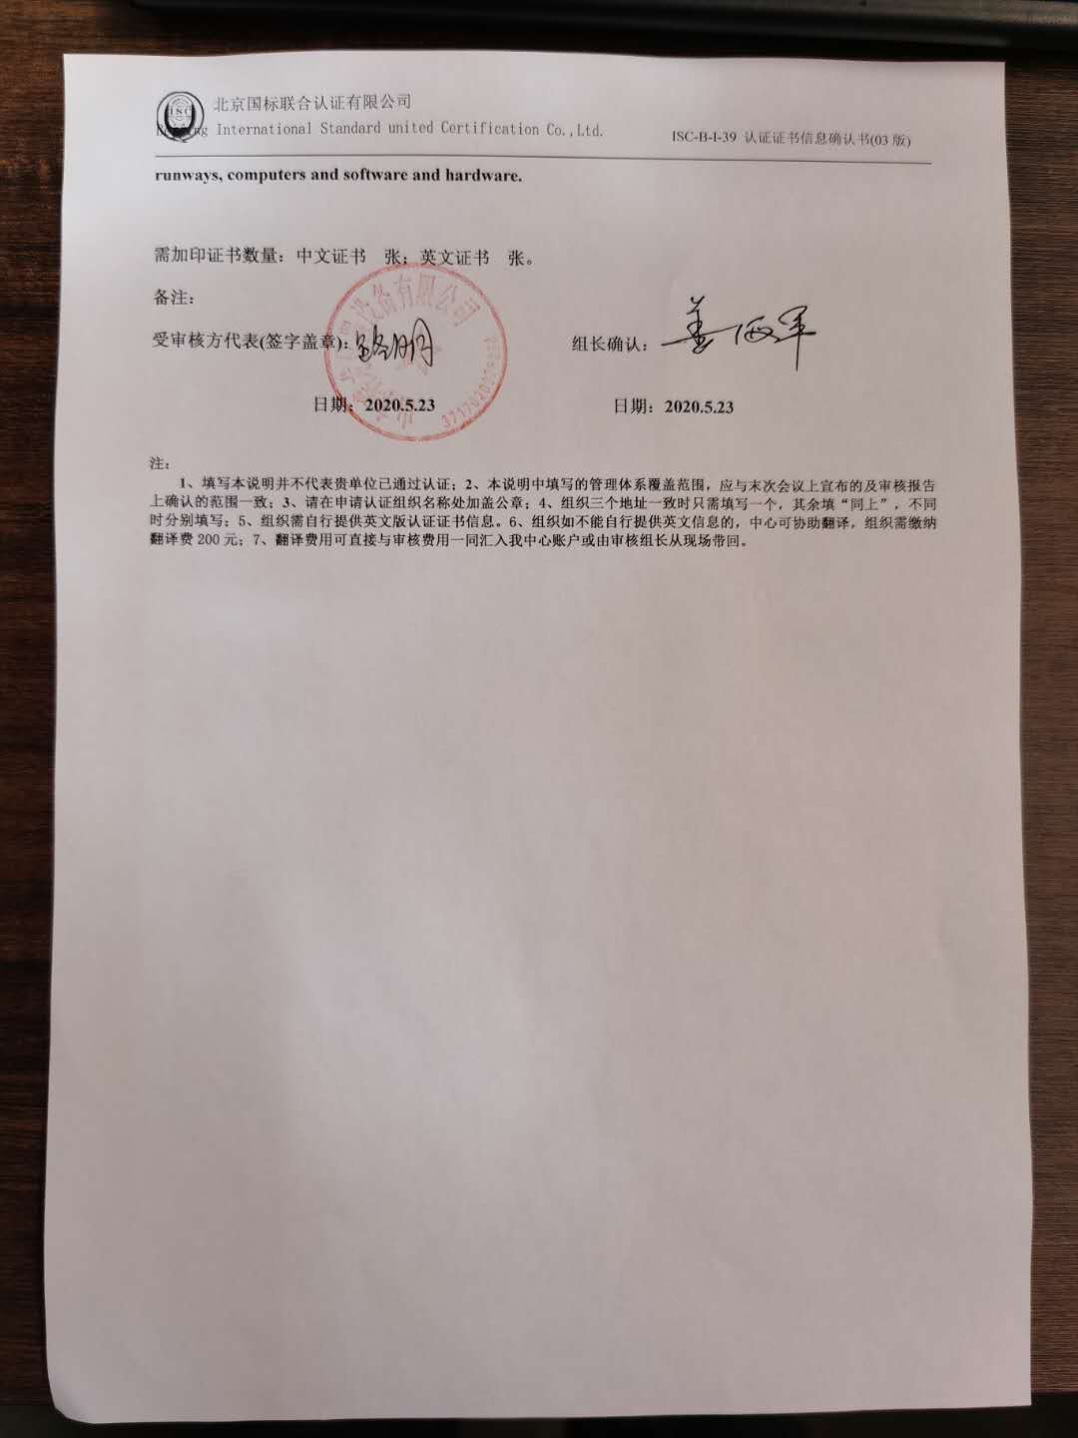

**需加印证书数量：中文证书 张；英文证书 张。**

**备注：**

**受审核方代表(签字盖章)： 组长确认：**

**日期：2020.5.23 日期：2020.5.23**

**注：**

**1、填写本说明并不代表贵单位已通过认证；2、本说明中填写的管理体系覆盖范围，应与末次会议上宣布的及审核报告上确认的范围一致；3、请在申请认证组织名称处加盖公章；4、组织三个地址一致时只需填写一个，其余填“同上”，不同时分别填写；5、组织需自行提供英文版认证证书信息。6、组织如不能自行提供英文信息的，中心可协助翻译，组织需缴纳翻译费200元；7、翻译费用可直接与审核费用一同汇入我中心账户或由审核组长从现场带回。**