**合同编号.:**0150-2020-QEO

**组织认证证书信息确认书**

**为保证认证证书准确反映组织实际情况及管理体系特点，请将组织准确名称、地址、体系覆盖范围等有关信息正式表述如下，以便打印认证证书时作为依据。**

**组织名称 (中文)：****江西金信科技集团有限公司**

**(英文)：** **Jiangxi Jinxin Technology Group Co., Ltd.**

**组织注册地址(中文)：****江西省宜春市樟树市城北经济技术开发区 邮编:** **331200**

**(英文)：Chengbei Economic and Technological Development Zone, Zhangshu City, Yichun City, Jiangxi Province**

**□组织经营地址(中文)：****江西省宜春市樟树市城北经济技术开发区 邮编:****331200**

**(英文)：Chengbei Economic and Technological Development Zone, Zhangshu City, Yichun City, Jiangxi Province**

**□组织经营地址1(中文)：江西省宜春市樟树市锦绣江南 邮编:331200**

**(英文)： Jinxiu Jiangnan, Zhangshu City, Yichun City, Jiangxi Province**

**组织机构代码证号（社会信用号）：****91360982MA35J9JKXA 传真：** **电话.：****0795-7878588**

**法人代表：****聂美良 管代/联系人(职务)：****邹林如 组织人数：** **45**

**认证标准：****Q：GB/T 19001-2016idtISO 9001:2015,E：GB/T 24001-2016idtISO 14001:2015,O：GB/T45001—2020/ISO 45001:2018认证类型：****Q:二阶段,E:二阶段,O:二阶段**

**变更内容：□组织名称变更□地址变更□认证范围变更（□扩大□缩小）**

**Q：办公家具（办公桌、办公椅）；钢木家具（钢（木）公寓床、钢（木）书架、钢（木）期刊架（柜）、钢（木）阅览桌（椅）、钢（木）展柜）；公交候车亭、智能公交电子站牌、课桌（椅）、军用床、智能型密集架、智能型书架、手动密集架、博物馆珍藏架、文物柜（架）、重型货架、药品架（柜）、文件柜、防磁柜、保险柜、智能枪（弹）柜、金库门、活动库房、爆炸危险品移动库房、智能存放架、电脑桌（椅）、会议桌（椅）、培训桌（椅）、茶水柜、古籍书柜、字画箱（柜）、服务台、讲台的设计、生产制造及环卫设备（垃圾箱、垃圾桶、环卫车）、教学仪器设备的销售**

**E：办公家具（办公桌、办公椅）；钢木家具（钢（木）公寓床、钢（木）书架、钢（木）期刊架（柜）、钢（木）阅览桌（椅）、钢（木）展柜）；公交候车亭、智能公交电子站牌、课桌（椅）、军用床、智能型密集架、智能型书架、手动密集架、博物馆珍藏架、文物柜（架）、重型货架、药品架（柜）、文件柜、防磁柜、保险柜、智能枪（弹）柜、金库门、活动库房、爆炸危险品移动库房、智能存放架、电脑桌（椅）、会议桌（椅）、培训桌（椅）、茶水柜、古籍书柜、字画箱（柜）、服务台、讲台的设计、生产制造及环卫设备（垃圾箱、垃圾桶、环卫车）、教学仪器设备的销售所涉及的相关环境管理活动**

**O：办公家具（办公桌、办公椅）；钢木家具（钢（木）公寓床、钢（木）书架、钢（木）期刊架（柜）、钢（木）阅览桌（椅）、钢（木）展柜）；公交候车亭、智能公交电子站牌、课桌（椅）、军用床、智能型密集架、智能型书架、手动密集架、博物馆珍藏架、文物柜（架）、重型货架、药品架（柜）、文件柜、防磁柜、保险柜、智能枪（弹）柜、金库门、活动库房、爆炸危险品移动库房、智能存放架、电脑桌（椅）、会议桌（椅）、培训桌（椅）、茶水柜、古籍书柜、字画箱（柜）、服务台、讲台的设计、生产制造及环卫设备（垃圾箱、垃圾桶、环卫车）、教学仪器设备的销售所涉及的职业健康安全管理活动**

**Q：Office furniture (desk, office chair); steel and wood furniture (steel (wood) apartment bed, steel (wood) bookshelf, steel (wood) periodical shelf (cabinet), steel (wood) reading table (chair), steel (wood) display cabinet); bus waiting booth, smart bus electronic station board, desk (chair), military bed, intelligent dense rack, intelligent bookshelf, manual dense rack, museum collection rack, cultural relic cabinet (shelf), heavy duty shelf, medicine rack (cabinet), filing cabinet, anti-magnetic cabinet, safe, intelligent gun (bomb) cabinet, gold storehouse door, activity storehouse, explosive dangerous goods moving storehouse, intelligent rack, computer desk (chair), conference table (chair), training table (chair) Tea cabinets, ancient bookcases, calligraphy and painting boxes (cabinets), service desks, podium design, manufacturing and sanitation equipment (garbage bins, garbage cans, sanitation vehicles), teaching equipment sales**

**E：Office furniture (desk, office chair); steel and wood furniture (steel (wood) apartment bed, steel (wood) bookshelf, steel (wood) periodical shelf (cabinet), steel (wood) reading table (chair), steel (wood) display cabinet); bus waiting booth, smart bus electronic station board, desk (chair), military bed, intelligent dense rack, intelligent bookshelf, manual dense rack, museum collection rack, cultural relic cabinet (shelf), heavy duty shelf, medicine rack (cabinet), filing cabinet, anti-magnetic cabinet, safe, intelligent gun (bomb) cabinet, gold storehouse door, activity storehouse, explosive dangerous goods moving storehouse, intelligent rack, computer desk (chair), conference table (chair), training table (chair)**

**O：Office furniture (desk, office chair); steel and wood furniture (steel (wood) apartment bed, steel (wood) bookshelf, steel (wood) periodical shelf (cabinet), steel (wood) reading table (chair), steel (wood) display cabinet); bus waiting booth, smart bus electronic station board, desk (chair), military bed, intelligent dense rack, intelligent bookshelf, manual dense rack, museum collection rack, cultural relic cabinet (shelf), heavy duty shelf, medicine rack (cabinet), filing cabinet, anti-magnetic cabinet, safe, intelligent gun (bomb) cabinet, gold storehouse door, activity storehouse, explosive dangerous goods moving storehouse, intelligent rack, computer desk (chair), conference table (chair), training table (chair) Occupational health and safety management activities related to the design, production and manufacture of tea cabinets, ancient book bookcases, calligraphy and painting boxes (cabinets), service 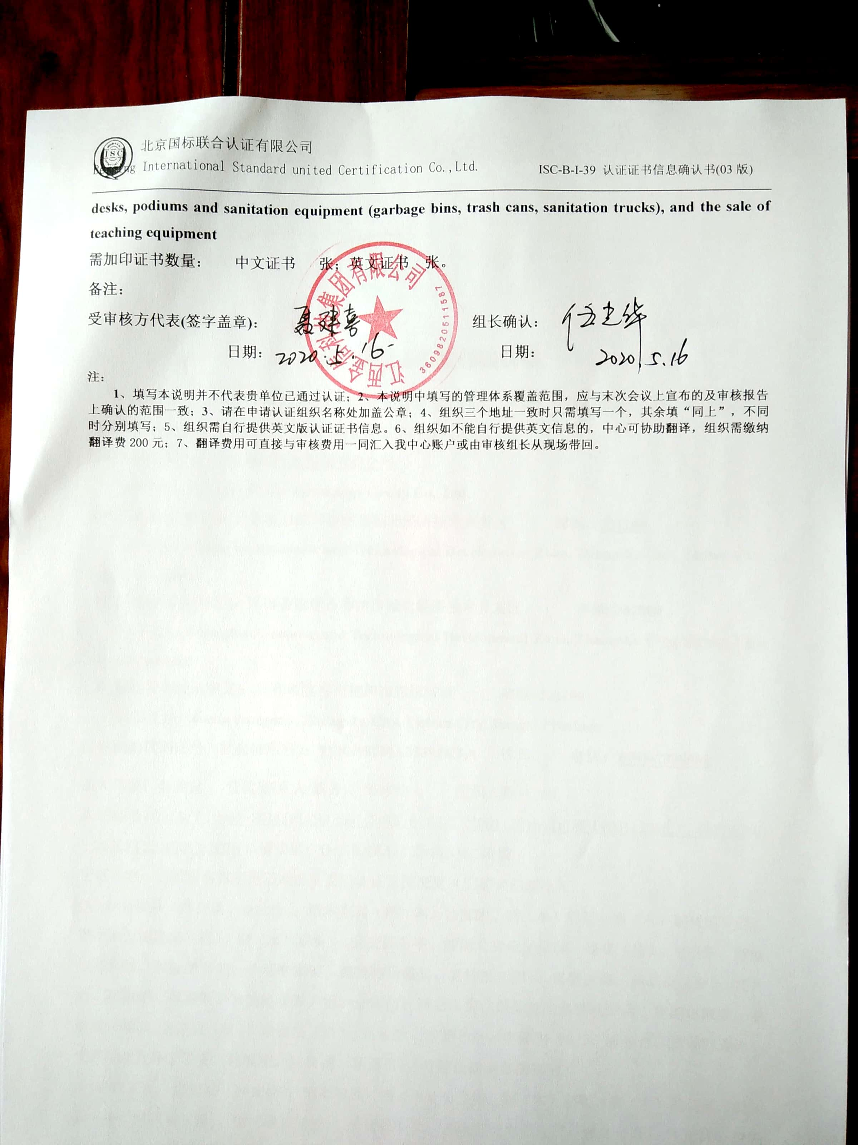desks, podiums and sanitation equipment (garbage bins, trash cans, sanitation trucks), and the sale of teaching equipment**

**需加印证书数量： 中文证书 张；英文证书 张。**

**备注：**

**受审核方代表(签字盖章)： 组长确认：**

**日期： 日期：**

**注：**

**1、填写本说明并不代表贵单位已通过认证；2、本说明中填写的管理体系覆盖范围，应与末次会议上宣布的及审核报告上确认的范围一致；3、请在申请认证组织名称处加盖公章；4、组织三个地址一致时只需填写一个，其余填“同上”，不同时分别填写；5、组织需自行提供英文版认证证书信息。6、组织如不能自行提供英文信息的，中心可协助翻译，组织需缴纳翻译费200元；7、翻译费用可直接与审核费用一同汇入我中心账户或由审核组长从现场带回。**