**合同编号.:**0136-2020-QEO

**组织认证证书信息确认书**

**为保证认证证书准确反映组织实际情况及管理体系特点，请将组织准确名称、地址、体系覆盖范围等有关信息正式表述如下，以便打印认证证书时作为依据。**

**组织名称 (中文)：****临沂腾飞教学用品有限公司**

**(英文)：****Linyi tengfei teaching supplies co., ltd.**

**组织注册地址(中文)：****兰山区银雀山办事处东苗庄居委0019号1号楼101;2号楼101 邮编:** **276000**

**(英文)：101, Building 1, No.0019, Dongmiaozhuang Residential Committee, tapiscia sinensis Mountain Office, lanshan district; Building 2 101.**

**□组织经营地址(中文)：****山东省临沂市兰山区临西九路与前十街交汇向北200米路东 邮编:****276000**

**(英文)：Lin Xi Jiu Lu and Qian Shi Jie, lanshan district, Linyi City, Shandong Province, meet 200 meters to the north and east of Lu Dong.**

**□组织经营地址1(中文)： 邮编:**

**(英文)：**

**组织机构代码证号（社会信用号）：****913713000643805246 传真：** **电话.：****13792993980**

**法人代表：****尤洪宁 管代/联系人(职务)：****孙成府 组织人数：** **10**

**认证标准：****Q：GB/T 19001-2016idtISO 9001:2015,E：GB/T 24001-2016idtISO 14001:2015,O：GB/T45001—2020/ISO 45001:2018认证类型：****Q:二阶段,E:二阶段,O:二阶段**

**变更内容：□组织名称变更□地址变更□认证范围变更（□扩大□缩小）**

**Q：教学仪器、教学设备、音体美器材、综合实践器材、实验室成套设备、学生床、课桌椅、办公用品、幼教设备、幼教器材、多媒体设备、电教设备、数字化教学设备、心理咨询室设备、教学软件、监控设备的销售**

**E：教学仪器、教学设备、音体美器材、综合实践器材、实验室成套设备、学生床、课桌椅、办公用品、幼教设备、幼教器材、多媒体设备、电教设备、数字化教学设备、心理咨询室设备、教学软件、监控设备的销售及相关环境管理活动**

**O：教学仪器、教学设备、音体美器材、综合实践器材、实验室成套设备、学生床、课桌椅、办公用品、幼教设备、幼教器材、多媒体设备、电教设备、数字化教学设备、心理咨询室设备、教学软件、监控设备的销售及相关职业健康安全管理活动**

**英文：**

**Q：Sales of teaching equipment, teaching equipment, audio-visual equipment, comprehensive practice equipment, laboratory equipment, student beds, desks and chairs, office supplies, preschool education equipment, preschool education equipment, multimedia equipment, audio-visual equipment, digital teaching equipment, psychological counseling room equipment, teaching software and monitoring equipment**

**E：Sales of teaching instruments, teaching equipment, audio-visual equipment, comprehensive practice equipment, laboratory equipment, student beds, desks and chairs, office supplies, preschool education equipment, preschool education equipment, multimedia equipment, audio-visual equipment, digital teaching equipment, psychological counseling room equipment, teaching software, monitoring equipment and related environmental management activities**

**O：Sales of teaching instruments, teaching equipment, audio-visual equipment, comprehensive practice equipment, laboratory equipment, student beds, desks and chairs, office supplies, preschool education equipment, preschool education equipment, multimedia equipment, electronic education equipment, digital teaching equipment, psychological counseling room equipment, teaching software, monitoring equipment and related occupational health and safety management activities**

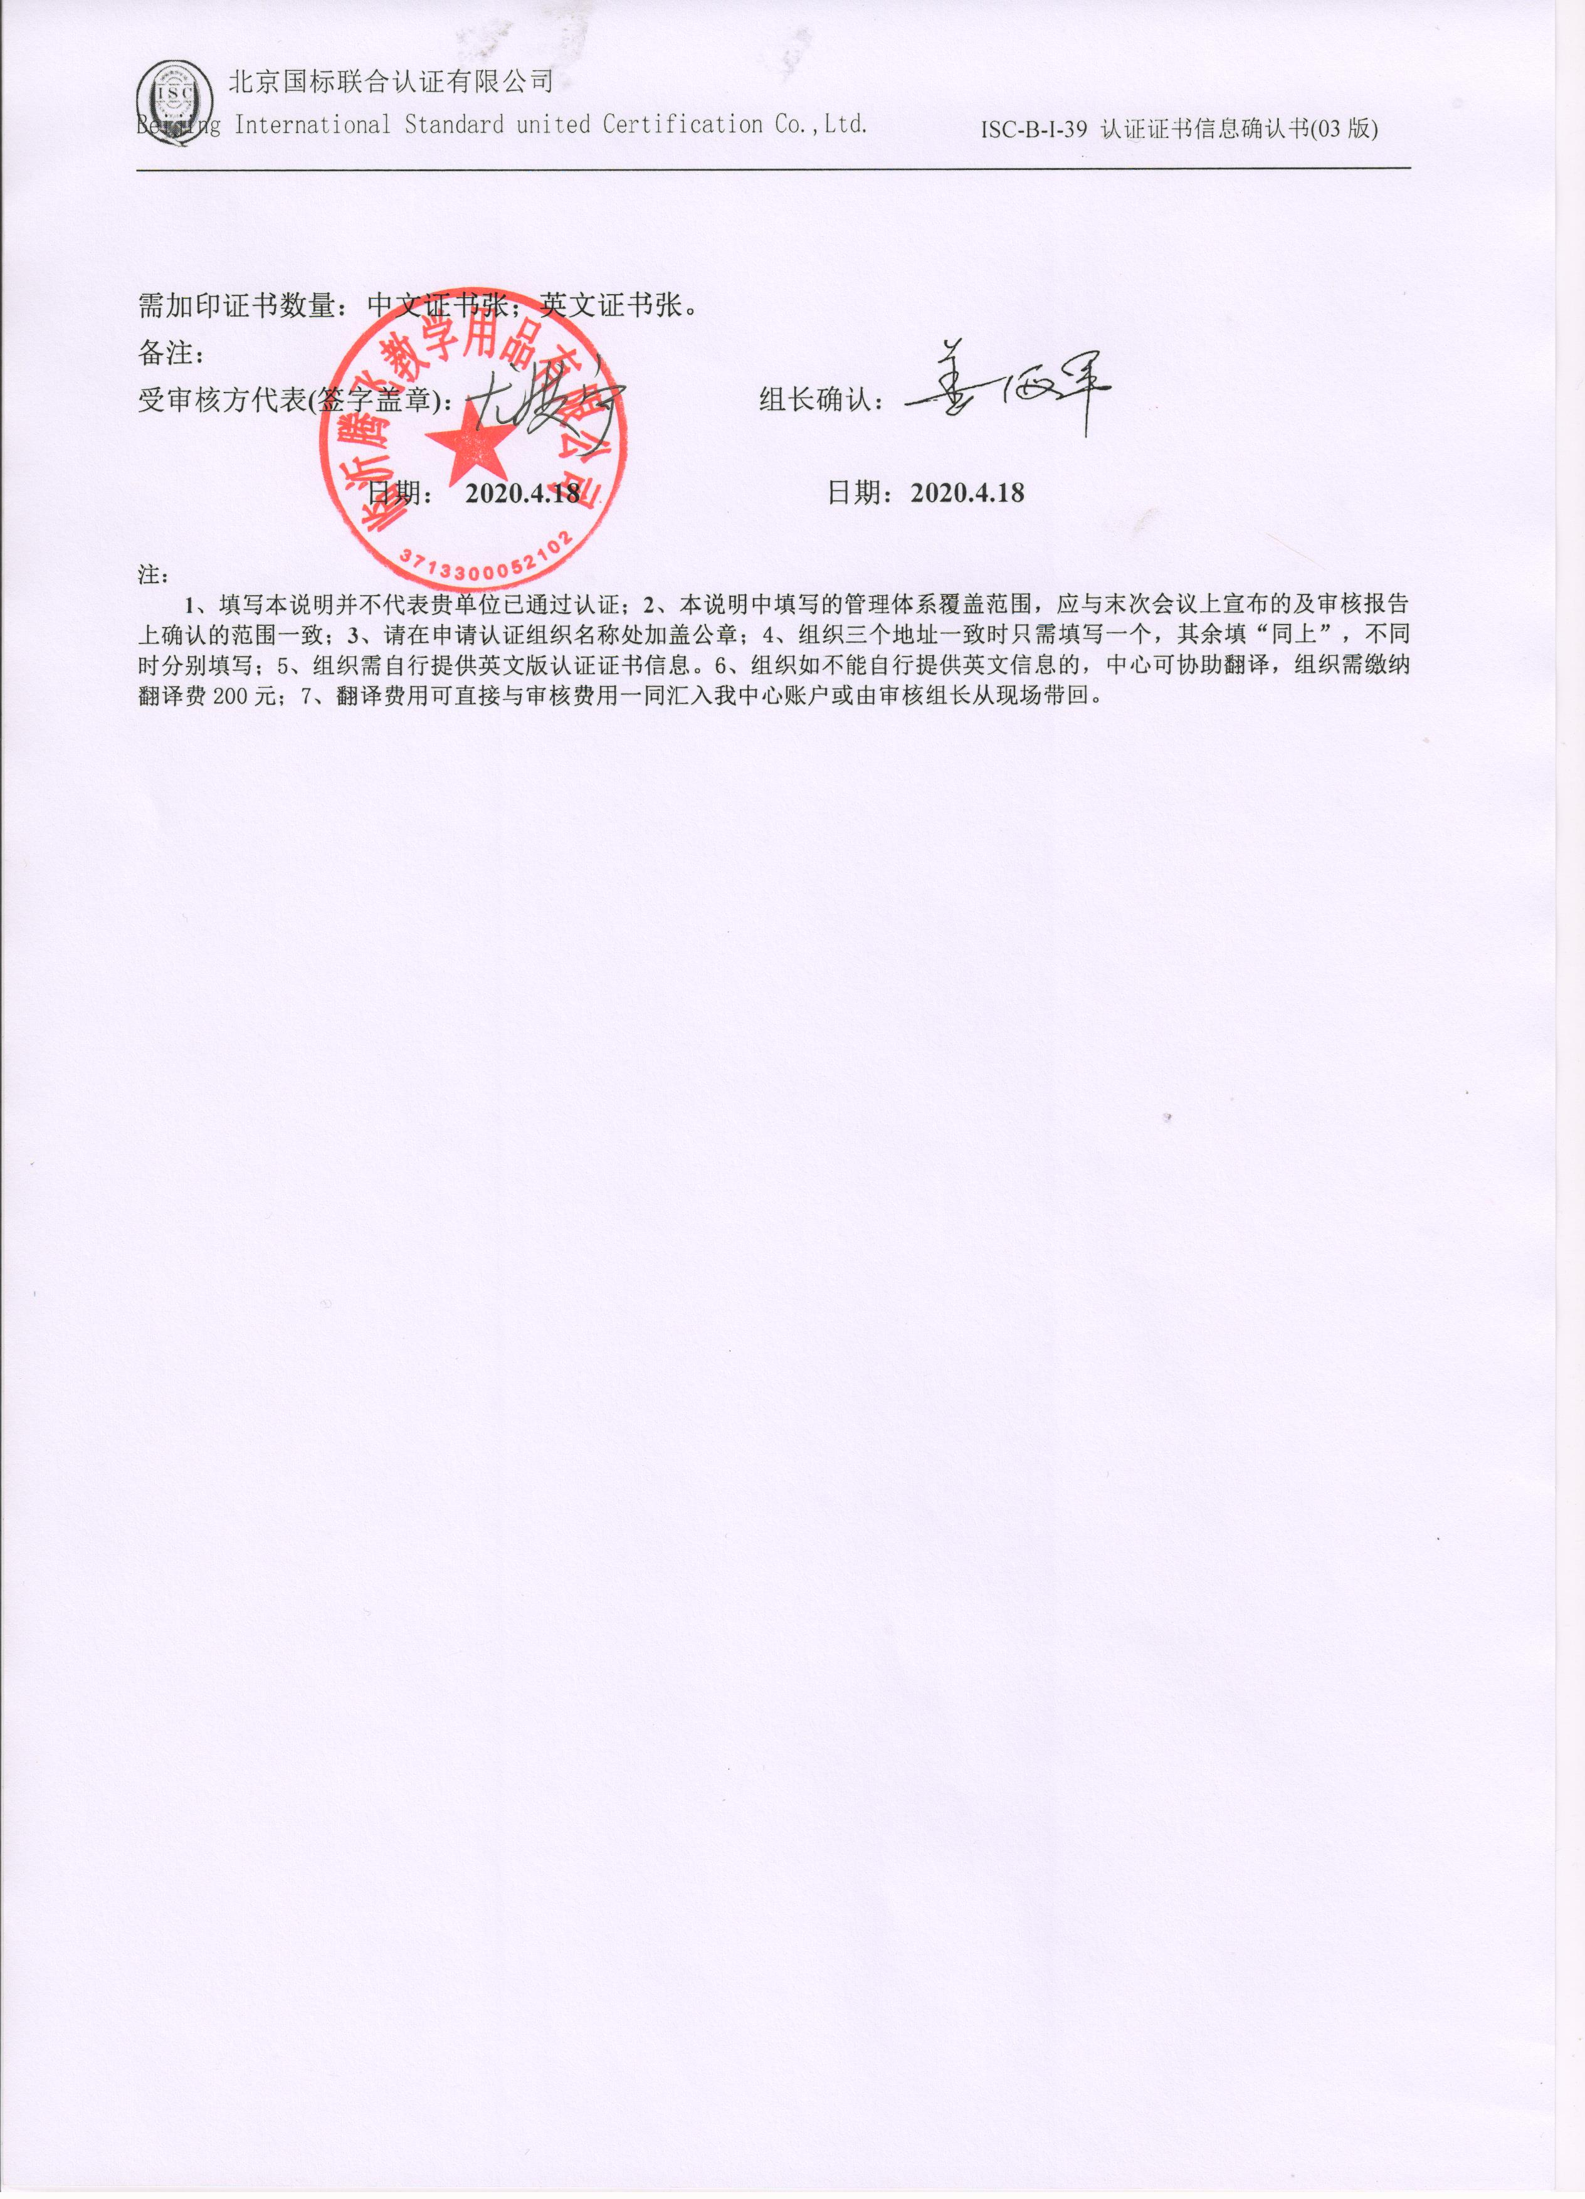

**需加印证书数量：中文证书张；英文证书张。**

**备注：**

**受审核方代表(签字盖章)： 组长确认：**

**日期： 2020.4.18 日期：2020.4.18**

**注：**

**1、填写本说明并不代表贵单位已通过认证；2、本说明中填写的管理体系覆盖范围，应与末次会议上宣布的及审核报告上确认的范围一致；3、请在申请认证组织名称处加盖公章；4、组织三个地址一致时只需填写一个，其余填“同上”，不同时分别填写；5、组织需自行提供英文版认证证书信息。6、组织如不能自行提供英文信息的，中心可协助翻译，组织需缴纳翻译费200元；7、翻译费用可直接与审核费用一同汇入我中心账户或由审核组长从现场带回。**