**在制品参数（厚度）测量过程监视记及控制图**

|  |
| --- |
| 被测参数：厚度 测量范围：0.3mm 允差范围：±5μm |
| 测量仪器：接触式测厚仪（0.05-2.0）mm 示值误差:+1μm |
| 监视方法：统计技术 |

在制品参数厚度数据如下，以佛山天奇产品，0.3mm±5μm为例：

|  |  |  |  |  |  |  |  |  |  |  |
| --- | --- | --- | --- | --- | --- | --- | --- | --- | --- | --- |
| 序号 | | 1 | 2 | 3 | 4 | 5 | 6 | 7 | 8 | 9 |
| 测量值 | 1 | 0.302 | 0.298 | 0.305 | 0.305 | 0.302 | 0.305 | 0.302 | 0.304 | 0.3 |
| 2 | 0.301 | 0.299 | 0.3 | 0.303 | 0.301 | 0.303 | 0.3 | 0.305 | 0.301 |
| 3 | 0.302 | 0.305 | 0.3 | 0.298 | 0.3 | 0.298 | 0.301 | 0.303 | 0.302 |
| 4 | 0.299 | 0.3 | 0.299 | 0.299 | 0.302 | 0.297 | 0.3 | 0.298 | 0.3 |
| 5 | 0.3 | 0.303 | 0.295 | 0.301 | 0.295 | 0.299 | 0.299 | 0.3 | 0.299 |
| 6 | 0.305 | 0.301 | 0.302 | 0.302 | 0.3 | 0.302 | 0.298 | 0.301 | 0.298 |
| 7 | 0.301 | 0.297 | 0.303 | 0.303 | 0.302 | 0.3 | 0.299 | 0.302 | 0.297 |
| 8 | 0.3 | 0.298 | 0.304 | 0.301 | 0.299 | 0.304 | 0.302 | 0.299 | 0.3 |
| 9 | 0.298 | 0.298 | 0.296 | 0.299 | 0.298 | 0.3 | 0.303 | 0.298 | 0.301 |
| 均值Ｘ | | 0.3009 | 0.2999 | 0.3004 | 0.3012 | 0.2999 | 0.3009 | 0.3004 | 0.3011 | 0.2998 |
| 极差R | | 0.0070 | 0.0080 | 0.0100 | 0.0070 | 0.0070 | 0.0080 | 0.0050 | 0.0070 | 0.0050 |



查表得：，,









控制图如下：

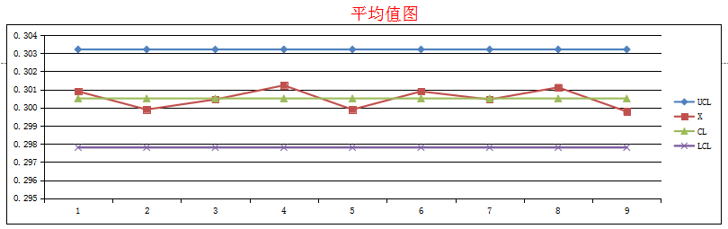

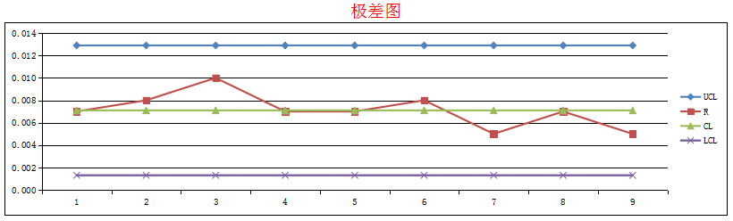

按控制图判异规则，判定该测量过程受控，状态合格。

核查人员：朱靖 日期：2022.06.08