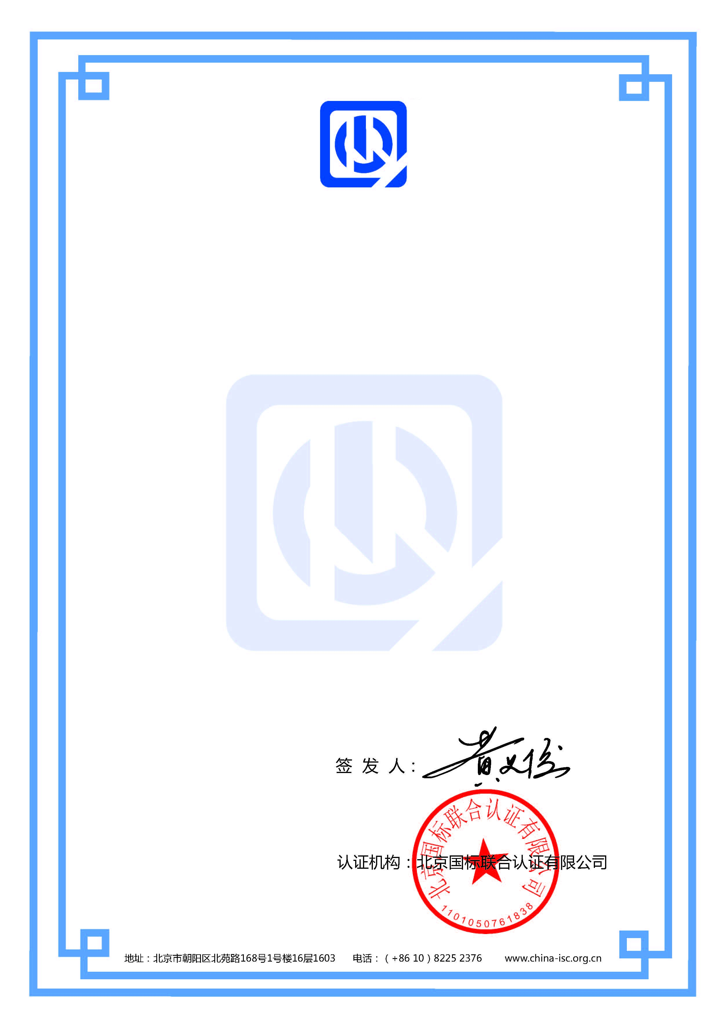

环境管理体系认证证书

证书编号：ISC-E-2022-1333
兹 证 明
青岛凝聚致远视觉科技有限公司

统一社会信用代码：91370211MA3DP1P37Q
注册地址：山东省青岛市黄岛区车轮山路388号1栋3办公3106户 邮编: 266400
审核地址：山东省青岛市黄岛区珠海街道办事处王家楼工业园 邮编: 266400

管理体系符合
GB/T 24001-2016/ISO14001:2015标准要求
认证范围：

视觉集成控制系统的生产（组装）所涉及场所的相关环境管理活动

本证书自有效期起始日期后的每年度进行监督审核，监督合格发放《年度监督审核合格通知书》和年度审核报告为准
本证书信息可在国家认证认可监督管理委员会官方网站(www.cnca.gov.cn)上查询
本证书信息可在认证机构官方网站(www.china-isc.org.cn)上查询

发证日期：2022年02月13日
有效期至：2025年02月12日



证书二维码

Environmental Management System Certificate

Registration No. ISC-E-2022-1333
This is to certify that
Qingdao NingJuZhiYuan Vision Technology Co., Ltd
The social credit code：91370211MA3DP1P37Q
Registered Address: Room 3106, office 3, building 1, No. 388, wheel mountain road, Huangdao District, Qingdao City, Shandong Province
Audit Address: Wangjialou Industrial Park, Zhuhai sub district office, Huangdao District, Qingdao City, Shandong Province

Which is in conformity with
GB/T 24001-2016/ISO14001:2015
This certificate covers the following scope of

Relevant environmental management activities of places involved in the production (assembly) of visual integrated control system

This certificate shall be subject to supervision and audit every year after the start date of validity, and the annual supervision and audit certificate and annual audit report shall be issued after the supervision is qualified.
The certificate information is available on the CNCA of the official website(www.cnca.gov.cn)
Search(www.china-isc.org.cn)

Issue Date：2022-02-13
Expiration Date: 2025-02-12

Cert code

